

School of Public Administration­­­­­  
Bachelor of Science in Computing­­­­­­

**COMP321 Information System Implementation  
Final Report**Academic Year 2017/18   
2nd semester

|  |  |
| --- | --- |
| Online Shopping Mall | |
|  |  |
| Project number: | 10 |
| Team members: | Tim (P1507859) |
|  | Cindy (P1507918) |
|  | Jack (P1507790) |
|  | Lee (P1507918) |
|  | Meng (P1504119) |
|  |  |
| Supervisor: | SIU KA MENG, Andrew |
| Assessor: | CHAN MEI POU, Calana |
|  |  |
| Submission Date: | Apr 23, 2017 |

Table of Contents

[1 Introduction 5](#_Toc512184220)

[1.1 Overview 5](#_Toc512184221)

[1.2 Objectives 5](#_Toc512184222)

[1.3 Risk Assessments 6](#_Toc512184223)

[2 Background and Related Work 7](#_Toc512184224)

[2.1 Background 7](#_Toc512184225)

[2.2 Related Work 7](#_Toc512184226)

[2.2.1 Introduction 7](#_Toc512184227)

[2.2.2 Customer account 8](#_Toc512184228)

[2.2.3 Shopping cart 8](#_Toc512184229)

[2.2.4 Online Category 9](#_Toc512184230)

[2.2.5 Payment 10](#_Toc512184231)

[2.2.6 Shipping and Return 11](#_Toc512184232)

[2.2.7 Comments and Reviews 12](#_Toc512184233)

[3 System Design 14](#_Toc512184234)

[3.1 Data Modelling 14](#_Toc512184235)

[3.2 Dynamic Modelling 17](#_Toc512184236)

[4 System Implementation 20](#_Toc512184237)

[4.1 Architecture 20](#_Toc512184238)

[4.2 Product Search and Detail Display 22](#_Toc512184239)

[4.3 Image Storage and Handling 23](#_Toc512184240)

[4.4 Register Validation 26](#_Toc512184241)

[4.5 Password Security 27](#_Toc512184242)

[4.6 Database information transactions 29](#_Toc512184243)

[4.7 Purchase Order Processing 30](#_Toc512184244)

[4.8 Notification for customers to track order’s status 31](#_Toc512184245)

[4.9 Customers’ Ratings and Reviews 32](#_Toc512184246)

[4.10 Price Change 36](#_Toc512184247)

[4.11 Out-of-Stock 37](#_Toc512184248)

[5 Results and Discussion 39](#_Toc512184249)

[5.1 Project Outcome 39](#_Toc512184250)

[5.1.1 Customers browse product 39](#_Toc512184251)

[5.1.2 Paging function 40](#_Toc512184252)

[5.1.3 Filter by brand 41](#_Toc512184253)

[5.1.4 Searching keywords 41](#_Toc512184254)

[5.1.5 Sort by price 42](#_Toc512184255)

[5.1.6 Product detail page 42](#_Toc512184256)

[5.1.7 Customer account setting 44](#_Toc512184257)

[5.1.8 Login and logout 46](#_Toc512184258)

[5.1.9 Change password 47](#_Toc512184259)

[5.1.10 Validators of user registration 50](#_Toc512184260)

[5.1.11 Automatic Redirection related to shopping cart 50](#_Toc512184261)

[5.1.12 Shopping cart 52](#_Toc512184262)

[5.1.13 Purchase order checking page 55](#_Toc512184263)

[5.1.14 Filter purchase 57](#_Toc512184264)

[5.1.15 Purchase order detail page 58](#_Toc512184265)

[5.1.16 Customer cancels order 60](#_Toc512184266)

[5.1.17 Vendor browsers and searches product 60](#_Toc512184267)

[5.1.18 Adding and editing new product 62](#_Toc512184268)

[5.1.19 Purchase order list page 64](#_Toc512184269)

[5.1.20 Purchase processing page 66](#_Toc512184270)

[5.1.21 Customer notification 67](#_Toc512184271)

[5.1.22 Product rate and review 68](#_Toc512184272)

[5.1.24 Price change 72](#_Toc512184273)

[5.1.25 Out-of-Stock 74](#_Toc512184274)

[5.2 Testing and System Evaluations 76](#_Toc512184275)

[6 Conclusion and Further Work 87](#_Toc512184276)

[References 89](#_Toc512184277)

[Appendix A. Project Management 91](#_Toc512184278)

[Appendix B. Peer Assessment Form 98](#_Toc512184279)

**Abstract**

With the development of the Internet, in real life, brick-and-mortar stores are replaced by online shopping gradually. Improving and consummating the online shopping mall always under consideration. This project is aimed to design a B2C online shopping mall, which means our website, welcomes all customers and will only have one supplier (one vendor).

This project introduces how to build a cosmetics online shopping website. The PHP, JAVASCRIPT, and Laravel (laravel, 2018) are used in this project. Laravel is most used on the server side and database. As for PHP (php, 2018) and JAVASCRIPT (javascript, 2018), they are most used in client-side. The database of our project will be built first. Then the structure of our website is next. Finally, the functions will be implemented.

The cosmetics online shopping mall provides a platform for customers to buy cosmetics online. It has a user-friendly interface and a strong category function. The website conforms to the tendency of the age, satisfies customers’ diversity needs. It is a promising website.

# Introduction

In this chapter, the basic concepts of our project will be discussed. The outline of this project will be listed and paragraphs will go through the whole project that we designed. The objectives will be introduced and risk assessments will be mentioned.

## Overview

Our website sales lipsticks, customers can find lipsticks they like by searching, sorting by category, click the thumbnail to see the detail of this product, then add to shopping cart, checkout and track their order. As for vendor, vendor can browse product as well and edit product, also edit status of order. The report is organized as follow: Chapter 1 is introduction. Chapter 2 introduces background of our work. Chapter 3 presents our design approach. Chapter 4 shows the implementation details of our work. Chapter 5 shows project outcomes and testing result. Last is chapter 6, which talk about the conclusion and further work.

Our project is an online shopping mall includes all general functions and five advanced functions. The details will be shown in the following chapters.

## Objectives

This project achieved both customer side functions and vendor side functions. For customers, they can browse and select desired products by paging, filtering the product brand and sorting the keywords of products, the browsing results can also be sort by price (for more details please check the appendix page from A1 to A7). Also, the website provides customer registration, a customer can register a new account for our website or existed customer can log in or log out. The customer can change their passwords if they want, passwords will be stored in hash values (for more details please check the appendix page from B1 to B5). Next, for any purchase, customers can add, remove or edit quantities of products to his/her shopping cart. Shopping cart provides product list for the customer to check and checkout function for the customer to purchase (for more details please check the appendix page from C1 to C6). What’s more, customers can use purchase tracking function to track and check their orders, can view the detail of every order they have made (for more details please check appendix page from D1 to D4). As for vendor side, the vendor can browse the product catalog, edit some properties of the product and add new products (for more details please check the appendix page from E1 to E6). What’s more, the vendor can list purchase orders by different status, the vendor can also ship, hold or cancel a purchase order in the purchase order processing page (for more details please check the appendix page from F1 to F7). Last but not least, here are some advance functions added to this project, such customer notification, rating and comment, price change and whether product is out of stock (for more details please check the appendix page form Z2 to Z6).

## Risk Assessments

There may be risks that append to our project; here listed three risks that we considered about, and for each risk, we offered solution and prevention.

Risk1: in some holidays or days with a huge discount, the website may not bear too much customer capacity; the server may not work functionally.

Solution to risk1: distribute customers to different servers.

Precaution to risk1: We add more servers before launching to the market.

Risk2: customers’ orders may be lost after the customer purchased.

Solution to risk2: customers can call for help with our customer services. After customers submit their payment bill, they can restore their purchase order.

Precaution to risk2: we set up customer service before launching to the market.

Risk3: vendor may upload duplicate product several times.

Solution to risk3: the website will alert the vendor by using an alert window if the vendor uploads duplicate products.

Precaution to risk3: we set up the alert window to remind vendor before this website released..

# Background and Related Work

In this chapter, the background of our project will be discussed and the comparison between two websites, www.sephora.com and www.lookfantastic.com will be listed as well. The comparison based on many aspects, for instance, customer account, shopping cart, online category and so on. This chapter helps us learn more website design experience, makes our website better.

## Background

Nowadays, with the tremendous speed of internet and the diversity of products, the e-commerce becomes more and more important in our social life. E-commerce is the activity of buying or selling online. Electronic commerce draws on technologies such as mobile commerce, electronic funds transfer, supply chain management; Internet marketing, online transaction processing, electronic data interchange (EDI), inventory management systems, and automated data collection systems (Wikipedia).

## Related Work

## Introduction

In this part, there are two cosmetics related e-commerce websites, sephora.com and lookfantastic.com, are chosen for the research study. Although these two websites contain almost all kinds of make-up stuff, this study would only focus on the lipsticks. The specific details from basic UI design to components interaction in each website would be described and analysed below.

By comparing with many online shopping websites, we summarize 6 parts that a website included. The first part is the online category. This part included the filtering, searching, sorting and so on. Second is payment. The shopping website needs to corporate with the third-party organization to guarantee customer’s payment security, like a credit card with banks or Alipay. The third is the shopping cart. This part includes the structure, logo and basic function of the shopping cart. What’s more, the customer account is also a significant part. Usually, it includes promotion and customer relationship management. The fifth is reviews and comments. This part is about customer rating and comments. Finally, is logistics. The delivery and return are all included in this part.

## Customer account

For customer account, these two websites both have sales force automation. After each purchase, customers can track the status of their products automatically.

Lookfantastic.com will list some products which are on sale to users. What's more, it would record the historical information of their purchase order at the bottom of each page. Customers can share their shopping list with email, Facebook, Twitter, and Weibo. Customers can contract with service staffs by email or posting letters.

The sephora.com is different. This website would record the users’ history and recommend some related products at the bottom of each page. It also has a special customer lifecycle, each customer could do some share tasks provide by the site in order to get some discount or free shipping. In this way, customers can attract more customers. Customers can give some advice to sephora.com by email or phone.

## Shopping cart

For comparing the shopping cart function between Lookfantastic.com and sephora.com, they both have a similar logo which looks like a basket. It can remind the customer of this function in order to help them know where to use it. Meanwhile, customers can add products to their shopping cart without login in. These websites would save the product information in a cookie which would keep in your browser until the browsing session ends.

In shopping cart page, customers can edit the quantities, delete their products. However, the Lookfantastic.com has a clear feedback page after customers adding products to their shopping cart. The shopping cart page would be updated instantly when customers change the quantity of any product. However, customers can only change the quantity one by one.

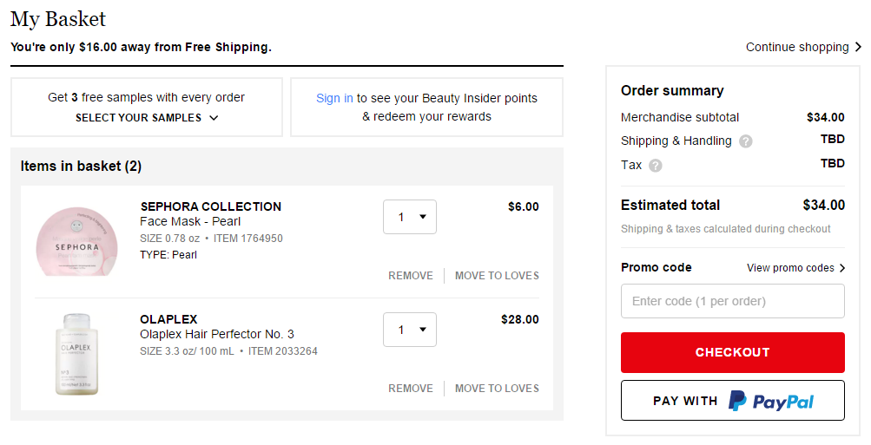The distribution of the shopping cart page of Lookfantastic.com is very consistent, which is from top to bottom. As for sephora.com, it has a left-right distribution which is a litter mess (Figure 1). Unlike Lookfantastic.com, sephora.com has a function called ‘love list’. This function supports customer to move their products from shopping cart to love list for a better shopping experience if they forget what they want.

Figure 1: shopping cart of Sephora.com

## Online Category

In the lookfantastic.com (Figure 2), the product list page uses six kinds of categories to identify various lipsticks. First of all, is called ‘Make-up product’, this category lists all makeup sets which contain different kinds of lipsticks inside (for example, an eye linear set contains an eye showdown and an eyeliner and a lipstick). The second category is filtered by Makeup colours. The third is ‘Brand’ and next is ‘Price’. And the fifth is called ‘Savings’ which means the customer can choose products by the discount rate of products. Finally, the last one is ‘Average reviews’, this function is filtered by the rating. What’s more, for a better filtering function, lookfantastic.com support customers to choose more than one options.

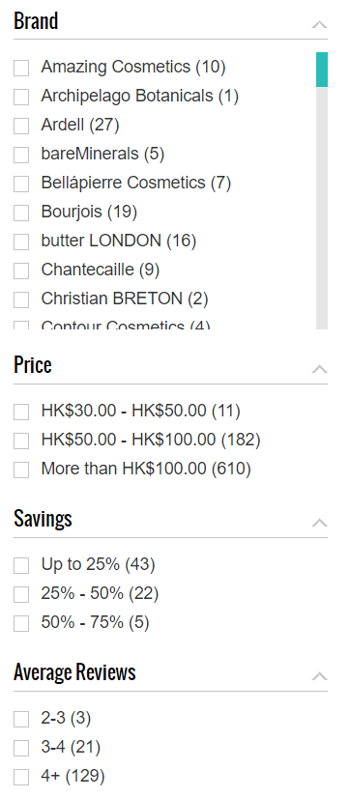However, in sephora.com (Figure 3), does not have an as powerful filter as lookfantastic.com has. Their product list only contains three categories for massive kinds of lipsticks. The first one is called lip, which means that all types of lipsticks are listed under this category. Second is Brand and the last one is ‘Price’, but one thing better is the range of price in sephor.com is larger than lookfantactic.com.

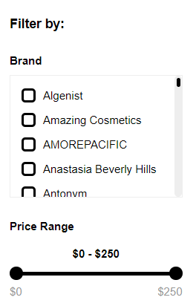

## Payment

Figure 2: filter of Lookfantastic.com

Figure 3: filter of Sephora.com

These two websites are both used the function customers should fill in their personal information about credit card before their final checkout and this is a widely used function for online payment usage.

Lookfantastic.com supports credit card payment which contains Visa, Master card, One4all and American express. What’s more, it also supports VISA checkout, PayPal, and Alipay, which is more suitable for the Chinese customers. The website uses credit cards which are accredited by banks, allows users to track their money from bank bill. If website or customers cancelled the order for some reason, the website will return the money back to customers through their credit card accounts. For Chinese version of Lookfantastic.com, supports Alipay, and Alipay will hold customers' money until the customer receives their orders.

As for Sephora, it only supports credit card payment, which contains VISA, Master Card, American Express, Discover, and JCPenny. When customers pay with Master Card, Visa or American Express, the related banks will get the certificate of authorization of the orders and hold the money which customer paid until the transaction is completed. When the order is shipped, the payment is processed.

## Shipping and Return

For shipping, there are some significant differences between these two websites. Website lookfantastic.com provides larger delivery range than the sephora.com, which is almost world-wild, even including Chinese in ‘delivery to China’ option and that is the reason why it has Alipay for payment. Comparing with lookfantastic.com, sephora.com only provides delivery service for seven countries. Customers cannot buy stuff on this website if they are out of these seven countries. What they have to do is that to ask their friends who live in the USA for help to receive stuff first, and then pay for the international transfer company to transferring their orders and get them.

In the aspect, as for shipping fee, lookfantastic.com provides free shipping if your order is over £40. In addition, if customers want to track their orders, they have to pay extra money according to their shipping addresses. However, it doesn’t provide any free shipping for the international shipping of sephora.com. It will charge you according to your address.

For the return, these two websites both provide a free return, but there are some differences. For lookfantastic.com, customers can only return goods with completed packaging, which means they can’t return the goods after using them. Sephora.com allows customers return goods after they lightly used.

Before returning, the customer of lookfantastic.com must connect to customer service for a unique returning code which is used for returning and goods tracking. But the customer of sephora.com can just use email to submit their return requirement.

Moreover, the duration of days you can use return service is limited. Lookfantastic.com only allows 14 days after customers receive goods and sephora.com allows 60 days.

## Comments and Reviews

For both websites, only the customers who bought a specific product could leave a review for that product. What’s more, a customer can only leave one comment for the product they bought with his/her account. Also, every review consists of the title, author, rating, comment, time, and date which is the buyer left this review.

On the other hand, sephora.com also provides the function that allowed customer add photos and videos for their reviews. Meanwhile, the reviews in sephora.com could be sort by reviewer’s age (Figure 4), skin type, and skin tone.

Lookfantastic.com provides a sort function to sort the reviews by rating, votes and the time that the review was created (Figure 5). Both websites support customers to vote whether the review is helpful or not, especially for Lookfantastic.com, customers can use ‘report this review’ function to report comments which they think are inappropriate, like an advertisement or dirty words. And it would be reported to the website management vendor for their statistical usage. The website management would delete these reviews when reports reach a certain amount (Figure 6).

However, there is a weakness in both websites. The customers cannot edit, change or delete the review once they submit it.

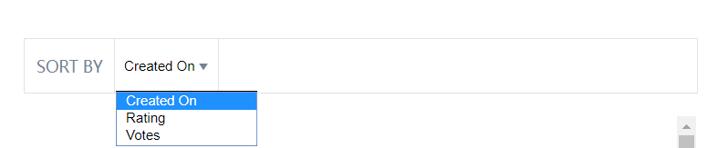

Figure 4: review filter of Lookfantastic.com

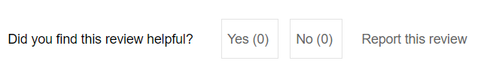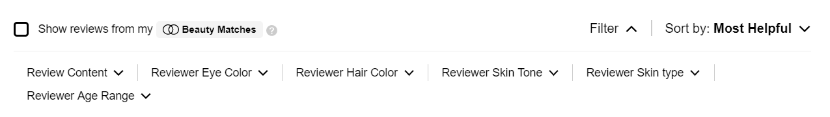

Figure 6: report of Lookfantastic.com

Figure 5: review filter of Sephora.com

# System Design

In this chapter, the database modelling and dynamic modelling would be explained.

The database modelling shows the Entity Relationship diagram, includes 9 tables, which are quite a lot in this project, are linked with foreign keys. This structure is used to reduce the duplicate data in a single attribute and save some storage. Because of joining tables, the weakness of this structure is the speed decreasing issue. For an online B2C e-commerce system, it is not a serious problem that it influences the speed evidently because of the limited amount of goods.

For dynamic modelling explanation, the activity diagram is chosen. There are two diagrams created for both user and vendor of products and could make the stream of activities from these two kinds of end users clearly.

## Data Modelling

Figure 7 below shows the Entity Relationship diagram of the database of this project. There are nine tables, including Product, Customer, Shopping\_cart, Purchase\_order, Purchase\_product, Product\_rate, Product\_review, Image, and Vendor. The detail description of these tables is shown as follow.

The first one is Product table; the detail information of each product would be saved here. It includes a unique productID for each product, productName for searching, brand, price, shades (the colour of lipsticks), texture, lip (the category of lipsticks) for filtering, tImage which is the address of small image is shown in product list for a general view of product, information which is the description of product writing by vendor and the out\_of\_stock which is a simple attribute for showing the status of a product which is out of stock to customers.

Because of a product may have one to four detail pictures, a subclass Image is used to deal with this storage wasting problem. It contains only two attributes, dImage for the address of detail image and another productID which is a foreign key for joining with Product table.

Next is the Customer table, which is the table mainly used for customer authentication and some information come from customers. Each customer has a unique customerID, a name which contains the full name of the customer, an e-mail address for contacting with them and they could use the e-mail address to log in, a password which is using hash code to keep the security and a shipping address.

Vendor table is quite different from other tables because it does not have any relationships. It is only used for authentication of vendor login. VID for the ID of vendor and password saves the password by hashing.

The Purchase\_order contains the information of each order, which are posted by customers. The P.O.Num is used as primary key and the identity for each purchase order and date is used to save the order date from a customer. The attribute status contains four kinds of statuses of this purchase order. Shipping\_time records the shipping time by the vendor. Cancel\_time and cancel\_by save the cancel time and the person, customer or vendor, who cancels the purchase. At last, there is a foreign key customerID for recording the belonging of customer.

There are four tables to handle the many-to-many relationship, which is the most complicated part of the database structure.

First one is Shopping\_cart table, which is used to deal with the many-to-many relationship between Customer and Product table. A unique id for each shopping cart record just for easier usage. Two foreign keys from customer and product and a quantity represent the quantity that customer choose to buy a certain product. After customer check-out, the record would be saved separately in Purchase\_order and Purchase\_product table, and then the record in Shopping\_cart table would be removed to deal with the duplicated problem from one customer by a certain product more than once.

Second is Purchase\_product class between Product and Purchase\_order table because one purchase order could have at least one product in it. It contains two foreign keys from Purchase\_order and Product, an attribute price to record the price when customers purchase that product. In this way, the price changing would not influence the product that already bought by customers. Another attribute quantity is used to save the quantity of the certain product.

Product\_rate and Product\_review have the similar structure, among Product table, Customer table and Purchase\_order table. The reason for recording the purchase order is to deal with the problem if a customer buys same product more than once and may duplicate the data in these tables. The rate attribute in Product\_rate table save the rates given by customers to products, the average rate would be calculated and represent on product detail page. The 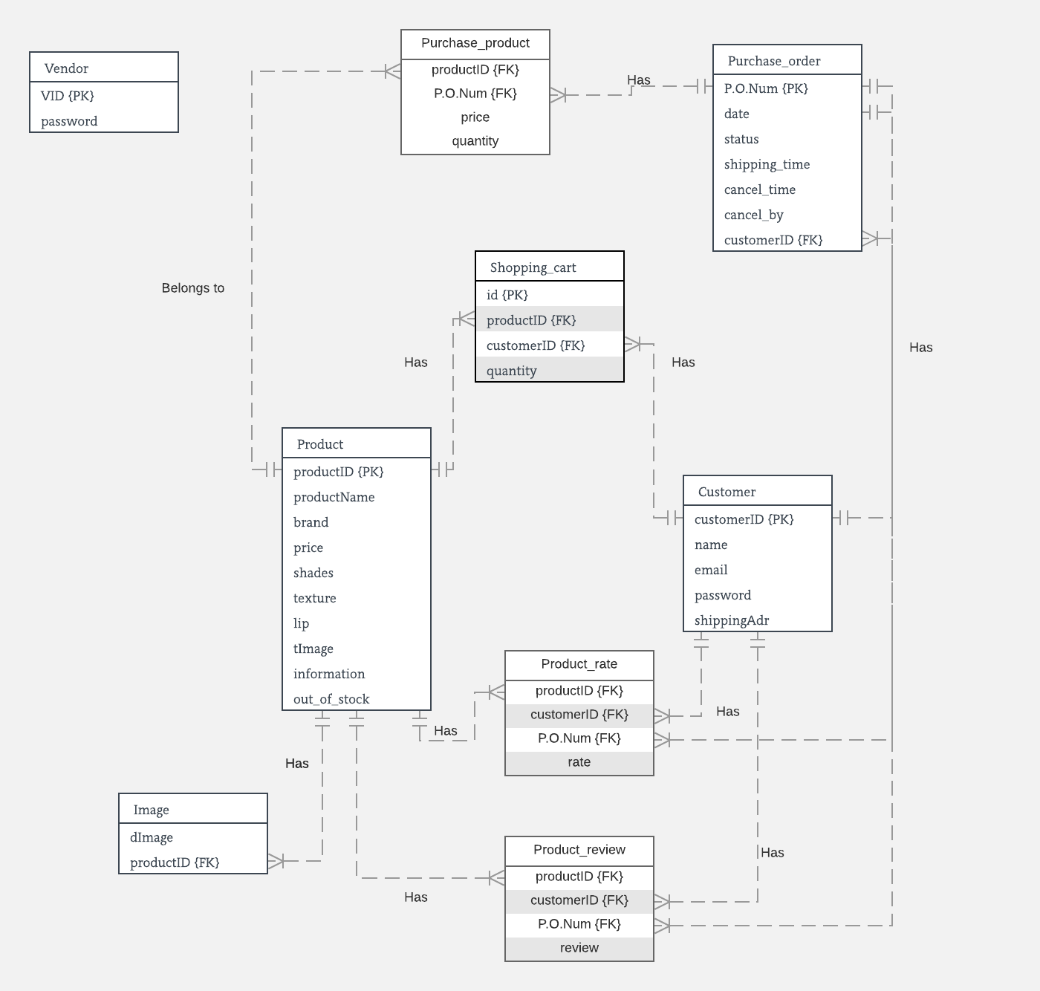review attribute in Product\_review table records the comment given by customers to products and shown in product detail page too.

Figure 7: Entity Relationship diagram of the database of this project

## Dynamic Modelling

For the Dynamic Modelling, the activity diagram is chosen because in this way, a much more obvious sequence of how customers and vendor use this website would be understood by everyone.

**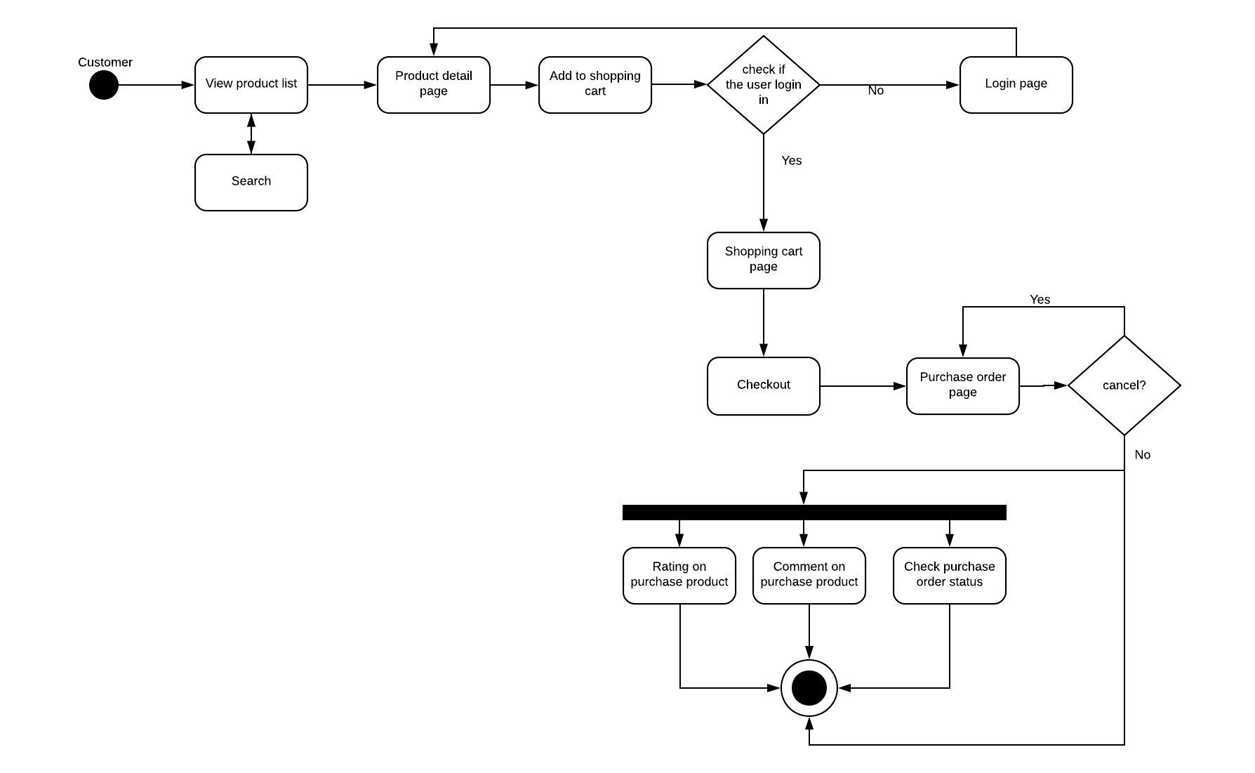****Figure 8: Activity Diagram for Beautilips customers**

Figure 8 shows the sequence of customers who use the Beautilips and represent almost all steps and functions he could do. The customer first views our home page as a product list page, they can use searching and filtering function to help them get what they want or they are interested in.

Next, they click the product, go to the detail page for the product. In there, they can get the information, some detail and uses pictures, and the rate and comment about this product. Also, they can change the number of product they want to get into their shopping cart. Then if they click the button ‘add into shopping cart’, the system will judge whether you are logged in already. If yes, the products would be put in your shopping cart. Otherwise, redirect customers to the log-in page.

The log-in page is quite common. Customers use their e-mail address and password to log in. If succeed, they would back to product detail page and choose the quantity they want again.

At the shopping cart page, customers could get the entire product they have put in it. They could change the quantity of them, delete the products they do not want, view the total price and then check out. After that, the data would be moved to the purchase order and the shopping cart would become empty at all. The customer could choose to go to their purchase order page or back to the product list.

In purchase order page, customers can view all purchase orders they have and sort by current purchase and past purchase. The name of the product, price quantity, total amount and status of a purchase would show directly and customers could view the detail information for that purchase by clicking. It would provide also the buyer name and address, shipping or cancelling time of this purchase record.

After the products are shipped, customers can give a rate and some comments on each product they have bought. These would be shown on product detail page for reference.

Figure 9 is the sequence of the vendor when he uses the website. First, the vendor should go to vendor’s log-in page, which is similar to customers for authentication. Then the vendor would be redirected to vendor centre for further changing.

At vendor centre, the vendor could search or add products and edit the information of them, then goes product detail page to see the changing.

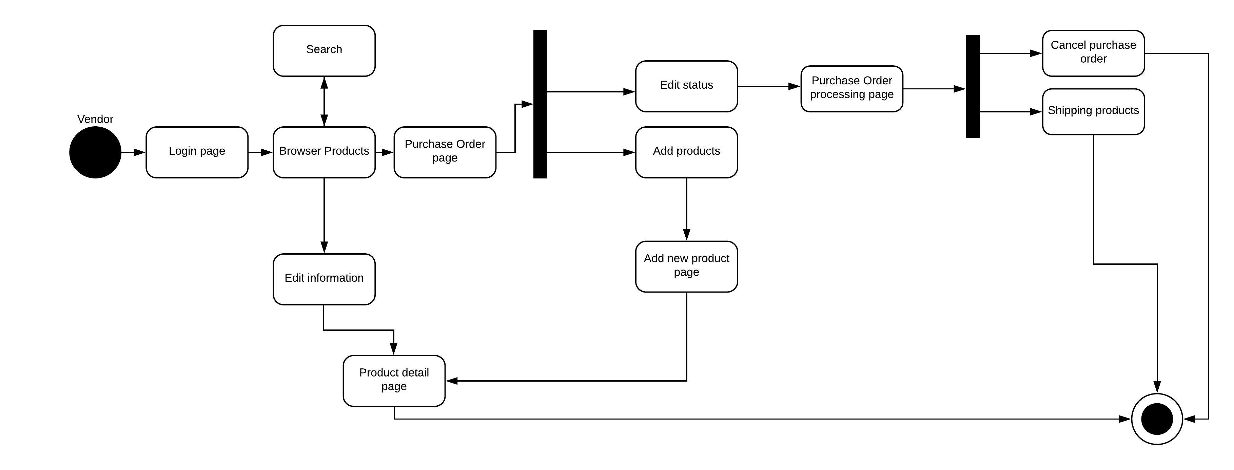The most significant function is to change the purchase order. The default status of a purchase is pending and vendor could change the status to holding, which means the purchase is paused, shipped and cancelled.

Figure 9: Activity Diagram for Beautilips vendor

# System Implementation

In this part, the implementation of Beautilips would be described. The architecture and some details of code for the complicated function would be shown and explained below.

## Architecture

For an online e-commerce website, the most suitable for the structural model is client-server architecture. Figure 10 shows the structure of the whole architecture of Beautilips. There is some JavaScript running on client-side and clients transmit HTTP requests to Apache web server, use PHP do the server-side programming and pass the SQL to MySQL database and get the data. Although it is a typical website structure, it is an experienced architecture for the website. What’s more, a framework for PHP, Laravel, has been used.

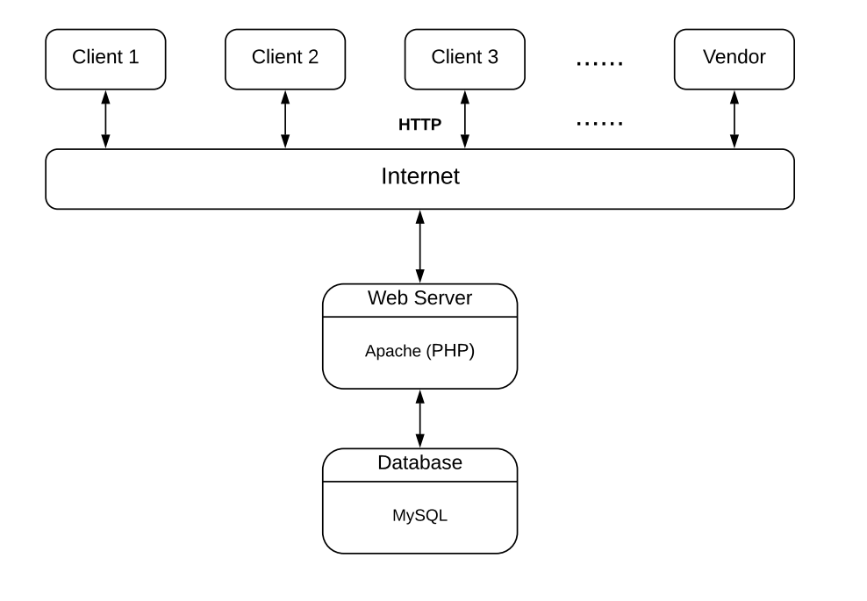

**Figure 10: Client-Server architecture for Beautilips**

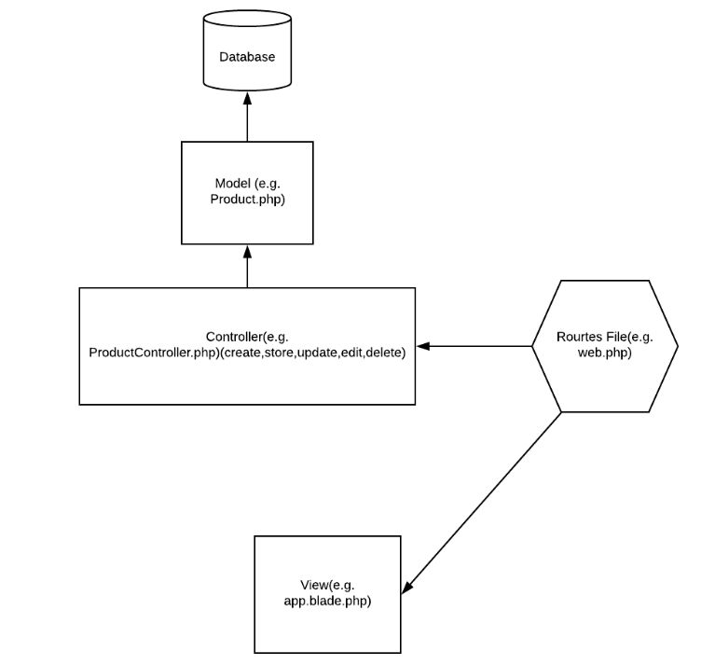 **Figure 11: MVC architecture for Laravel**

Laravel has its own architecture to handle the requirement of a website. Figure 11 shows the architecture of Laravel. First is the routes file which contains all the routers. The authentication, like the vendor center, can be only viewed by the vendor, could be directly handled by this file. What’s more, you could use it to route the function in controller file.

The view file contains HTTP structure for the website. In Laravel, there are some special codes that you could use in an HTTP format file. For instance, the layout file could be codding first of all and then used by all the pages using some codes. What is more, Laravel supports to write a for-each function to load more than one data and put them into the similar structure of HTTP content. It would much more convenience.

Almost all the functions, like create, show, store, update remove, etc., would be saved automatically in controller file if the function CreateController is used. Also, you could make some functions by yourself in these files and use them in the same way.

The model files are the simulation of the database. The interesting part is that you could use migration function in Laravel to create the whole database and model files and linked themselves with your Laravel system automatically.

By the reason of these advantages, Laravel became the framework of Beautylips website.

## Product Search and Detail Display

For Beautylips.com, Laravel framework provides some functions to process SQL (Figure 12). For default searching, it provides ‘where function’ to search products by product name, also it can sort the products by price using ‘orderBy function’.

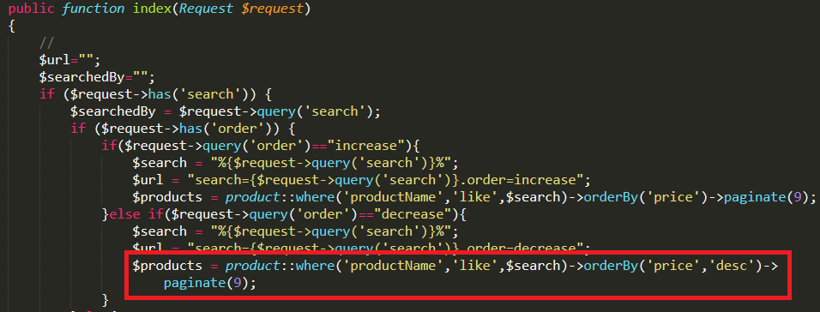

Figure 4:12: code of searching function

When users filter and search the products, they should filter the products with the brand before searching with products’ name that can decrease the searching time (Figure 13).



Figure 13: code of filtering function

We use foreach() loop (Figure 14) to display all of the searched products, in each item, there are img() tag and p tag to display its’ image and data.

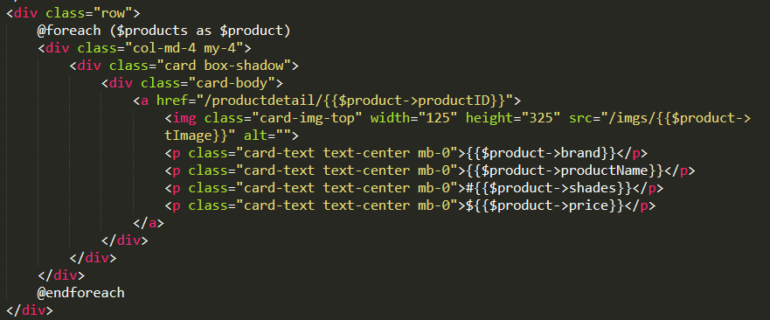

Figure 14: code of foreach loop

## Image Storage and Handling

For Beautylips.com, there are two functions which need to handle images in the Vendor part. One is that vendor may want to change the thumbnail image and detail images when vendor edits an existing product. Another one is that vendor may want to add a thumbnail image and upload 1 to 4 detailed photographs when vendor adds a new product. An example is taken below to show how to add thumbnail image and detail images. There is an <input> tag which is used inside the <form> tag as shown below.

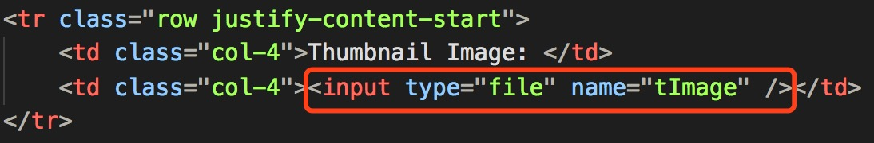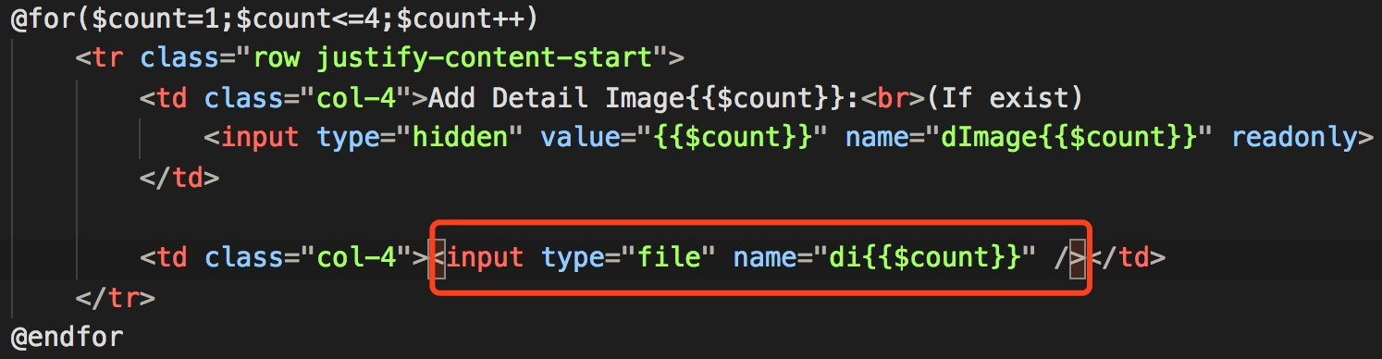

Figure 15: code of adding thumbnail and detail images

The <input> tags with the name “tImage” and “di{{$count}}” would be sent to the URL “/productadding/store” through the form submit function. And the route information for URL “/productadding/store” is shown below.



Figure 16: Route information for url

And the URL would send the inputs to the Product Adding Controller (Figure17).

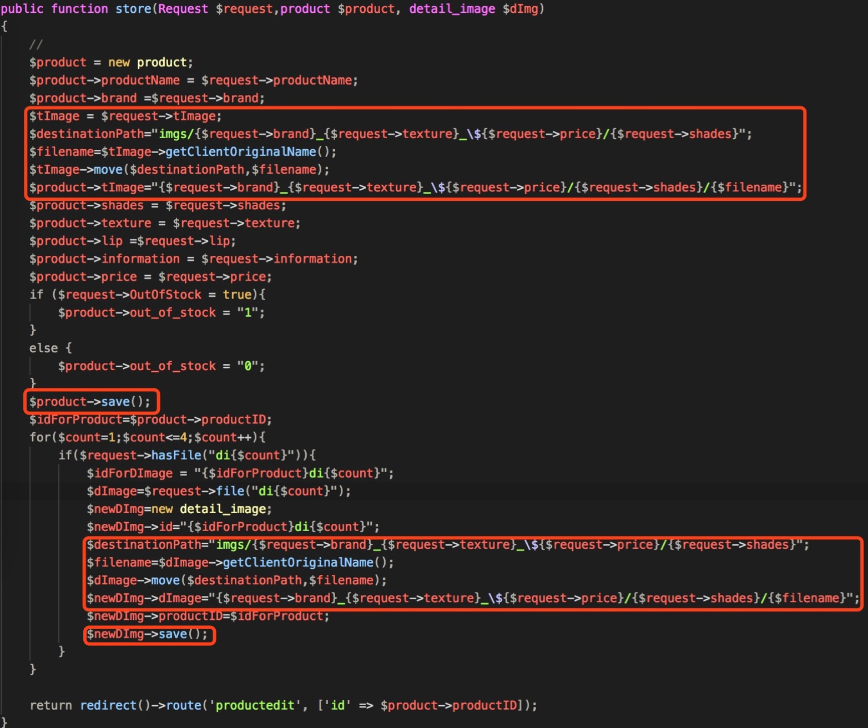

Figure 17: code of sending the inputs to the Product Adding Controller

For adding images, a new entry is built. The images are acquired by variable $tImage and $dImage. The variable $destinationPath is the path where the image would store in. For this path, the folder name is related with the properties such as brand, texture, price and shades and here is an example, “/Beautylips/public/imgs/3CE\_matte\_$13/116” where ‘3CE’ is the brand, ‘matte’ is the texture, ‘price’ is 13 and ‘116’ is the shades. And the url(s) are stored in the database through ‘$product->tImage="{$request->brand}\_{$request->texture}\_\${$request->price}/{$request->shades}/{$filename}" ’ and ‘$newDImg->dImage="{$request->brand}\_{$request->texture}\_\${$request->price}/{$request->shades}/{$filename}"’.

For the updating image, all the processes are the same and the only difference is that an existing entry would be used here instead of building a new entry.

When the situation turns to remove the image, the code would be like below.

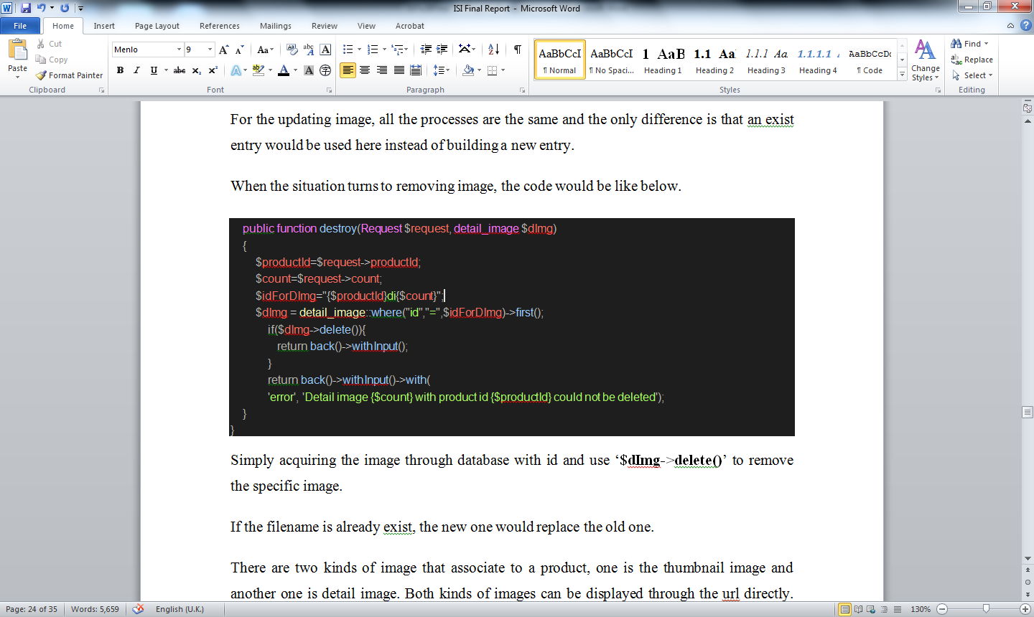

Figure 18: code of removing image

Simply acquiring the image through the database with id and use ‘$dImg->delete()’ to remove the specific image.

If the filename already exists, the new one would replace the old one.

There are two kinds of image that associate to a product, one is the thumbnail image and another one is the detailed image. Both kinds of images can be displayed through the URL directly. The URL of a thumbnail image is stored in the database table product which can be accessed by the primary key productID, with the name tImage. The URL of a detail image is stored in the database table detail\_image which can be accessed by the foreign key productID, with the name dImage. In short, the images can be acquired once the productID is known..

## Register Validation

The validation for the account is a big issue for all e-commerce website. To solve this problem, Laravel authentication has the validation function when a user registers an account or when a user changes the password. The places of these two validation functions are different but the working theory of them are totally the same. In this part, the validation of register would be introduced below.

The validation function for user’s register is called validator, placed in app/Http/Controllers/Auth/RegisterController.php file. For using validator function, the built-in function in Illuminate/Support/Facades/Validator should be used at first. And then code the validator function with an array variable which is posted from user to register. If the built-in function ‘php artisan make:auth’ is used to create authentication, all the requires for authentication, including validator, are provided automatically and what needs to be done is rewrite the function already exist.

Figure19 shows the validator function in Beautylips. All the variables passed from register.blade.php could be validated by this function with various restrictions. Validator::make() is a built-in function in Laravel, if the validator is passed, no message will be as default and if the validator is failed, the message for different restriction will be passed back to the corresponding position in the page.

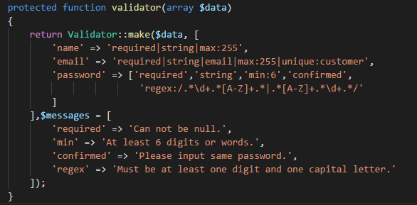

Figure 19: Validator function in Beautylips

The first variable in Validator::make() is $data, which is the information sent by the customer from the web page. Second is an array, as the restrictions. Different variables have different restrictions apparently. Before Laravel 5.4, the restriction for in validator should be used in an array for each variable like the restriction for the password in Figure 19. After Laravel 5.5, different restrictions could be put in a simple array, divided by the symbol “|”, which is much easier to define and type.

‘Required’ stands for required place and cannot be null, ‘string’ is the input type and save type to the database, ‘min’ is the length of the variable at least, ‘confirmed’ means this variable should be as same as the words in another variable which id is ‘VariableName-confirm’ and ‘regex’ is the regular expression form for some requests used in a password. There are also plenty of restriction functions that not be used for password restriction.

What’s more, for different restrictions, the message could be defined in third variable $messages.

## Password Security

The password should be hashed before putting into the database to give a security environment for each user of Beautylips. In Laravel, the hash function is provided in a simple function Hash::make() or simpler bcrypt(). Figure20 shows the code doing hashing and Figure21 shows the data saved in the database.



Figure 20: Hashing in Beautylips

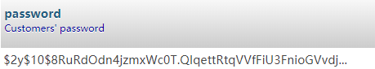

Figure 21: data after hashing in database

For change password function, Laravel provide an e-mail token function. However, to use this function, although most of the things are done by Laravel structure (by the code in terminal：php artisan make:auth), there is still some extra knowledge should be known in Laravel structure.

The logical of changing password function is: as explained in Data structure part in this report, a password reset table is used to store the automatically generated token to the customer who wants to change their password and send it to customer’s email box. Then the customer could click the link, which includes the token, in that email to go back to Beautylips system and use the token match up to the token in the database and to identify the customer. After that, the customer could change their password.

To set up the email function in Laravel, in .env file, which is an environment file for Laravel, there are some variables related to the mail function, shown in Figure 22. What should be done is put in MAIL\_USERNAME and MAIL\_PASSWORD of the specific mail address for using. In this part, every email could be set if the mail encryption function is known. The figure is using the mailtrap for testing. And if the Gmail is wanted to be used, the MAIL\_HOST should be changed to smtp.gmail.com, MAIL\_PORT 25, and MAIL\_ENCRYPTION is tls.

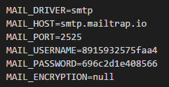

**Figure 22: Mail setting in Laravel**

In the config/mail.php, plenty of setting are related to the mail would be sent to the customer. For example, the mail address and name could be set by ‘from’ parameter, as shown in Figure 23.

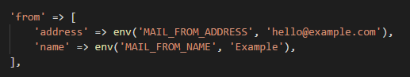

**Figure 23: Set the mail address and sender’s name**

## Database information transactions

For an e-commerce website, there are many information transactions happens every time and most of the transactions happen related to shopping cart functions. In this part, two major kinds of transactions, which are product add to the shopping cart and after goods in the shopping cart are checked-out and data becomes purchase order, would be described as follows.

Figure24 is the product detail page, placed in resource/view folder and this is the transaction from client-side to the server-side. Laravel use a form element to transmit data and the action attribute is to pass this data through the URL predefined in web.php. The entire div element with class form-group would be transmitted to the server. The first element to transmit is the product id of the current page, which is saved in the value of the first input and hidden to the customer. Next is a quantity change function of the website. The function minus() and plus() are using JavaScript to change the quantity dynamically on client-side only. Also, the functions would change the hidden value of another input element ‘hidQ’ in div which have the form-group class. The reason does not use original one to transmit is to keep the structure of buttons and numbers. Last form-group div is the submit button to send the data to the server.

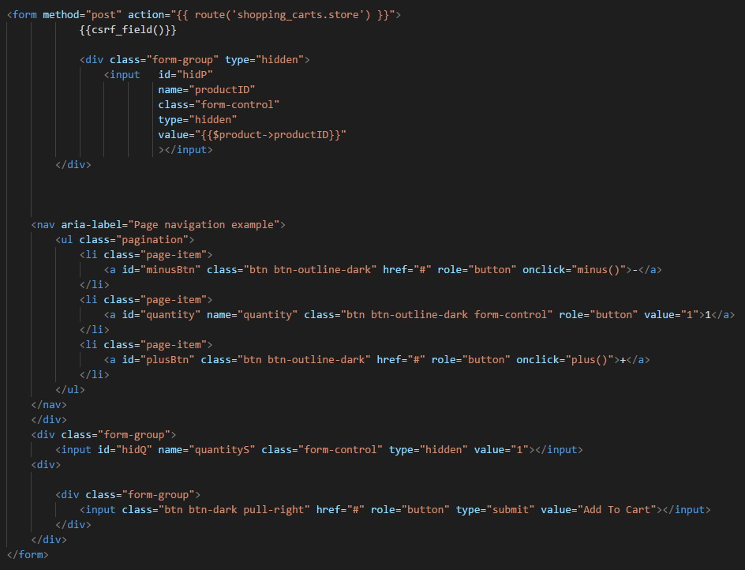

Figure 24: Http form of posting data to the server

After passing the data through web.php, it would be redirected to the ShoppingcartController.php file and put into the store() function, shown in FigureB. Auth::check() is the authentication check that if the user does not login already, it would redirect to login page.

## Purchase Order Processing

In purchase order page, we use JavaScript to set the change of status. The Laravel can quote the status of each purchase order. Therefore, we use an ‘if’ and ‘display’ to control the hold, shipped and cancelled button in the different status. The detailed code is listed below as Figure 25.

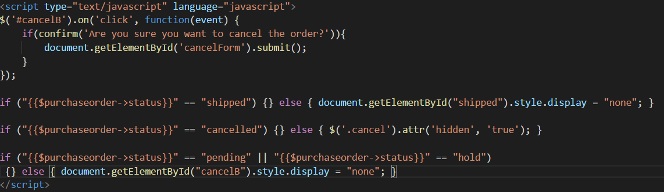

Figure 25: code of displaying status

Also, we use the Laravel update function to change the status of each purchase order, shown in Figure 26.

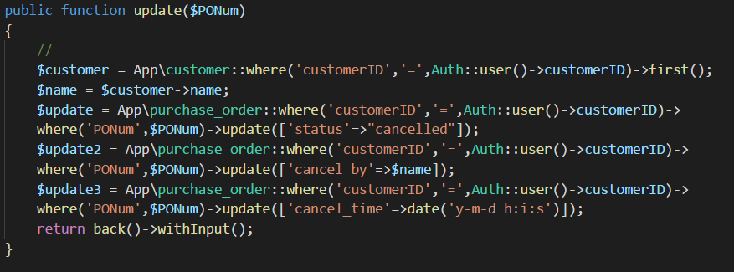

Figure 26: code of changing status

We use an Array to calculate the total amount of each purchase order (Figure 27). In this code, we first use a foreach() loop to calculate the total amount of each purchase order. And put it in our Array. After that, we use a foreach() loop on the website to print our purchase orders.

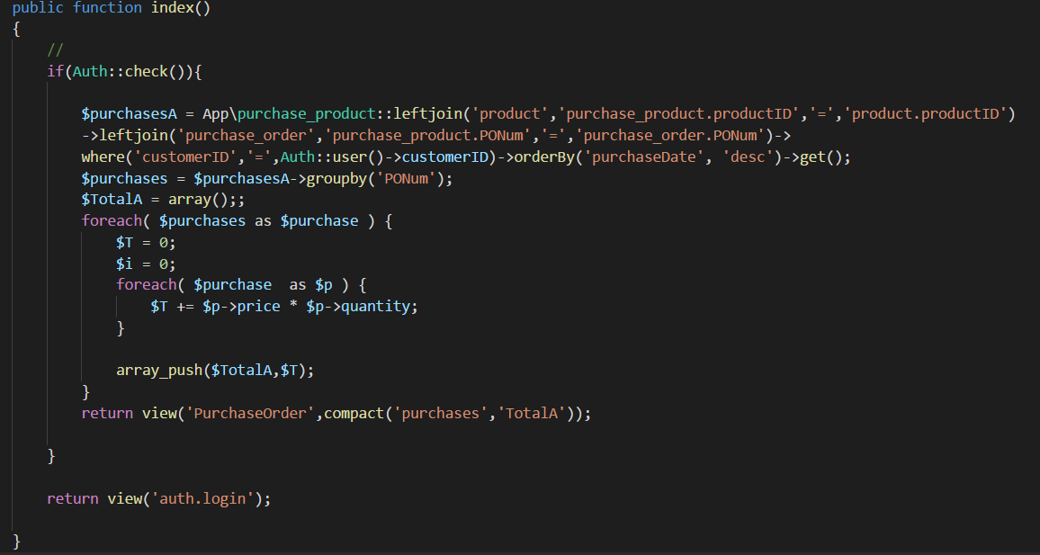

Figure 27: code of calculate the total amount

## Notification for customers to track order’s status

For customer page, using “get” method to get whether there is a new notification or how many unread notifications every second.

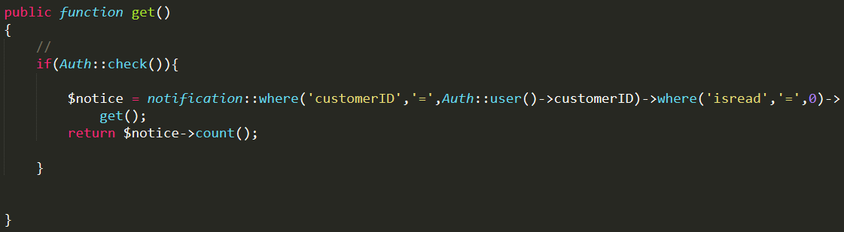

Figure 28: using get method to new notification

Use “index” method to check all notifications with customer’s id and sort notifications by “isread”, then show shorted notifications on notification page to customer.

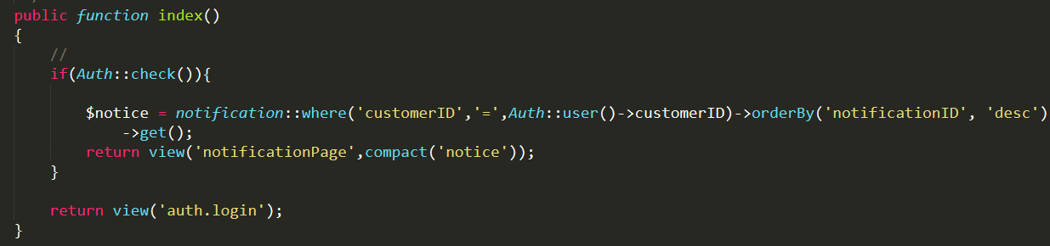

Figure 29: use index method to check notification

After customer read the notification, the notification will turn from “unread” to “isread”. Unread notification is marked with 0 in database while isread notification is marked with 1. Use “update” method to update the database, record which notification turn into isread.

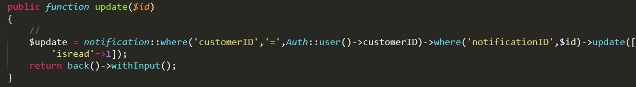

Figure 30: update notification status to database

## Customers’ Ratings and Reviews

After vendor shipping the product and change the status of the order to ‘shipped’, the comment button would appear and let customer rate and give the review to each product in this order one by one.

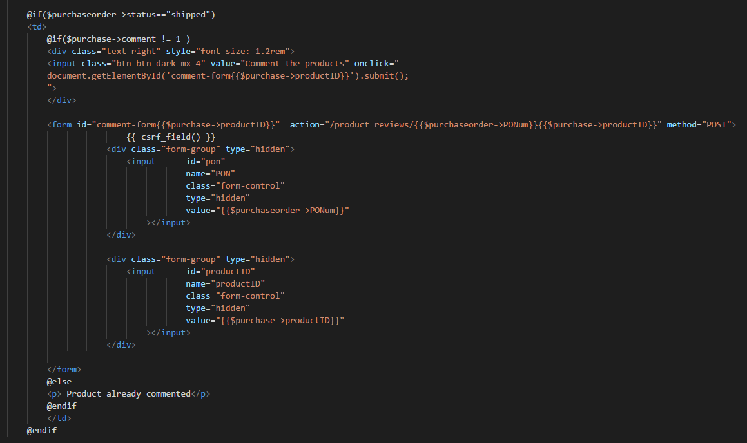

Figure 31: Code of comment button

The information would be passed, code are shown in Figure 32, to a new page through function pass(), shown in Figure 33, in ProductReviewController.php.



Figure 32: Router of passing product information to pass() function

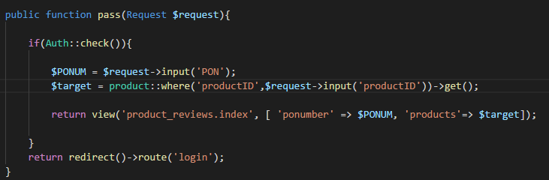

Figure 33: Pass() function in ProductReviewController.php

Customer would be redirect to a new product review page to comment and give the rate to the specific product. The purchase order number, rate, and comment would send back to store() function in ProductReviewController. The code of product review page is shown in Figure 34 and 35.

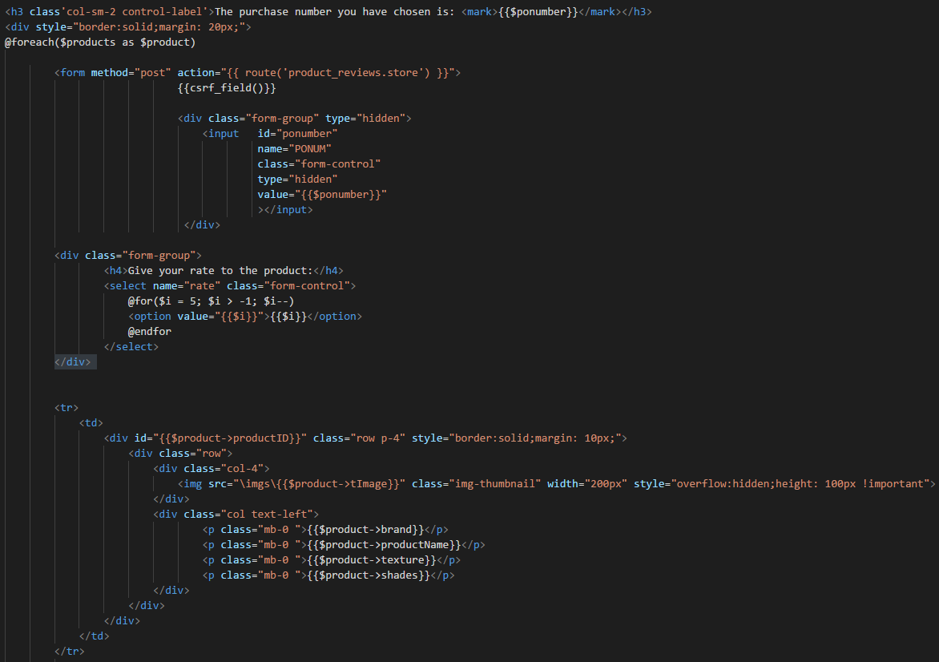

Figure 34: Comment page (1)

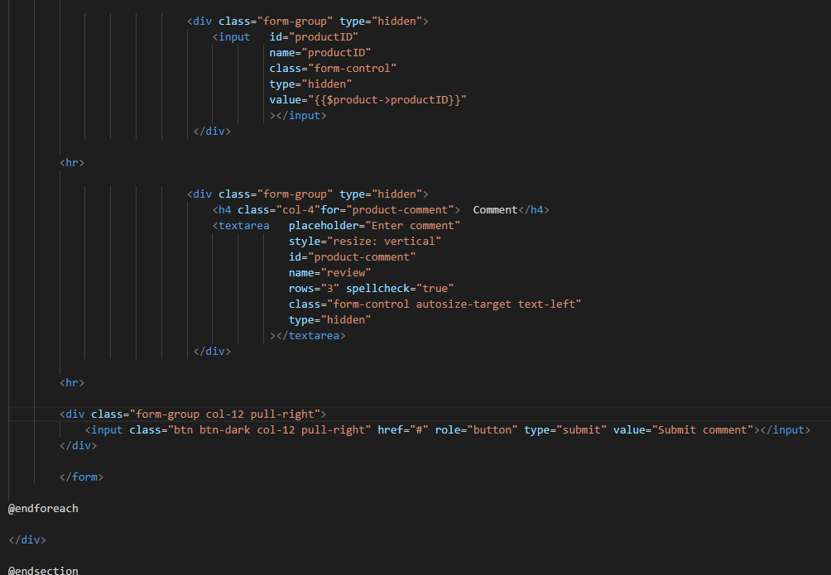

Figure 35: Comment page (2)

Similar to the above functions, the comment and product rate would be stored in two databases, which are product\_review and product\_rate. After comment and rate are saved, the attribute ‘comment’ in purchase\_product would be updated to 1, which means is has already commented and do not need to comment again. Code is shown in Figure 36.

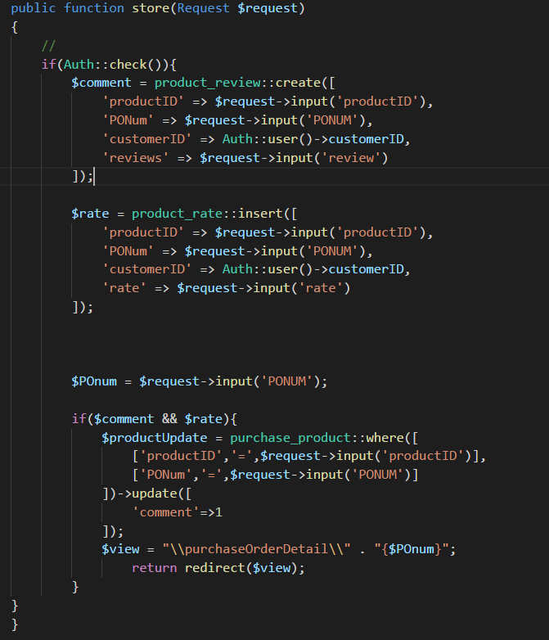

Figure 36: Store() function in ProductReviewController.php

Product rate would be calculated an average number with one digital place and product review would get back, shown on product detail page. These functions are coded in ProductController, shown in Figure 37.



Figure 37: Average calculate and product review getting in ProductController

Then, just use two simple foreach() loop to show every comment by different customers in product detail page.

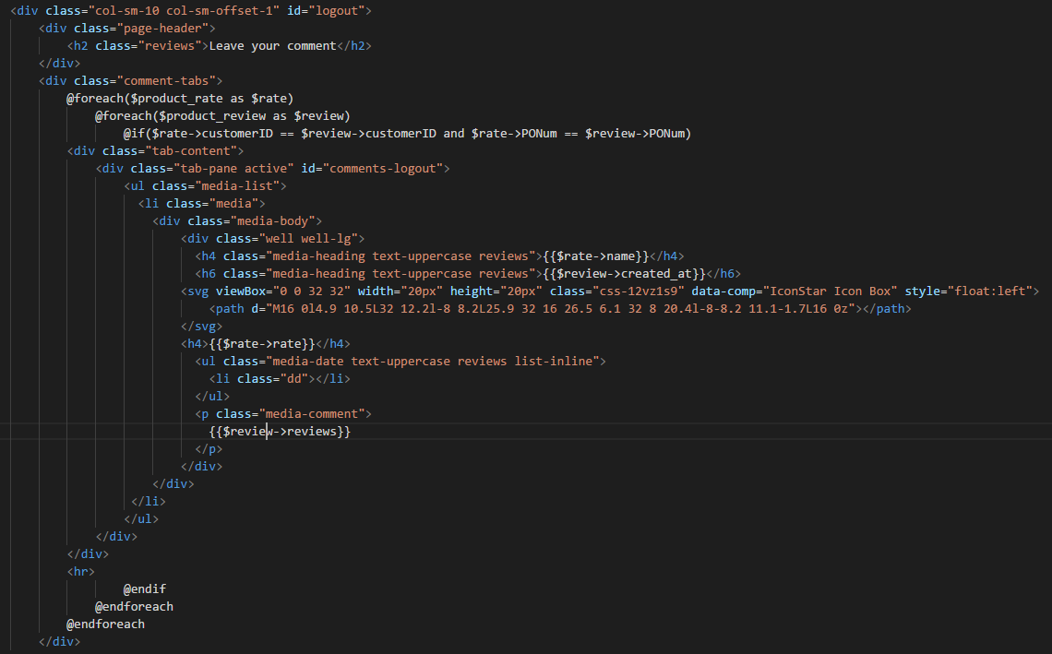

**Figure 38: Comment HTTP code in product detail page**

## Price Change

For each purchase, it store the current price in purchase\_product table. When vendor wants to change one or some products’ price, it will not effect the product price of customer’s purchase order. When we display the purchase order page, the price data will be loaded from purchase\_product table.



Figure 39: load product data form purchase\_product table

## Out-of-Stock

The vendor can mark a product as temporarily out-of-stock in ProductEdit page.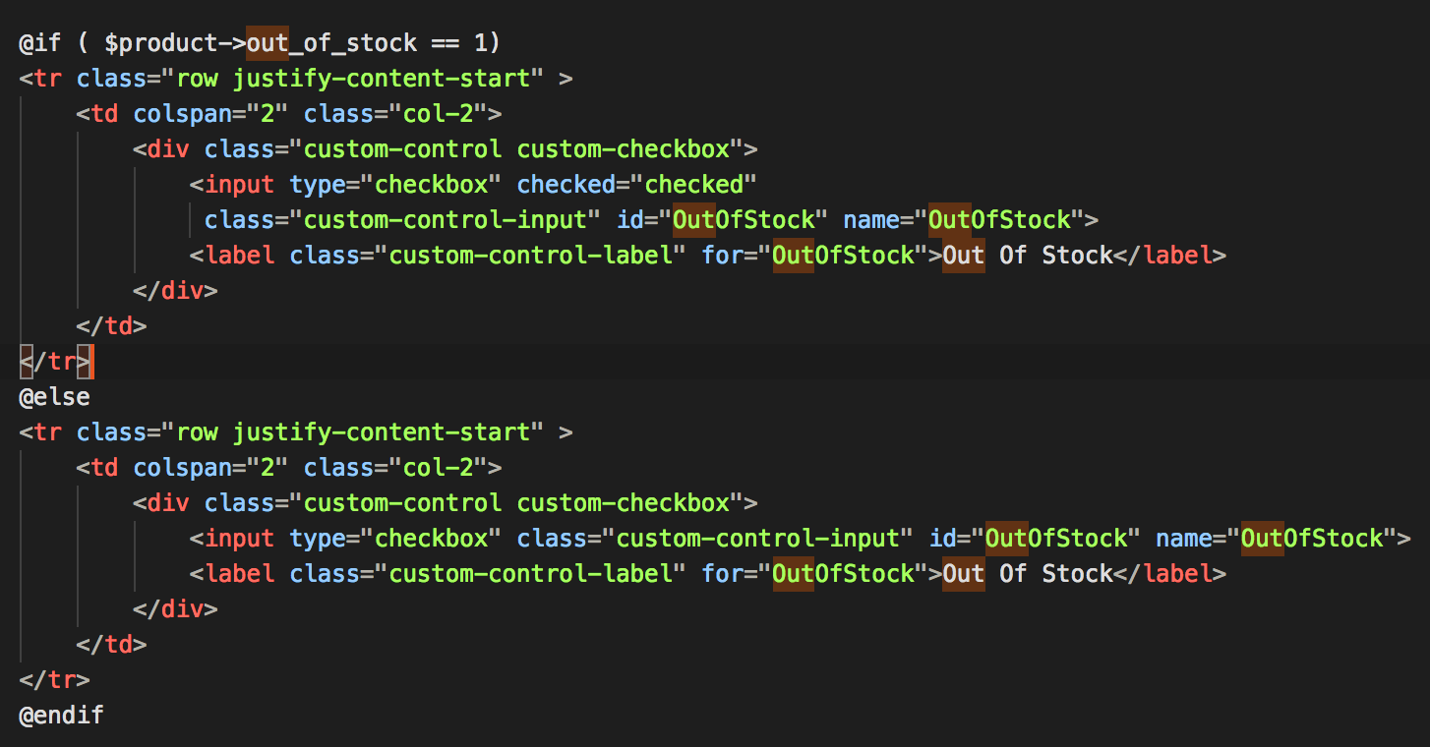

Figure 40: Vendor mark product as temporarily out-of-stock

As Figure 41 shown, a checkbox will be provided for vendor to tick if the product is out-of-stock and vice versa.

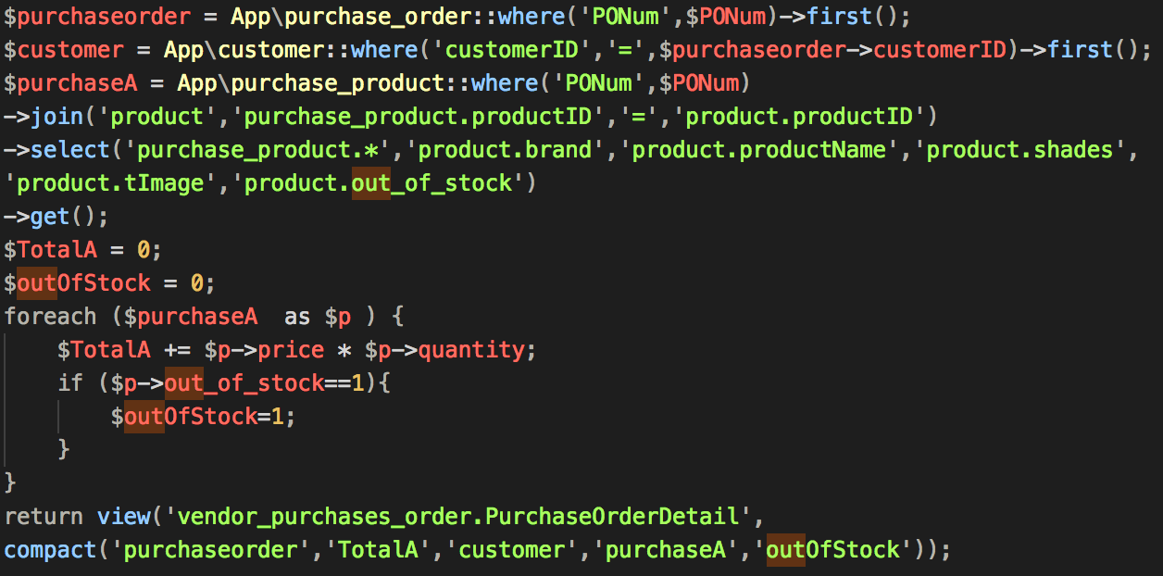

Figure 41: code for vendor to tick the check box

After customers placing orders for the such out-of-stock products, the system will check whether there is one of the products inside this order is out-of-stock for vendor like Figure 42 shown. If there are one or more products are marked out-of-stock, “$outOfStock” will equal to 1. Once the product of the order is out-of-stock, vendor is not able to ship this order unless the product is in-stock. To handle this, as shown in Figure, if the purchase order which the status equals to pending or hold and one or more products inside the order is out-of-stock, the shipping button would be hided.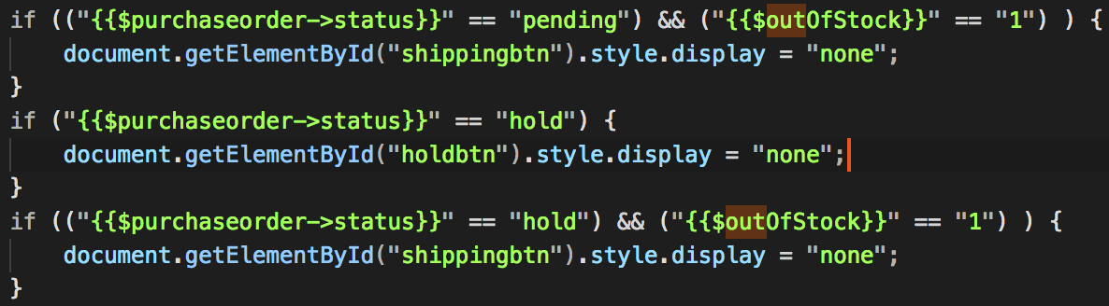

Figure 42: code for checking whether the product is out of stock

# Results and Discussion

The Beautylips website is an online shopping mall system which sales lipsticks. This chapter displays the outcomes of the project. The outcomes will be shown mostly by Screen Shot and several sentences explain them. The sequence of displaying the outcomes will follow function specifications attached to the appendix.

## Project Outcome

This project concludes customers shopping experience and vendor operating website experience. In this part, customers shopping experience will be discussed first then is the operating experience of the vendor. The sequence for all function refers to the functions order attached to the appendix.

### **Customers browse product**

Customer will see the home page of our website once they type our URL. This picture (Figure 43) shows the main home page of our online shopping mall. There is a name ’Beauty Lips’ at the upper left corner. Four pictures are rolling in the front of our page. The products are listed after a recommendation line; customers can see the detail by clicking the link after each product. For each product, there is a thumbnail and information about the product, such as product brand, product name, shade and price.

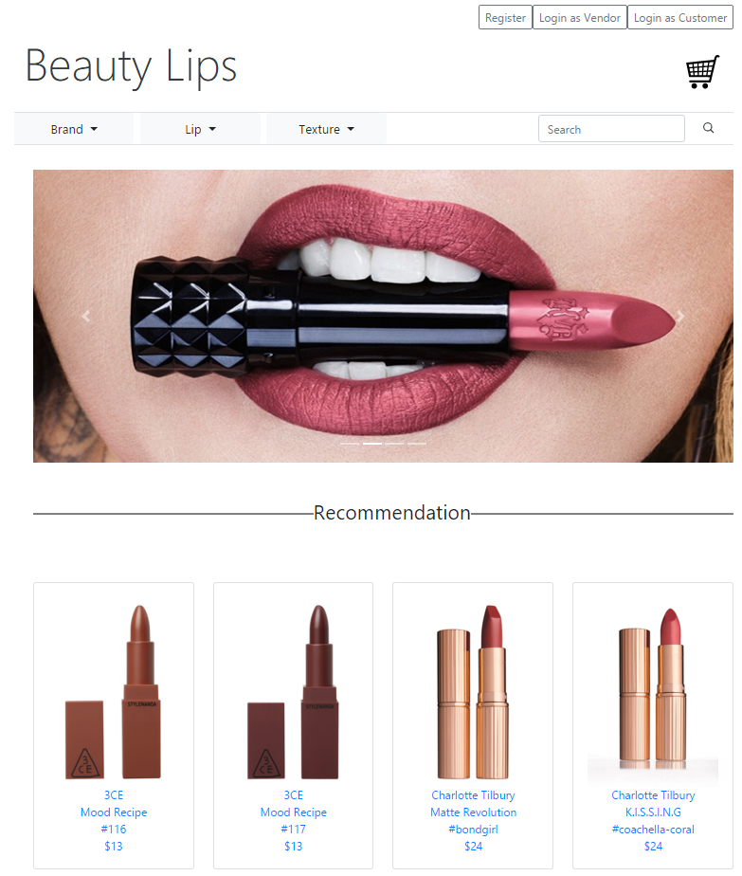

Figure 43: home page

### **Paging function**

At the bottom of product listing page (Figure 44), customers can choose which page to jump to. Also, they can choose to go to the next page or go to the specific page.

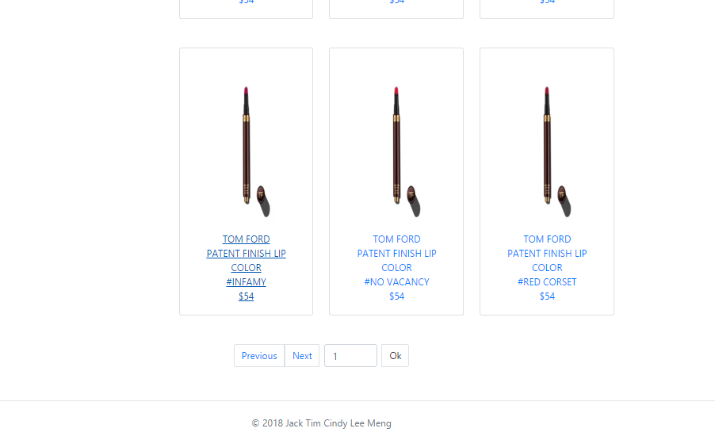

Figure 44: screen shot of paging

### **Filter by brand**

Customer nor only can choose which page to go to, but also can filter the products by brand. The searching bar provides a dropdown list for customers. Figure 45 is shown below.

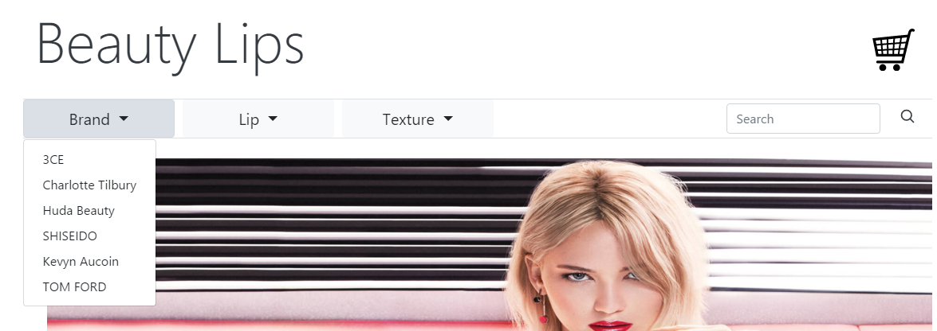

Figure 45: screen shot of filtering products by brand

### **Searching keywords**

After filtering products by brand, the customer can search the keyword of all products if they want more specific result (Figure 46).

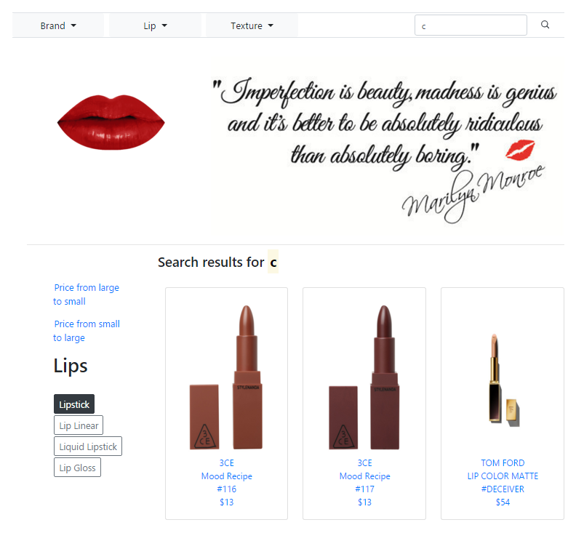

Figure 46: screen shot of searching the key word

### **Sort by price**

The result page provides sorting by price function to customers. The customer can show products’ price from ‘large to small’ or ‘small to large’. And filter the products by the category this function also be added to product list page (Figure 47).

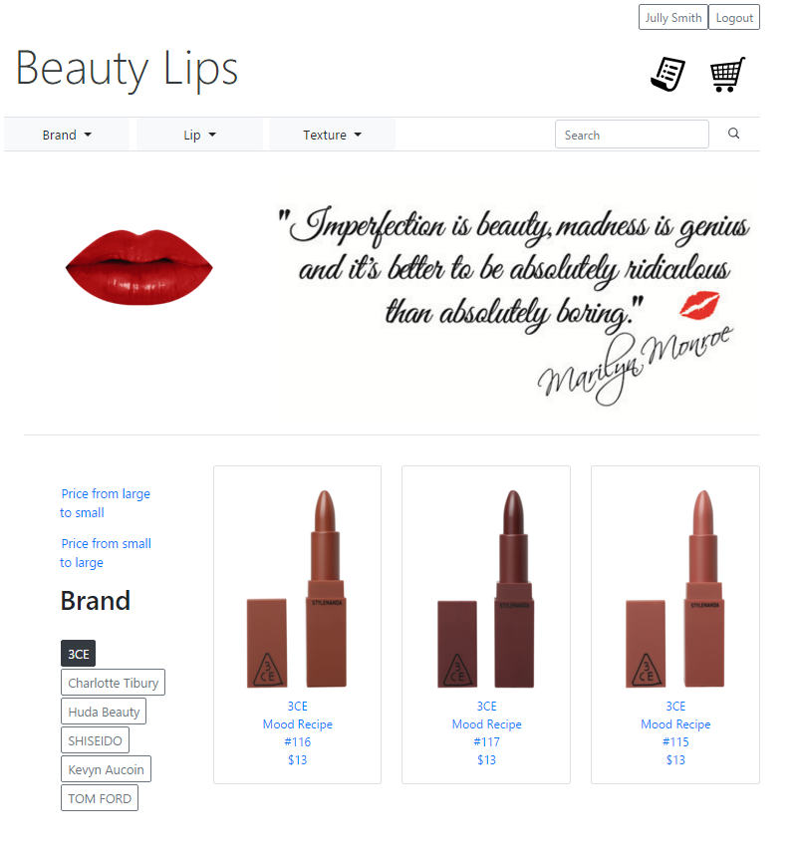

Figure 47: screen shot of sorting by price

### **Product detail page**

Customers may want to select one product for more information, just click the thumbnail to go to the product detail page. The product detail page shows the all information about this product and loads at most 4 pictures about this product. Customers can click “Add to cart” button to add the product to shopping cart. The product detail page will be shown in Figure 48.

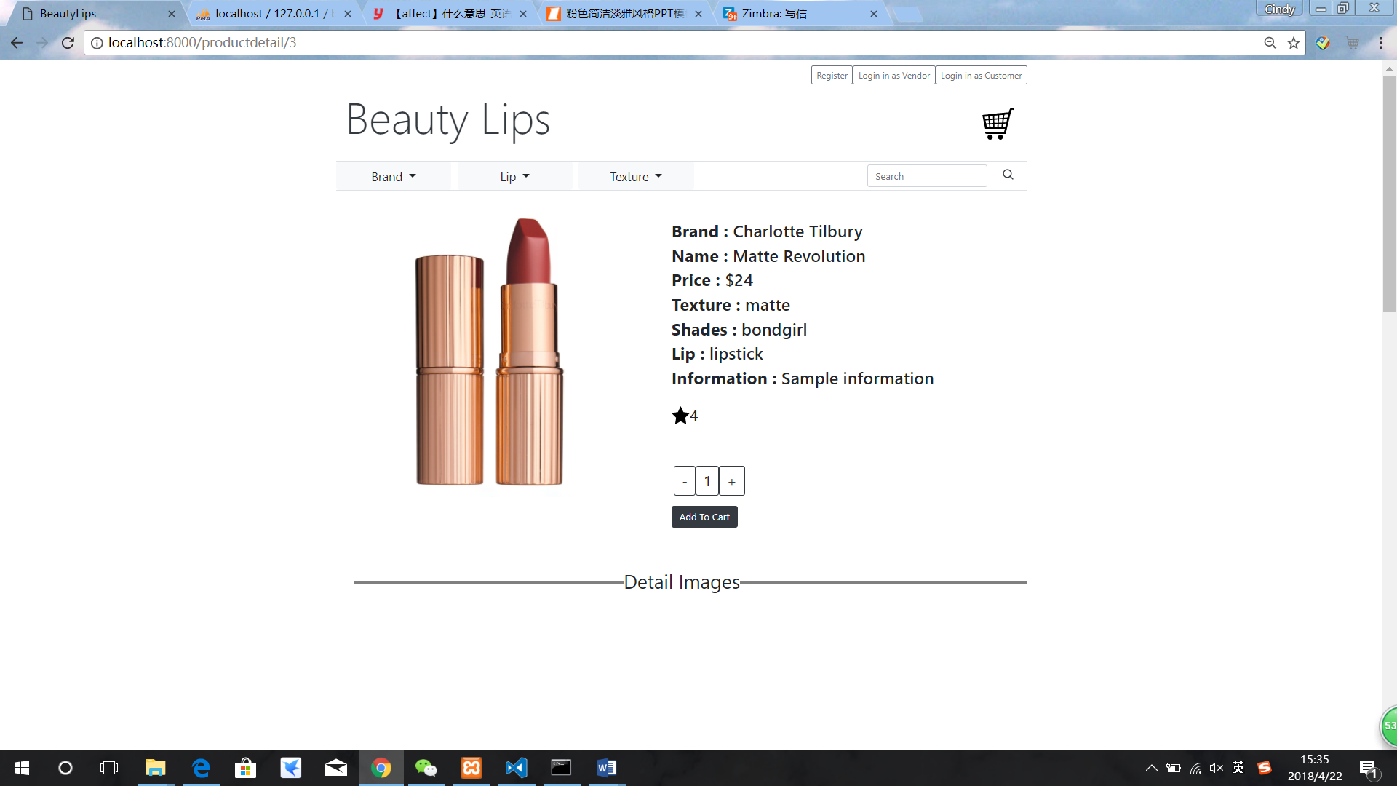

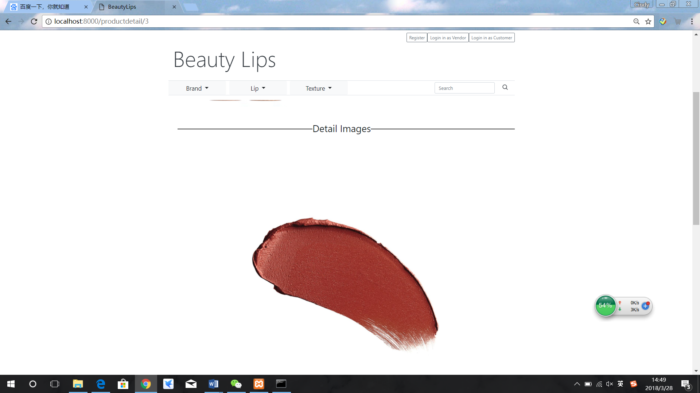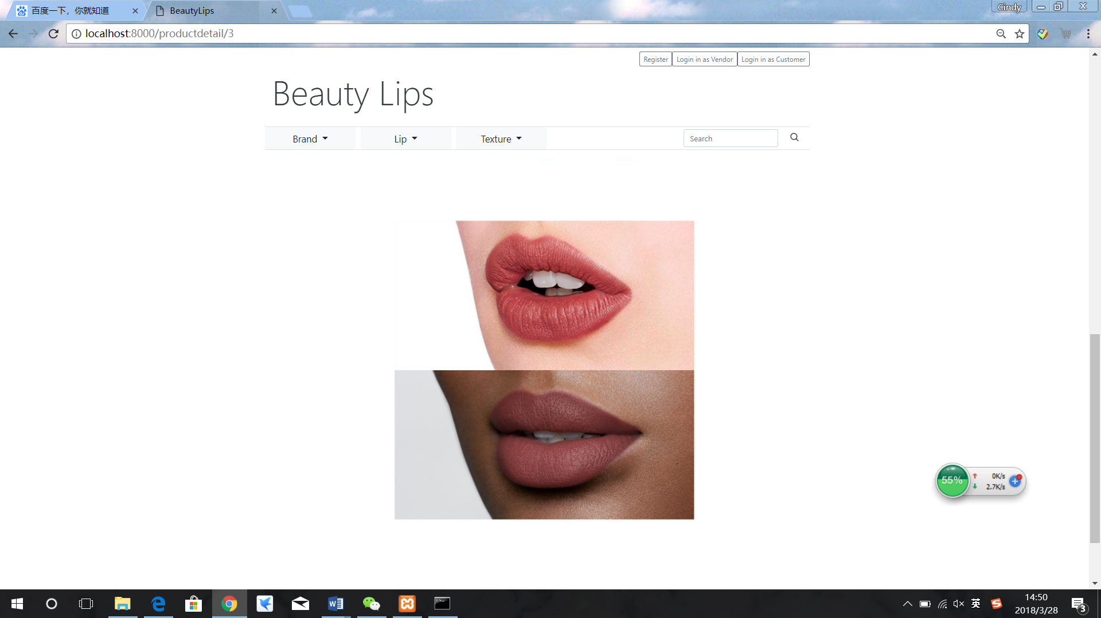

Figure 48: screen shot of product detail page

### **Customer account setting**

For an online shopping website, customers can register an account to purchase. After clicking the Register button in the top right corner, the system would directly send the customer to the Register Page, shown in Figure 49. Register page provides all questions that a website need to know form customers and provide validation.

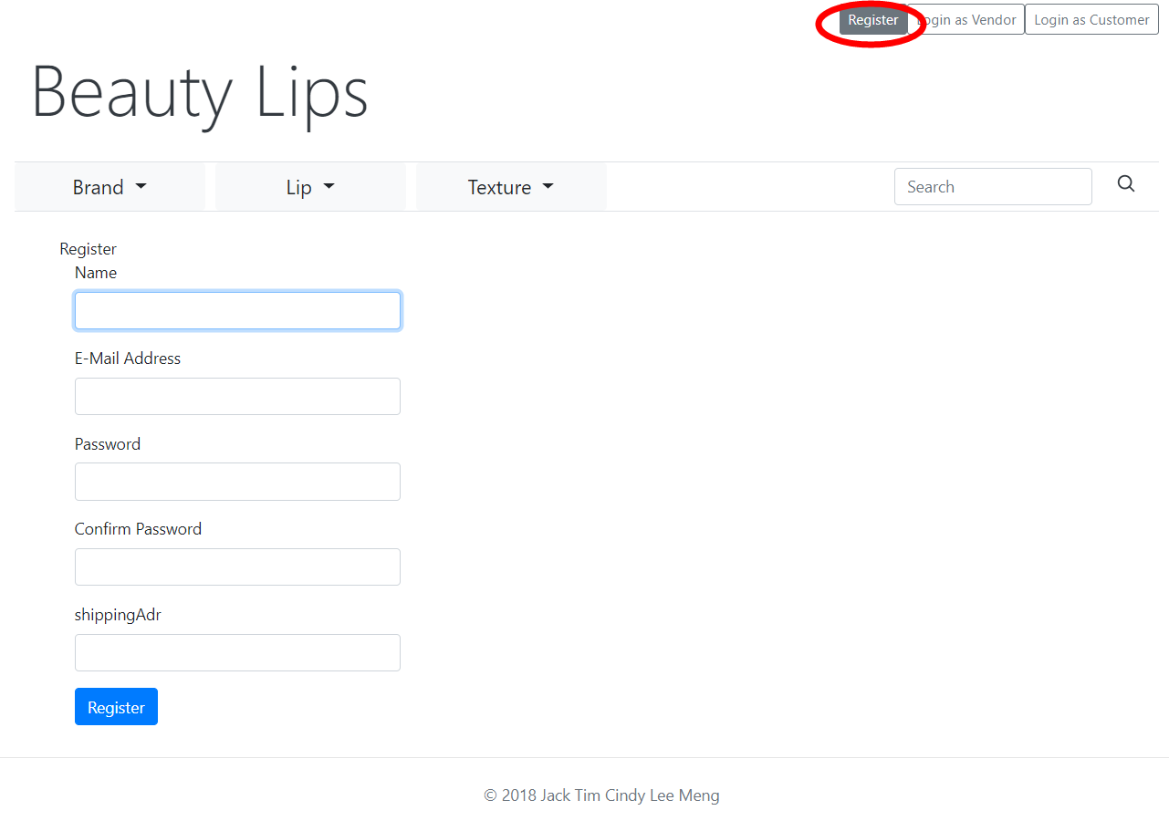

Figure 49: Customer register page

Here customer should type in their name, e-mail address, password, confirm password and shipping address. All the files are required and the Laravel help to do the client-side checking. If the customer leaves one of them empty, the page would show a message (the language of the message is depended on original language in customers OS) to the customer and move the focus to the empty box. Also, the e-mail address format is another client-side checking in Laravel.

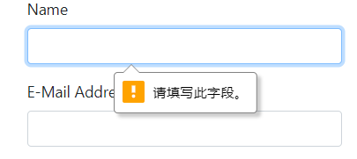

**Figure 50: Client-side empty input error checking in Laravel**

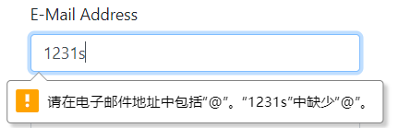

Figure 51: Client-side e-mail address format error checking in Laravel

For security issues, the password should contain at least 6 characters which there must be at least one digit and one capital letters and this check could not rely on client-side checking. All the faults that do not pass the requirement would be shown in the top of the page as the shown in Figure 52, which typed a short password without number and different in confirm password.

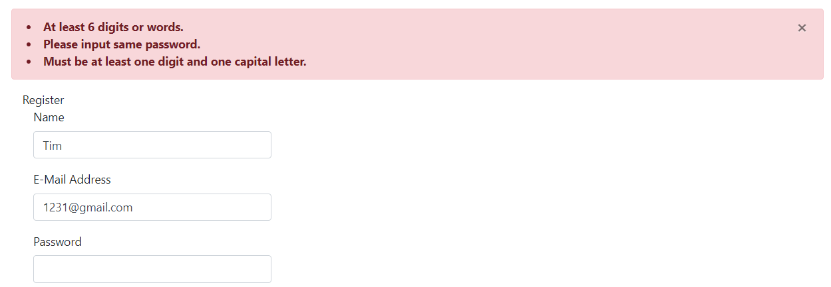

Figure 52: Insecure password case1

And in Figure 53, which typed a six digits password, same in confirming but without a capital letter.

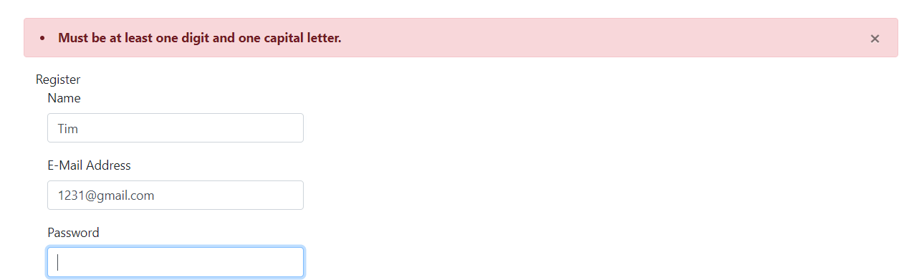

Figure 53: Insecure password case2

After fulfilling all the requirements and filling in all input boxes. The user clicks the register button and the user would be redirected to top page and already logged in.

### **Login and logout**

Both customer and vendor need to be login to use this system and there are two login buttons. One is for the customer and another for the vendor. After clicking the button “login as customer in top page”, the system would redirect the user to the customer login page. Vendor’s login page is looked similar to customer login page and without forgot password link.

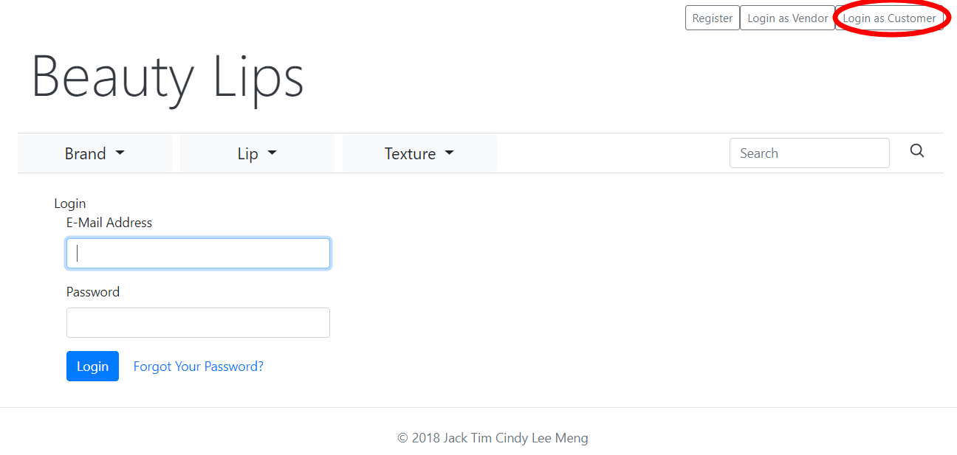

Figure 54: Login page for customer

If the customer enters a nonexistent e-mail address or the wrong password, the system would send back a message, shown in Figure 55.

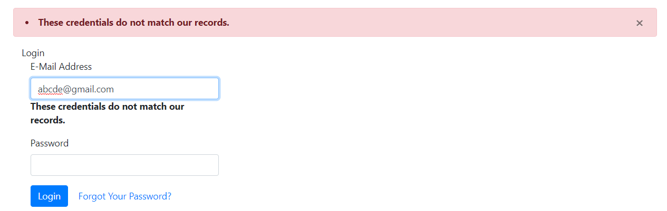

Figure 55: Miss typing of e-mail address or password

After typing the right e-mail address with the right password, the user could log in as a customer and system would redirect to top page.

The customer can whenever click the “logout” button in the top-right corner to log out.

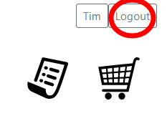

Figure 56: Logout function

### **Change password**

In Beautylips, a quite traditional and secure function to change the password is by the email link. In reset password page, the user needs to type in the e-mail address already exist, shown in Figure 57.

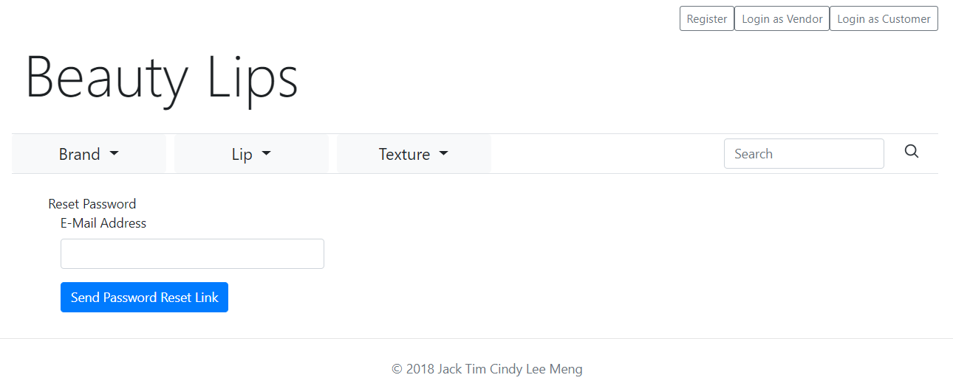

Figure 57: Reset password page

In this part, a demo email address in Mailtrap will be used as the user's e-mail address. Typing the e-mail address and click the “Send Password Reset Link” button, to request a find-back e-mail address from the server. If the e-mail address does not exist in the database, it will send back a message to tell the customer, shown in Figure 58.

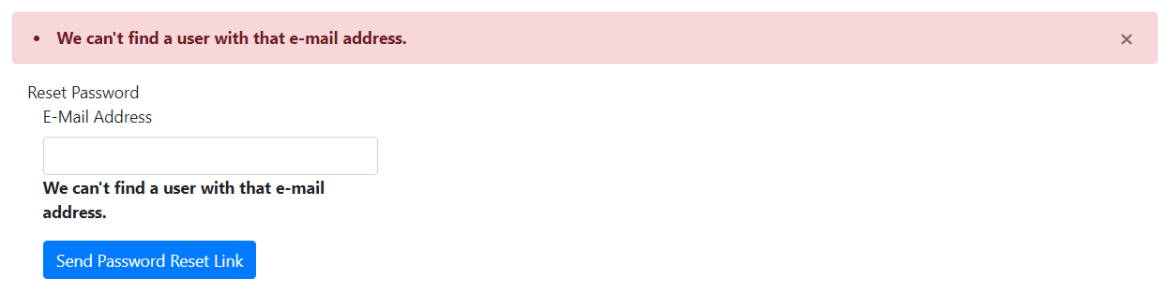

Figure 58: Forget password function with undefined e-mail address

After input the right e-mail address, the server will send an e-mail to the customer’s mailbox and post a message back, shown in Figure 59.

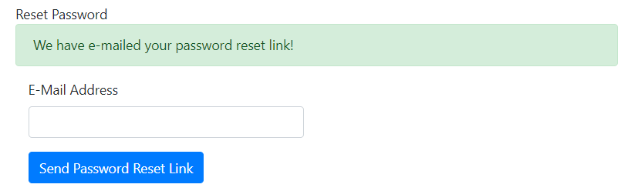

Figure 59: Success send the request to change password

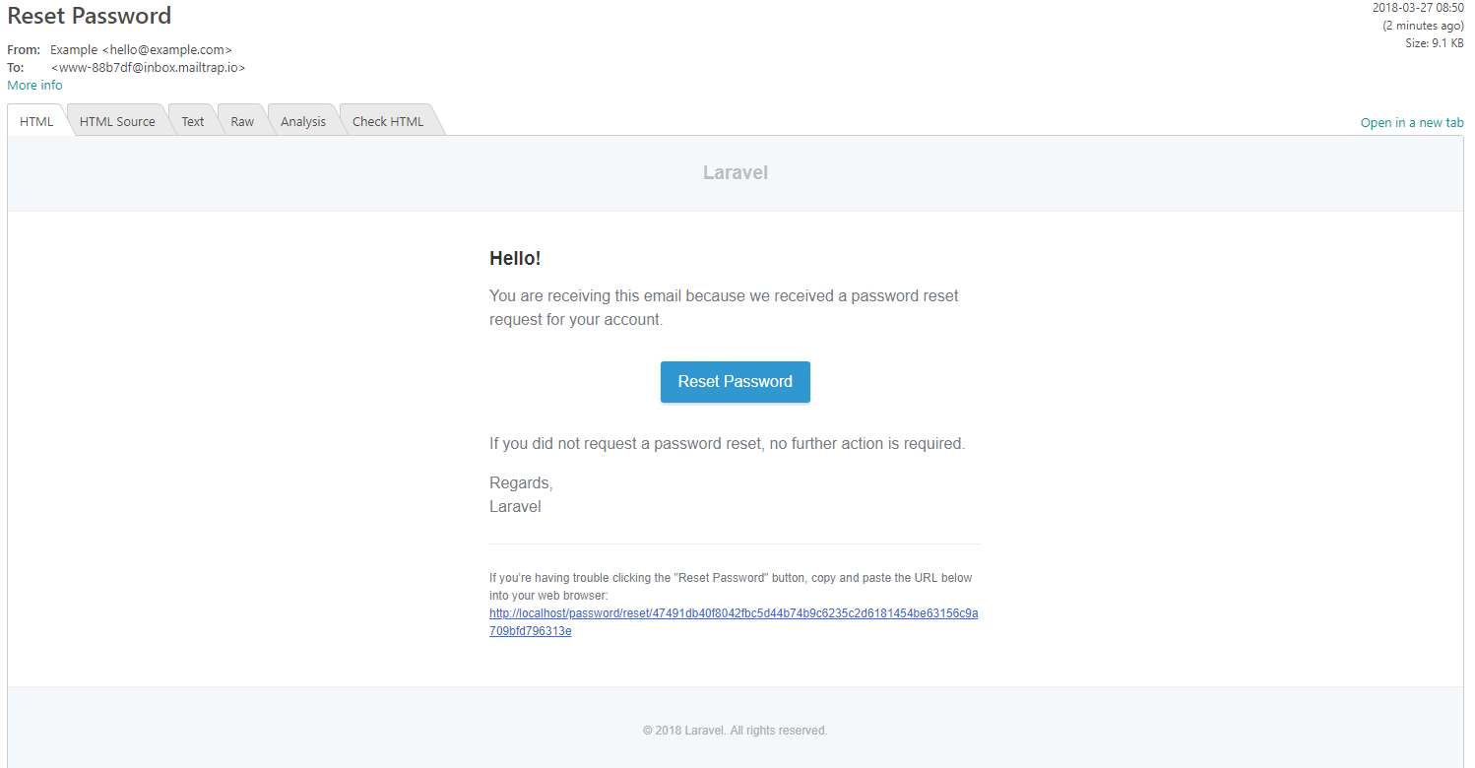

Figure 60: Sample e-mail to change password

The email in customers’ mailbox is shown in Figure 60.

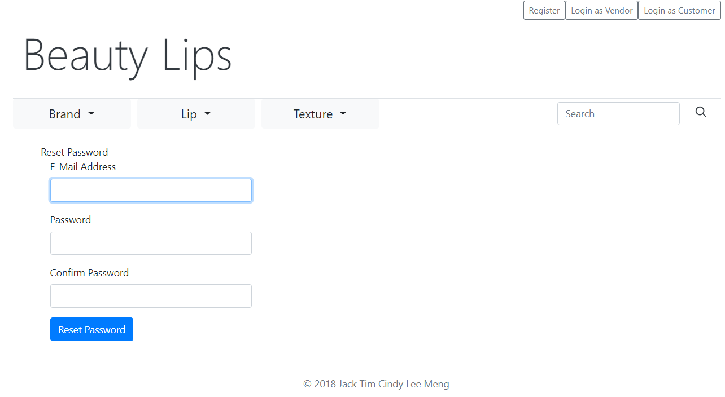

Figure 61: Reset password page in Beautylips

Click the “Reset Password” button; it would redirect the customer to the reset password page, shown in Figure 61.

### **Validators of user registration**

In reset password page, customers need to fill in their e-mail address, new password and confirm the new password to change the old one. The password security request is as same as it in Register part, shown in Figure 62.

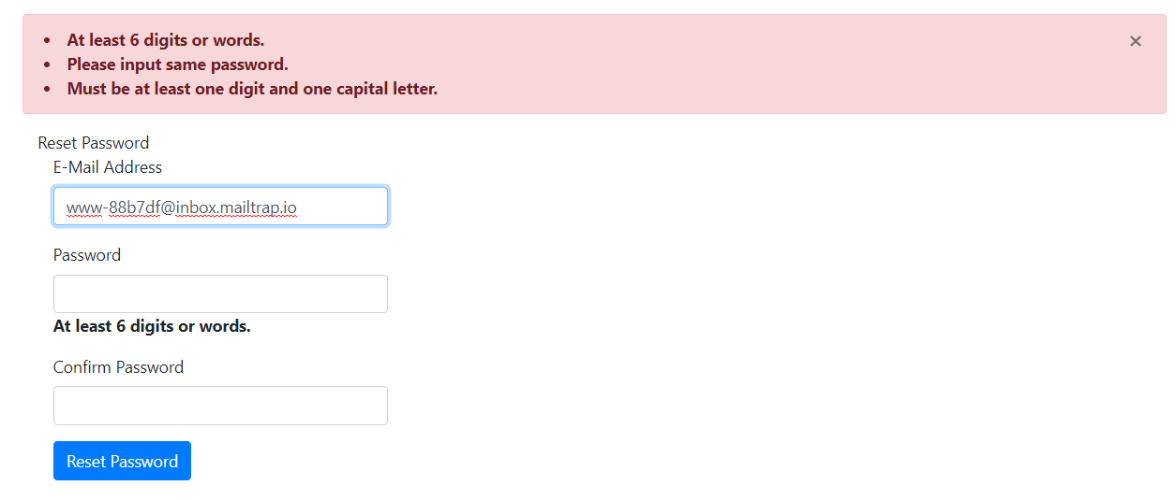

Figure 62: Insecure password changing in reset password page

After the change to the password which suitable the request, the customer would be redirected to top page with already logged in.

### **Automatic Redirection related to shopping cart**

Customers in Beautylips could view the product without login as a customer or a vendor in product list page and product detail page. But an account is required when customer want to add products to their shopping cart. If customer click whether ‘shopping cart’ button or ‘add to cart’ button in product detail page, the system would redirect the user to the customer login page.

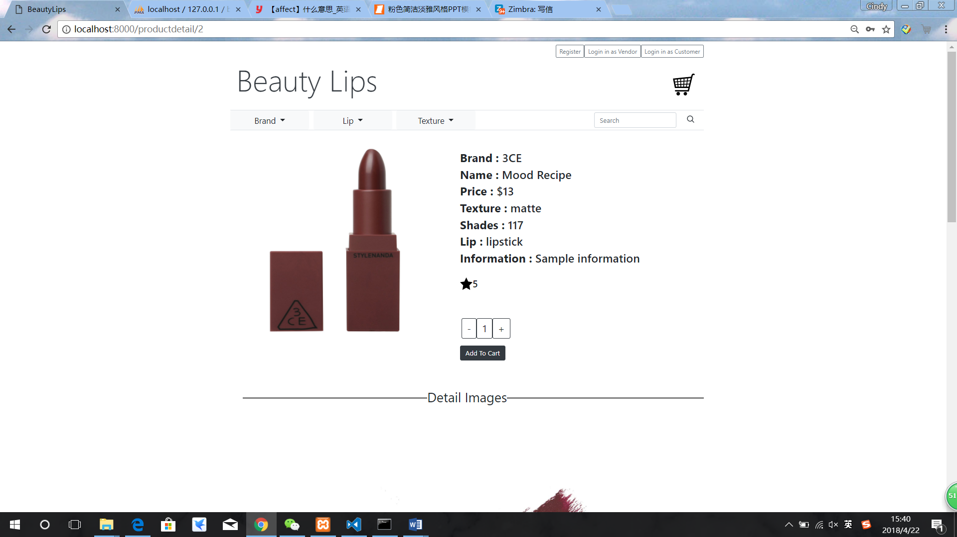

Figure 63: Redirection required button in product detail page

After logging in, the customer would back to the product detail page.

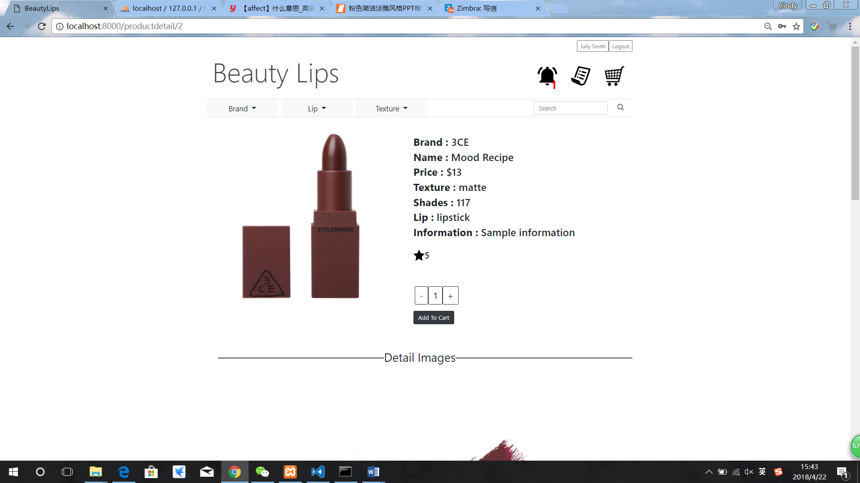

Figure 64: Redirection after login

### **Shopping cart**

Shopping cart function is a significant function for customers to buy any products. After customers have logged in, they could click the shopping cart button to view their shopping cart. Figure 65 shows the empty shopping cart format.

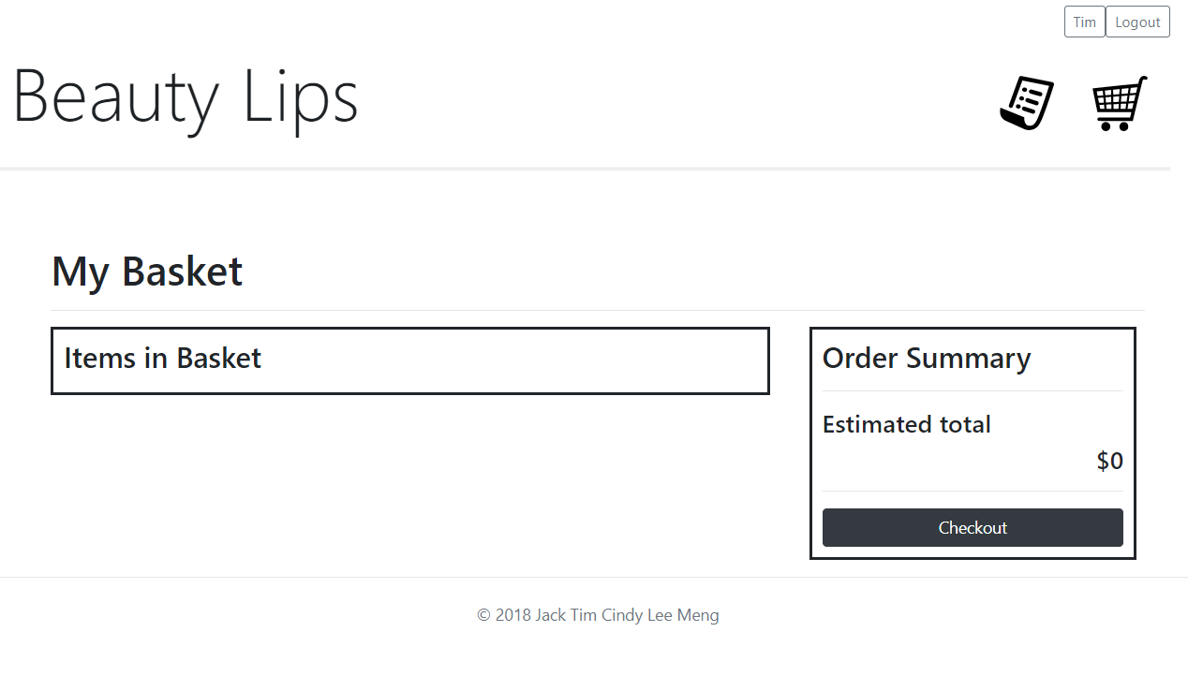

Figure 65: Empty shopping cart

The customer could change the quantity they want in product detail page and click “add to cart” to add the product to the shopping cart. Then it would be shown a success message for the customer if the product as Figure 66; if customers try to put a duplicated product into the shopping cart, an error message would be sent shown in Figure 67.

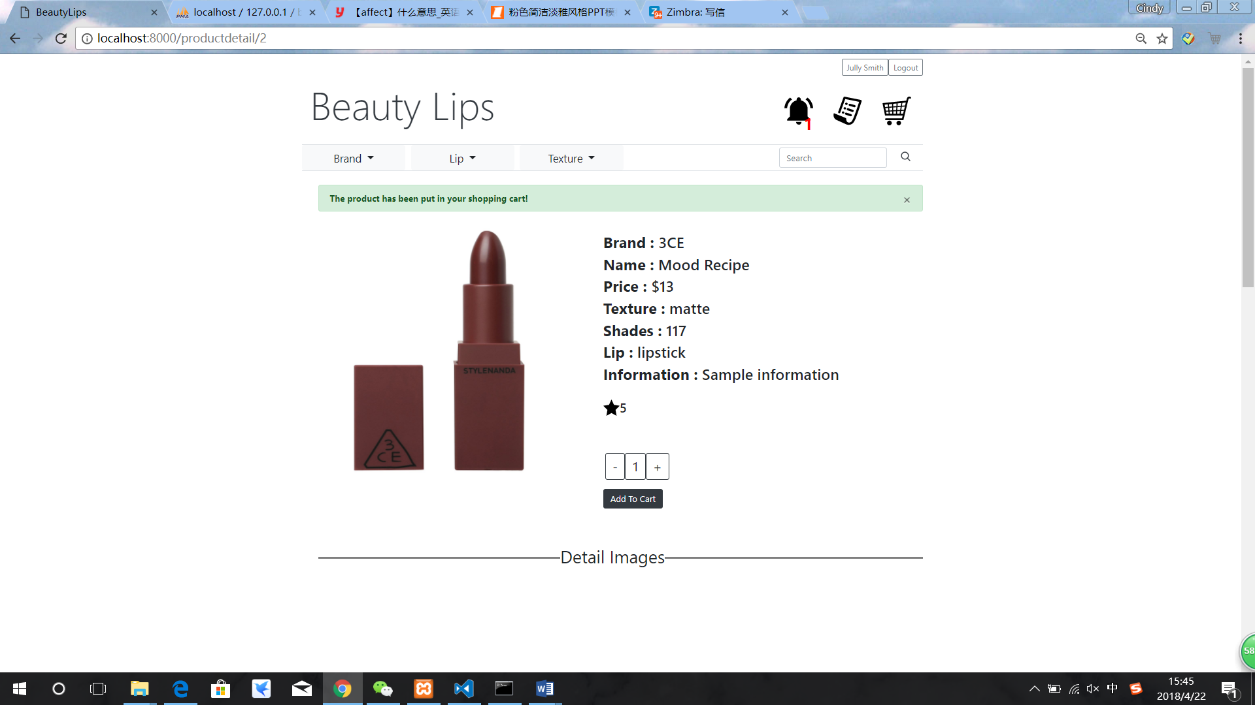

Figure 66: Add product to shopping cart

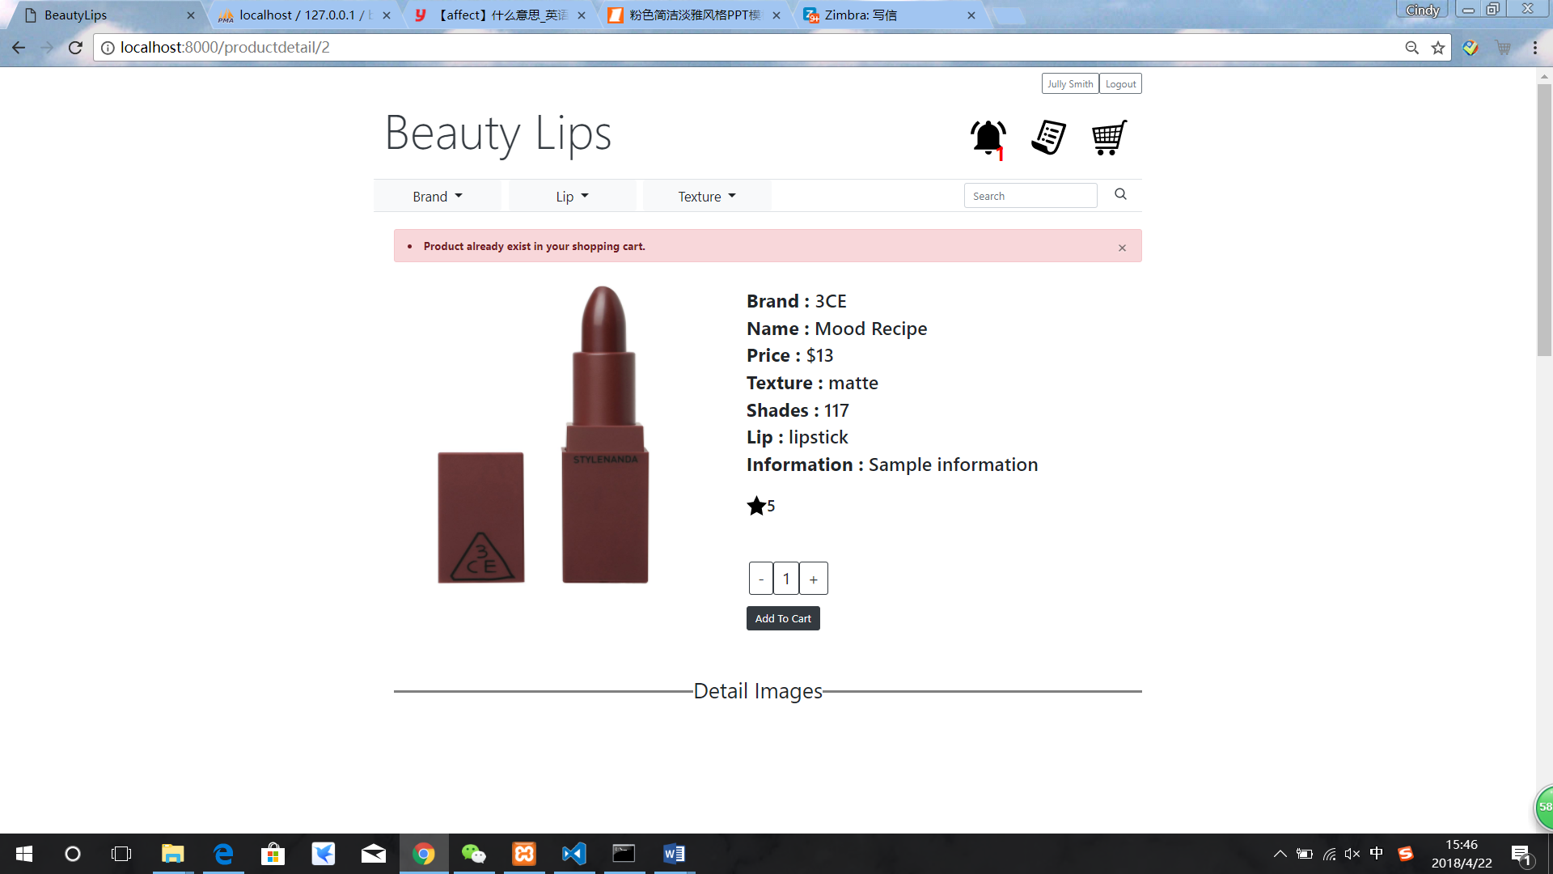

Figure 67: Add duplicate product into shopping cart

In shopping cart page, the customer could check the product, change the quantity, delete the product and check out for the entire product as one purchase order.

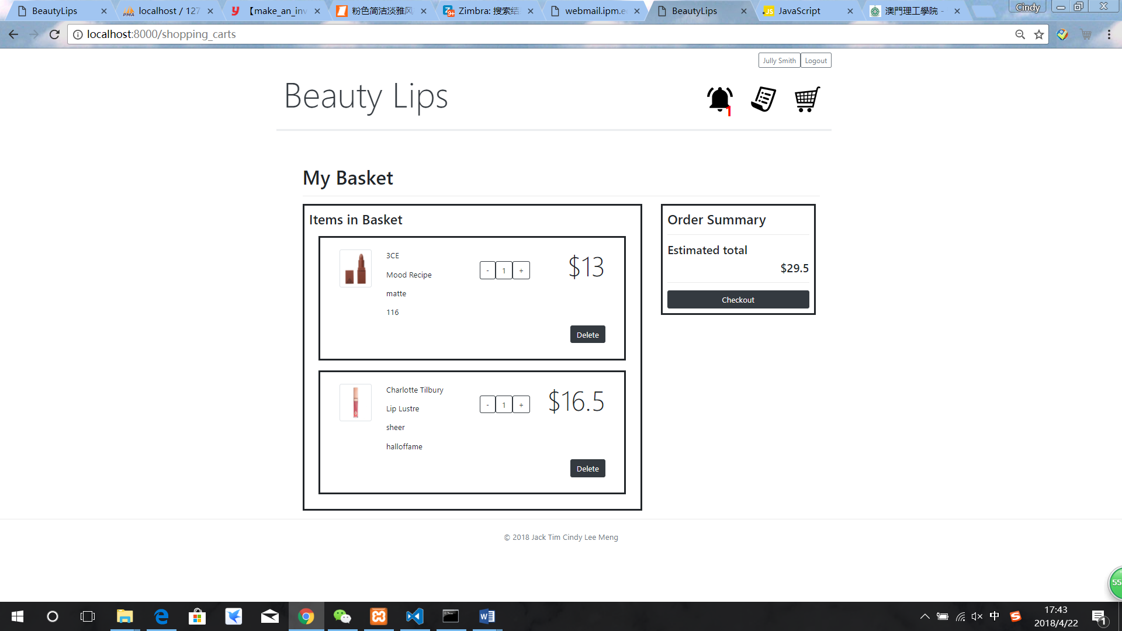

Figure 68: Shopping cart with products

After customer check the product and the Estimated total. Click the “Checkout button and one confirm window would show to the customer, which is the final check before making an order.

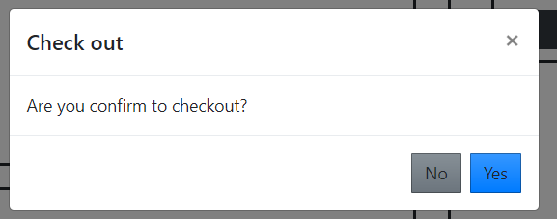

Figure 69: Confirm window

After check out, the customer would be automatically redirected to certain purchase order detail page, shown in Figure 70.

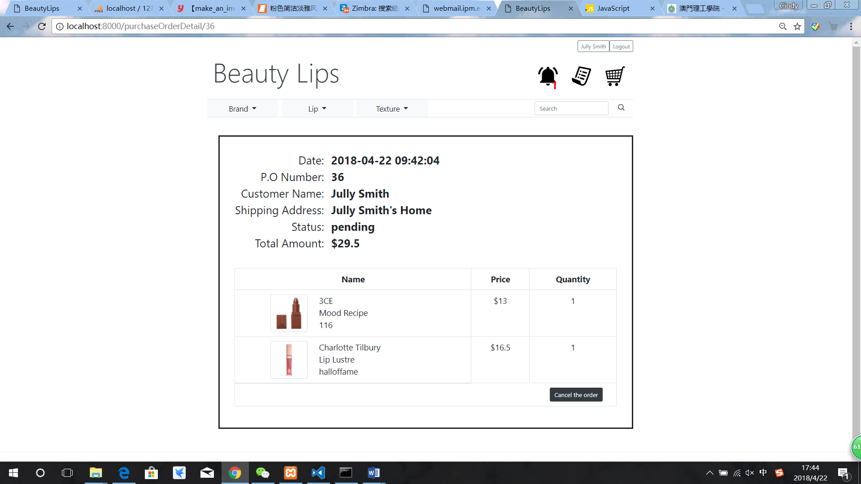

Figure 70: Purchase order detail page after check out

### **Purchase order checking page**

After customer login in, they will see their name at the upper left corner. Also, they can log out by clicking the logout button. The purchase order list icon will be displayed near the shopping cart icon. The customer can click purchase order list icon to purchase order list page.

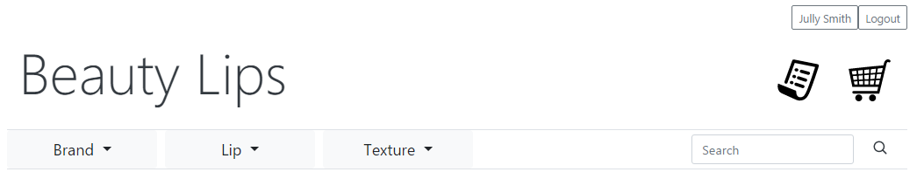

Figure 71: purchase order icon

Customer’s purchase orders will be listed when customer jumps to the purchase order list page. It includes the Date, POnumber which is the purchase order number of one purchase order, the total amount of each purchase order, product’s name, brand, shade, price, quantity, and status of each purchase order.

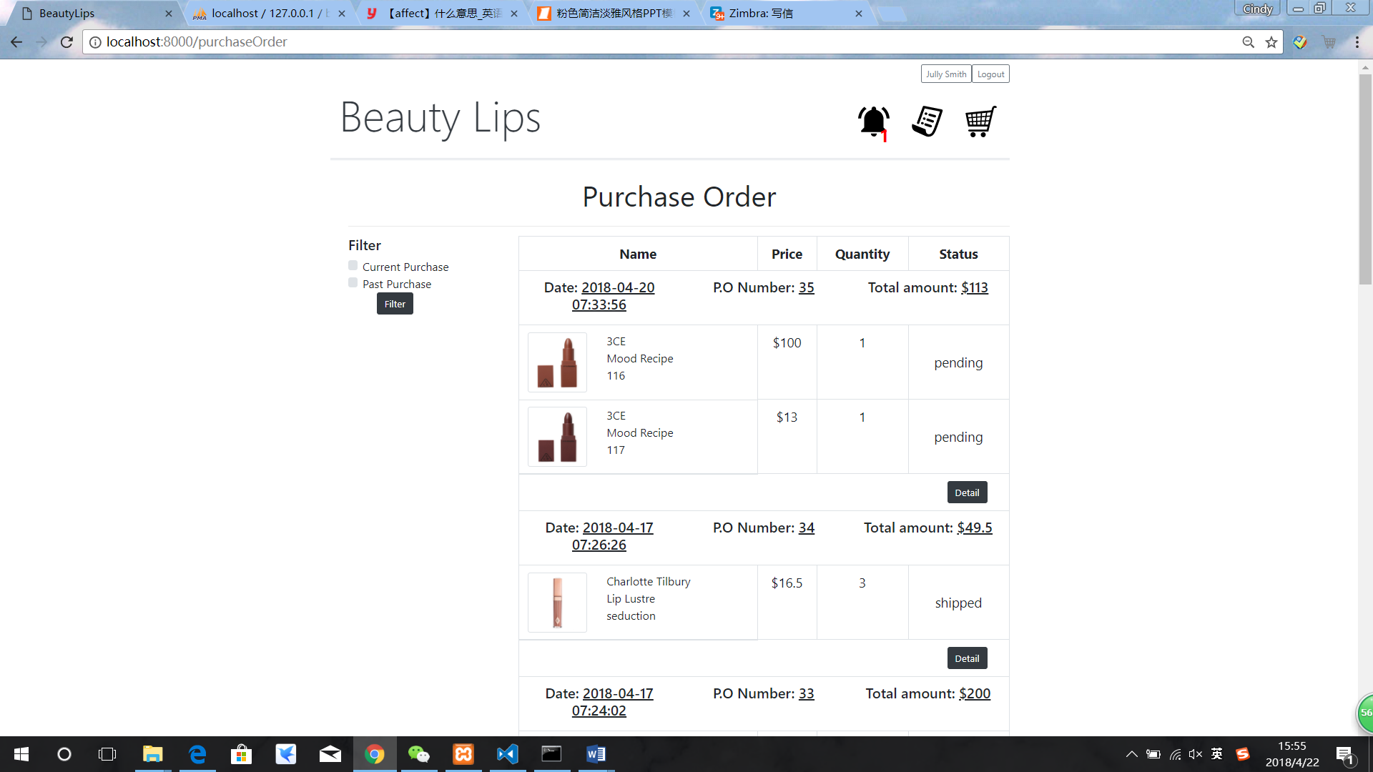

Figure 72: purchase order listing page

The customer can click the detail button to go the purchase order detail page.

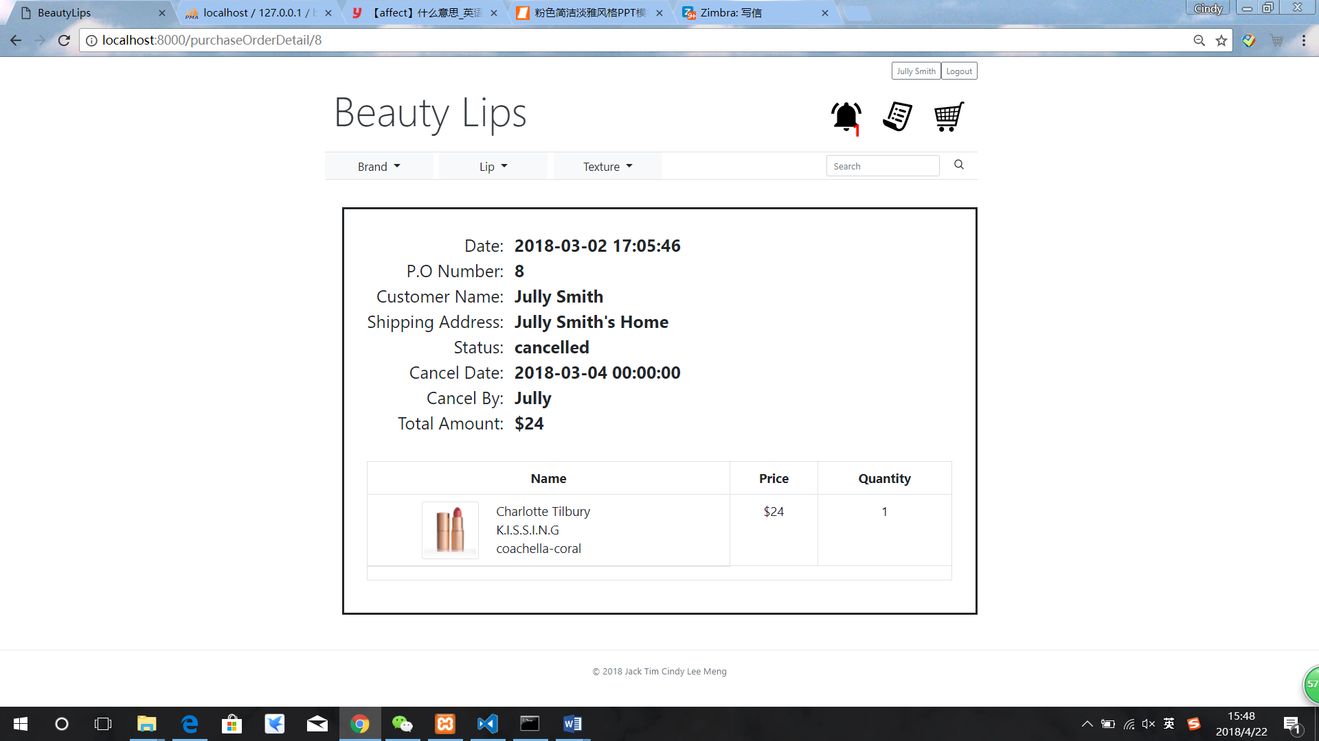

Figure 73: purchase order detail page

### **Filter purchase**

Customers can also filter these purchase orders by clicking the checkbox ‘Current Purchase’ which includes the statues ‘pending’ and ‘hold’ of purchase orders.

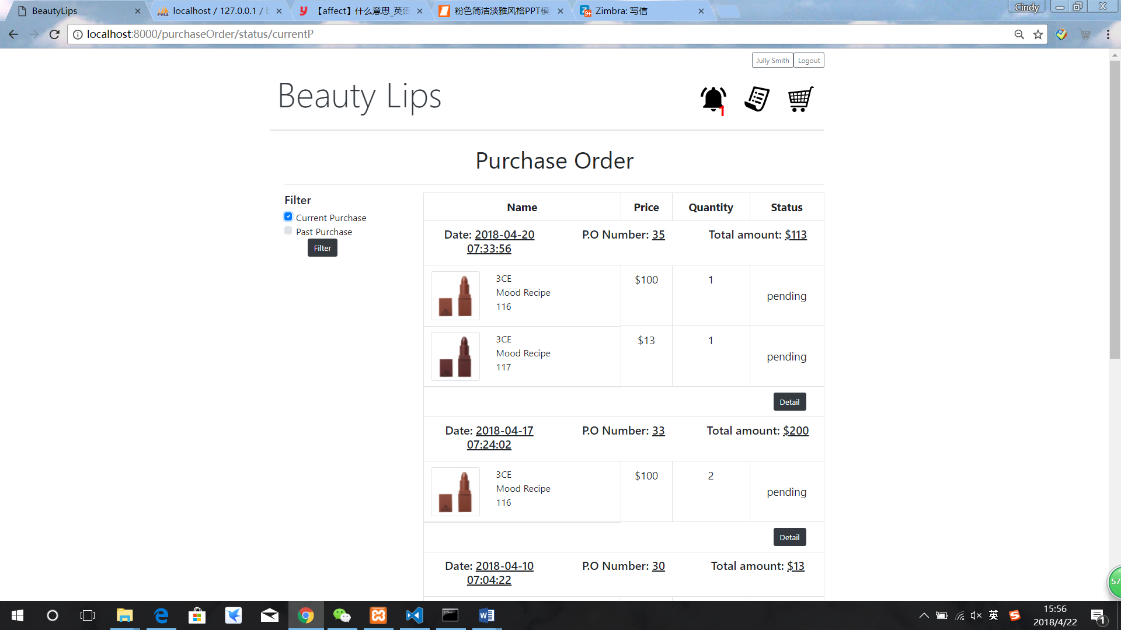

Figure 74: filter current purchase

The ‘Past purchase’ which includes the status ‘shipped’ and ‘cancelled’ of purchase orders. The ‘Detail’ button can lead the customers to the detail page of each purchase order.

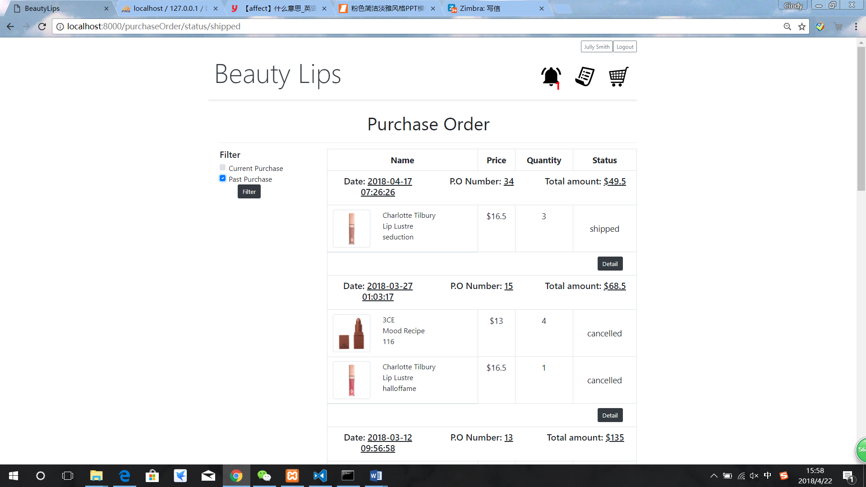

Figure 75: filter past purchase

### **Purchase order detail page**

The customer can click the detail button to go the purchase order detail page. If this order is cancelled, the cancel date and cancel by someone will be displayed in the purchase order with cancelled status.



Figure 76: purchase order detail page with status cancelled

Also, in purchase order detail page, if this order is shipped, the shipment date will be displayed in the purchase order with shipped status.

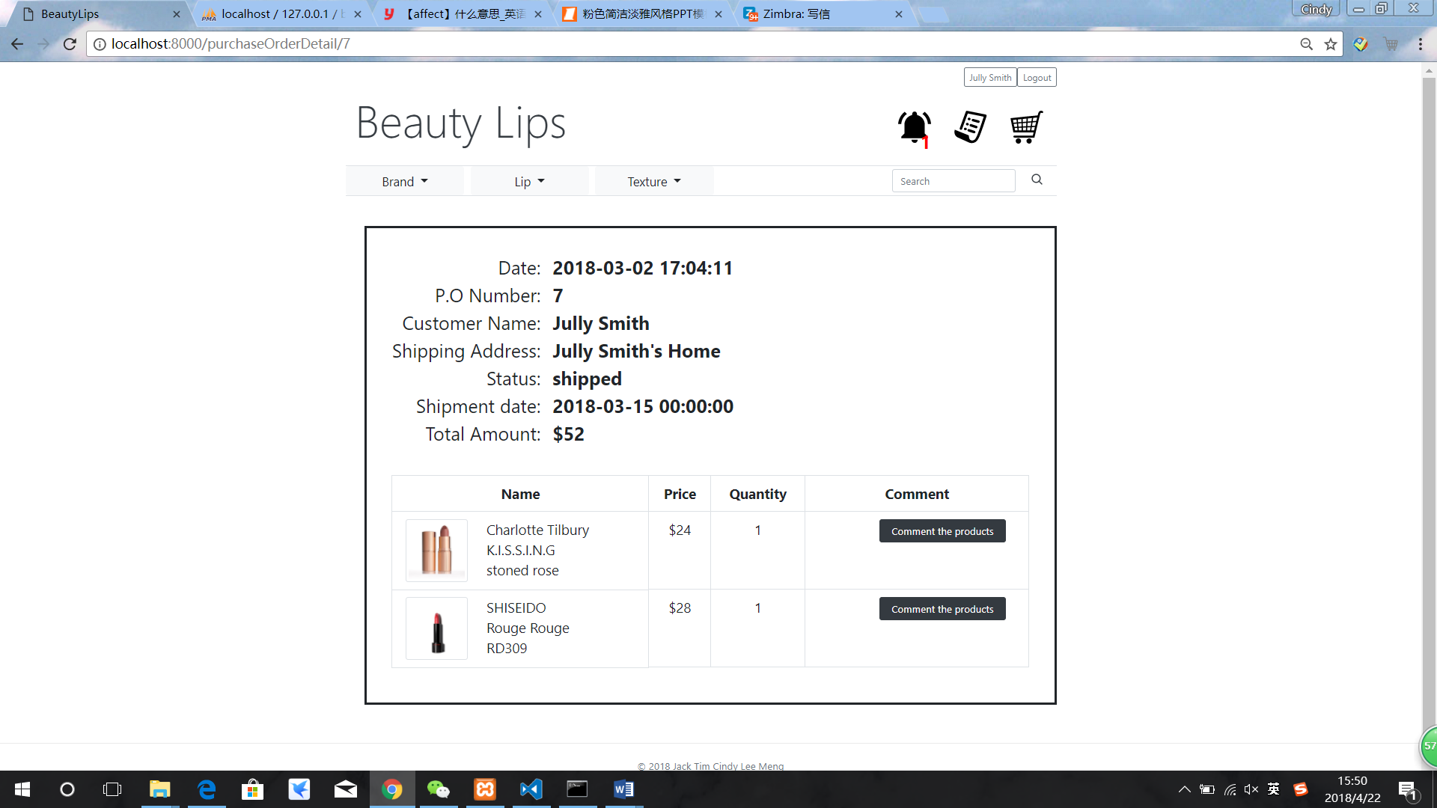

Figure77: purchase order detail page with status shipped

### **Customer cancels order**

This figure 78 shows the detail information of one purchase order, which is in purchase order detail page. In general, the Date, PONumber, customer name, shipping address, status, total amount and the basic information of the purchased products will be displayed. The customer can cancel the order only if the status is ‘pending’ or ‘hold’.

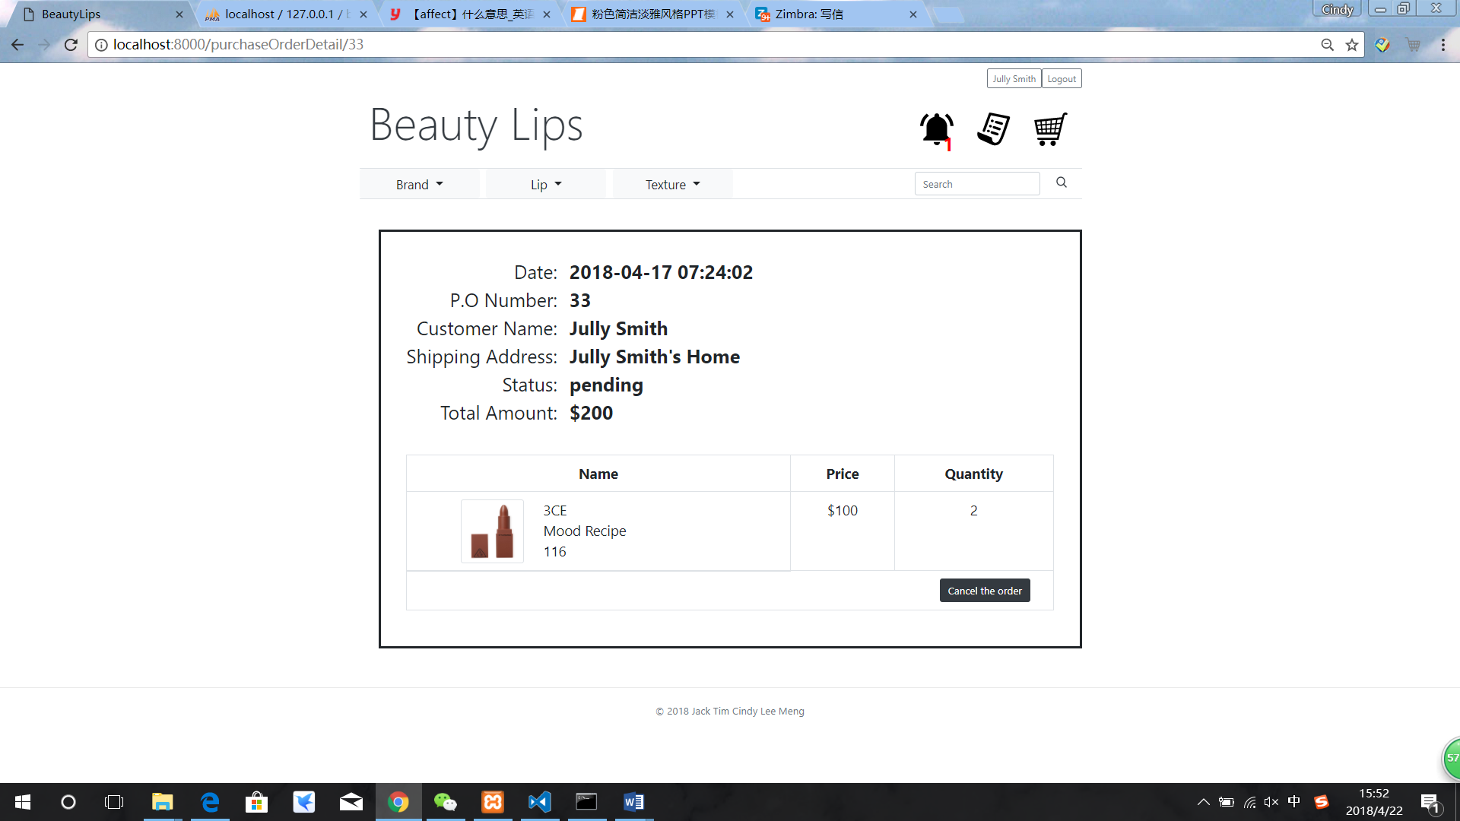

Figure 78: cancel the order

### **Vendor browsers and searches product**

When the vendor login in, the page will jump to the vendor centre. All products will be listed on this page just like customer side. Also, the vendor can search product both by product name and product id. Also, the vendor can click edit to edit each product.

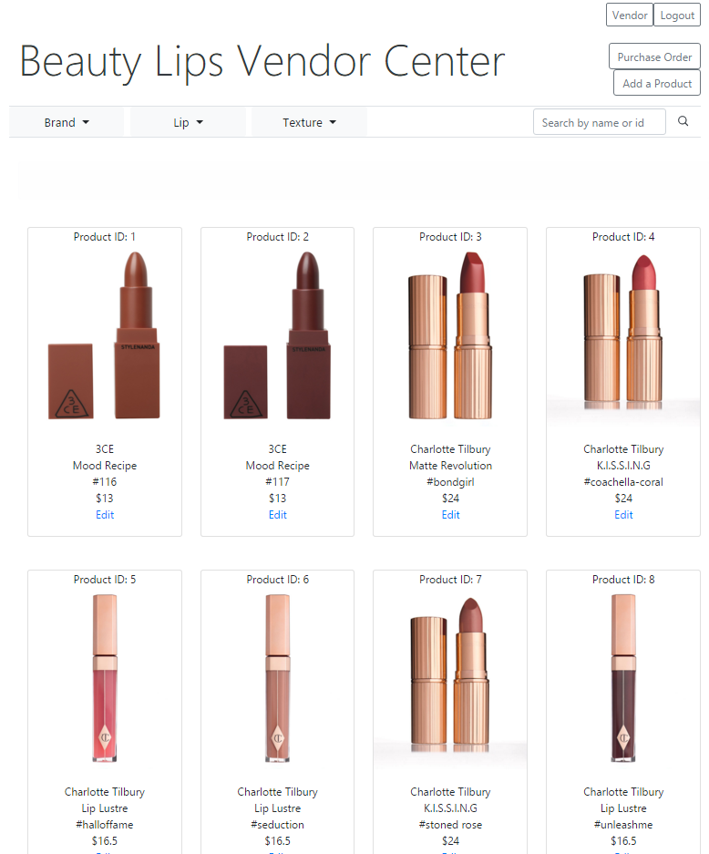

Figure 79: vendor side website

### **Adding and editing new product**

The vendor can add a new product to the upper right corner. When vendor clicks the ‘add new product’ button, it will take the vendor to this page. The vendor needs to fill in the information that a product need and upload the thumbnail image and the detail images. There can be 1 to 4 detail images with one product. 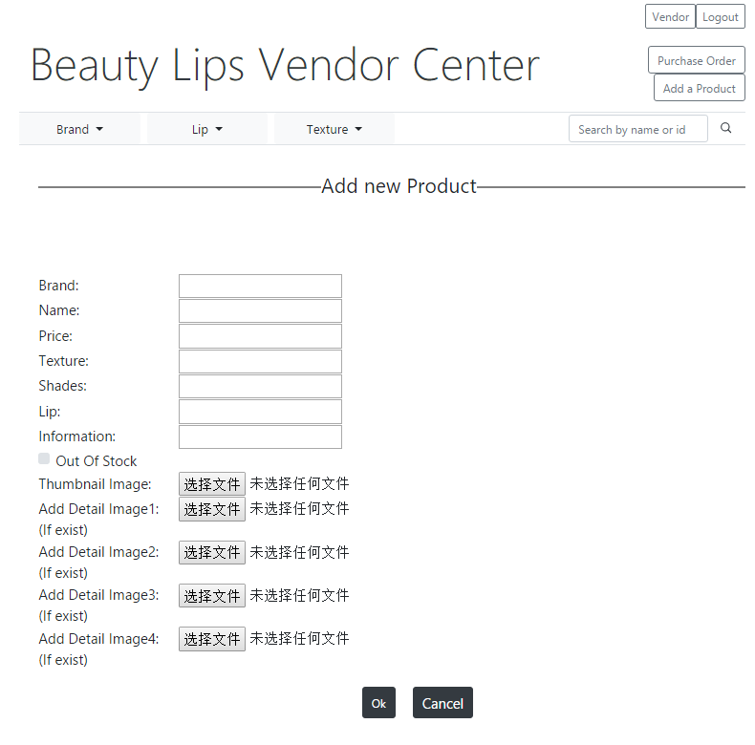

Figure 80: adding new product

After adding a new product, the website will jump to the edit page. it will display the images and information to the vendor. The vendor can check whether it is correct, he/she can also the choice to change each of them. The vendor can delete the images which they do not want at the bottom of each edit page.

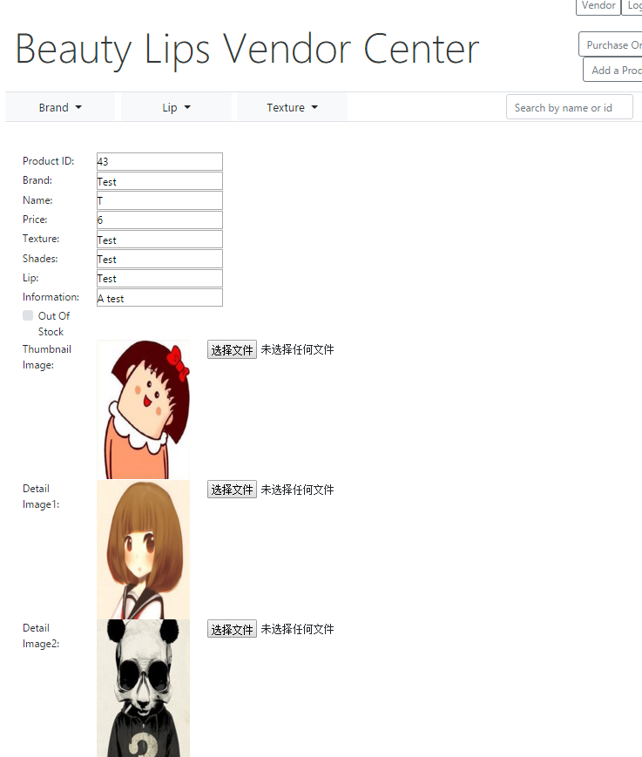

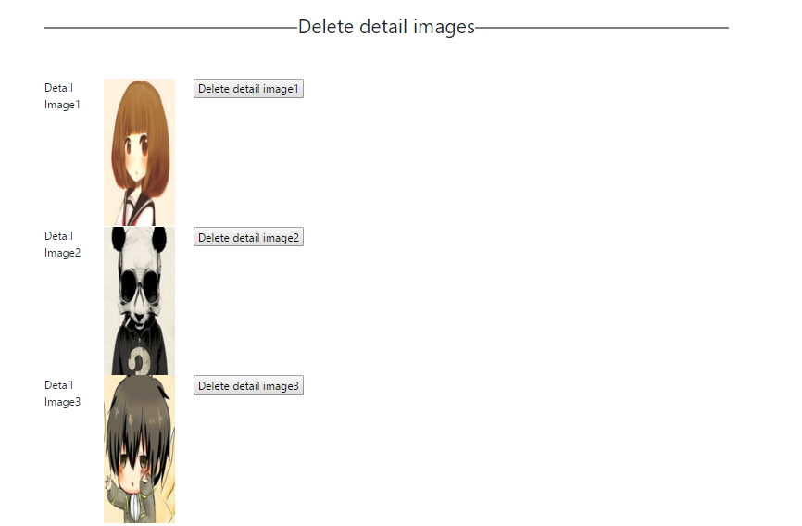

Figure 81: product editing page

### **Purchase order list page**

The vendor can press the Purchase Order button to go to the purchase order list page, it will show in figure 82. The purchase orders of all customers will be listed and some simple information will also be displayed on this page.

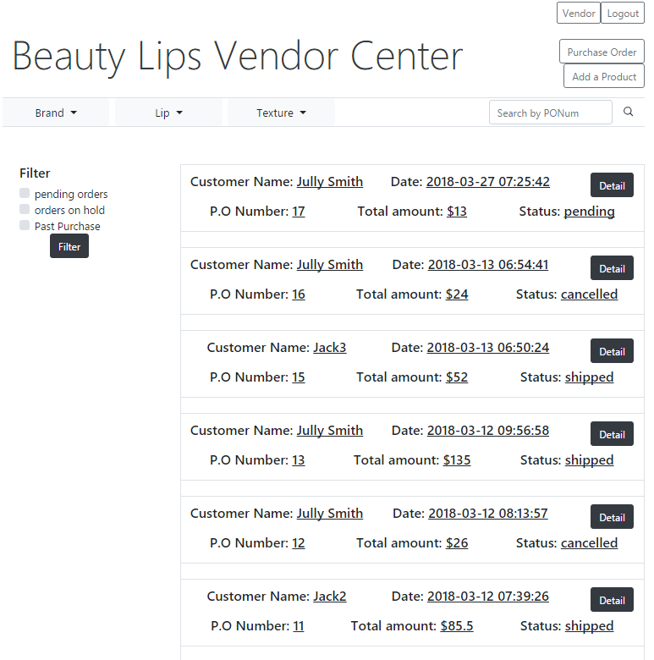

Figure 82: purchase order list page

Vendor can search the purchase orders by their P.O number.

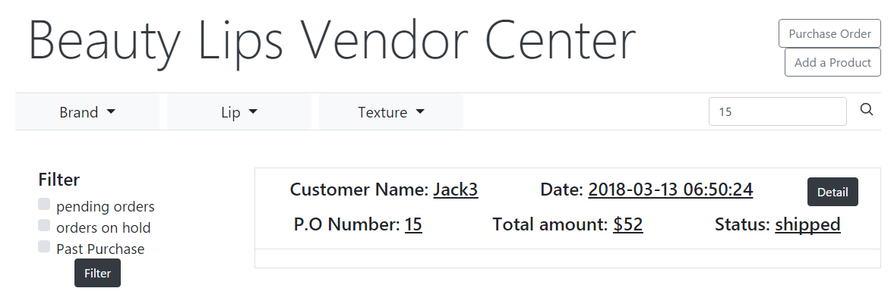

Figure 83: searching by PONum

But lists all orders are not convenient for the vendor to find some specific orders, to solve this problem, the website provides filter function on the left-hand side, three checkboxes. The vendor can click “pending orders” to check all orders with status “pending”, click “orders on hold” to check all orders with status “hold” and click “Past Purchase” to check all orders with status “shipped” or “cancelled”.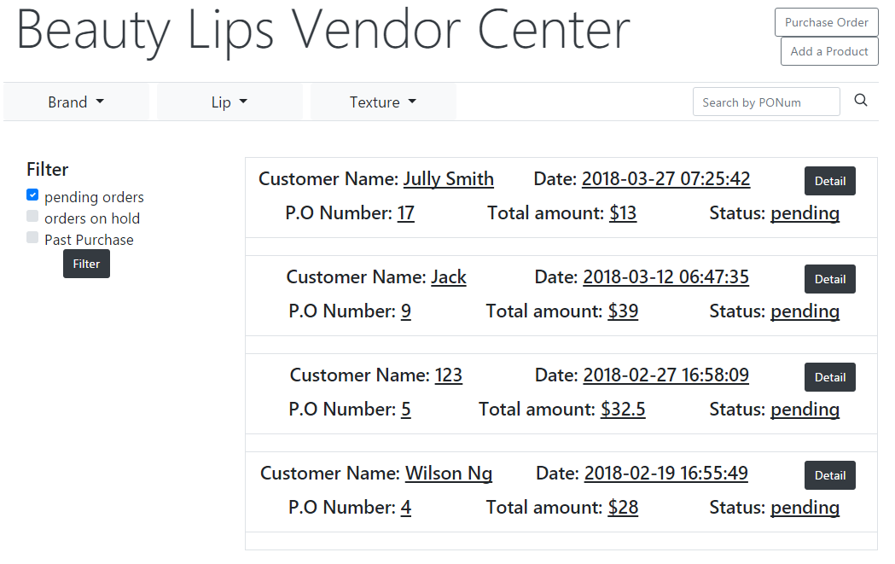

Figure 84: orders with pending status

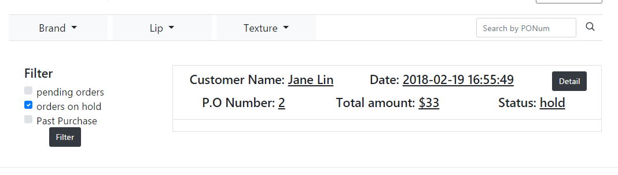

Figure 85: orders with hold status

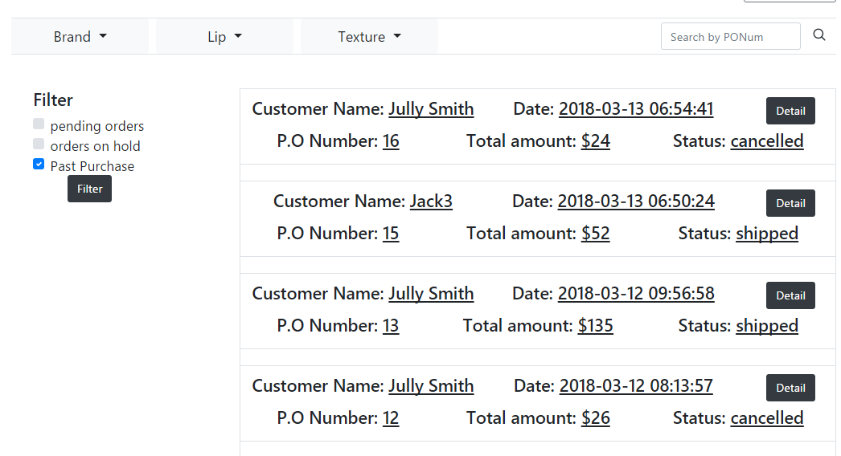

Figure 86: orders with shipped or cancelled status

### **Purchase processing page**

Vendor presses “Detail” button to go to that order’s processing page. Then he/she will see the following detail about a purchase order. The vendor can ship the order, hold the order or cancel the order by clicking the buttons at the bottom of a detail page. The attention, which only the purchase orders with pending status, will display these three buttons. The purchase orders with hold status will only display shipping and cancel button. As the orders with ‘shipped’ or ‘cancelled’ status, the order will display no button.

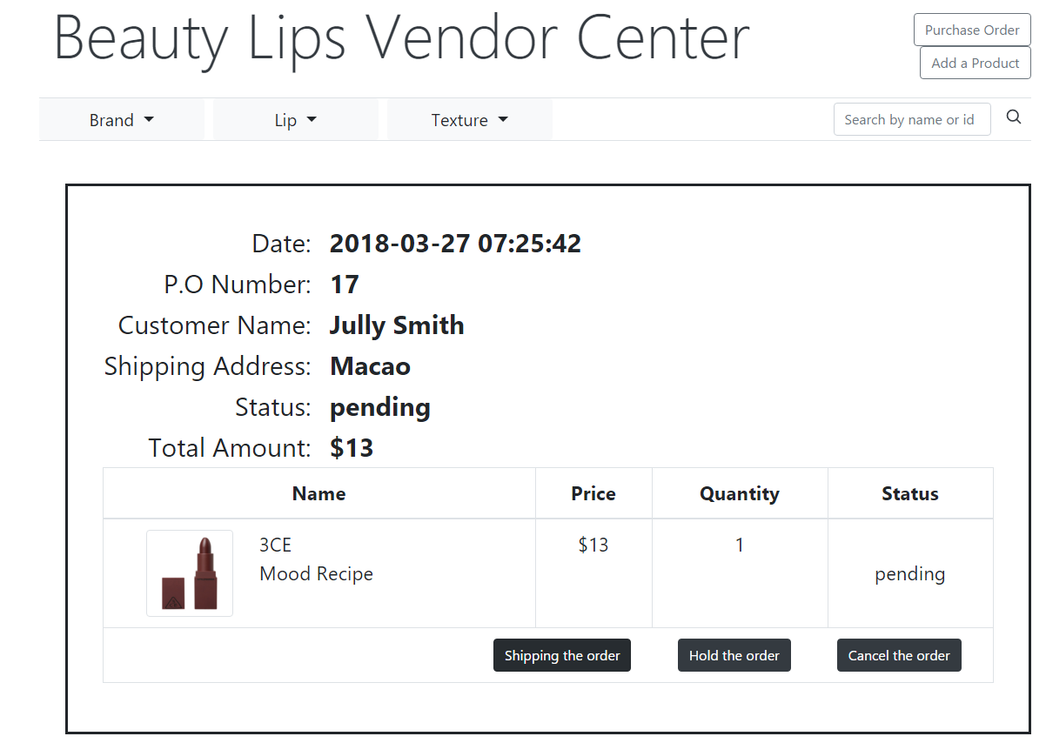

Figure 87: purchase order processing page

### **Customer notification**

Vendor will receive purchase orders after customer checked out, ship or hold or cancel the purchase order according to particular situations. There is a bell icon on the right-top corner on customer page, this icon will show how many notifications if vendor changes the status of customer’s purchase order. As the figure 88 shows, there are two notifications for this customer.

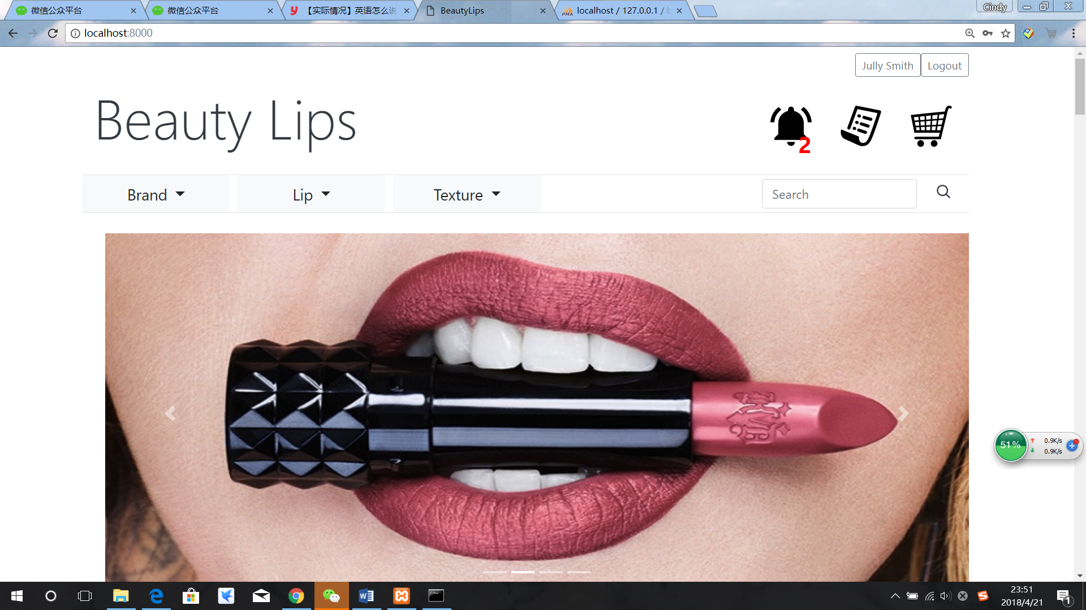

Figure 88: bell notification

Customer can press this bell icon to notification page, there are three types of notifications, “All”, “Unread” and “Read”. Customer can check all notification whatever is unread or read under “All’ and unread or read notification will be stored under “Unread” and “Read” separately.

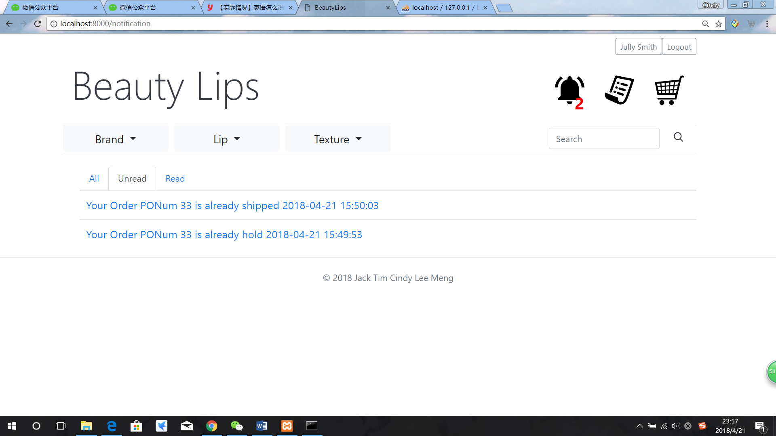

Figure 89: notification page

The unread notification is colour blue, after customer click the notification, the status of this notification will turn from unread to read, and the colour will turn from blue to grey, the number of notification on the bell icon will be gone at the same time.

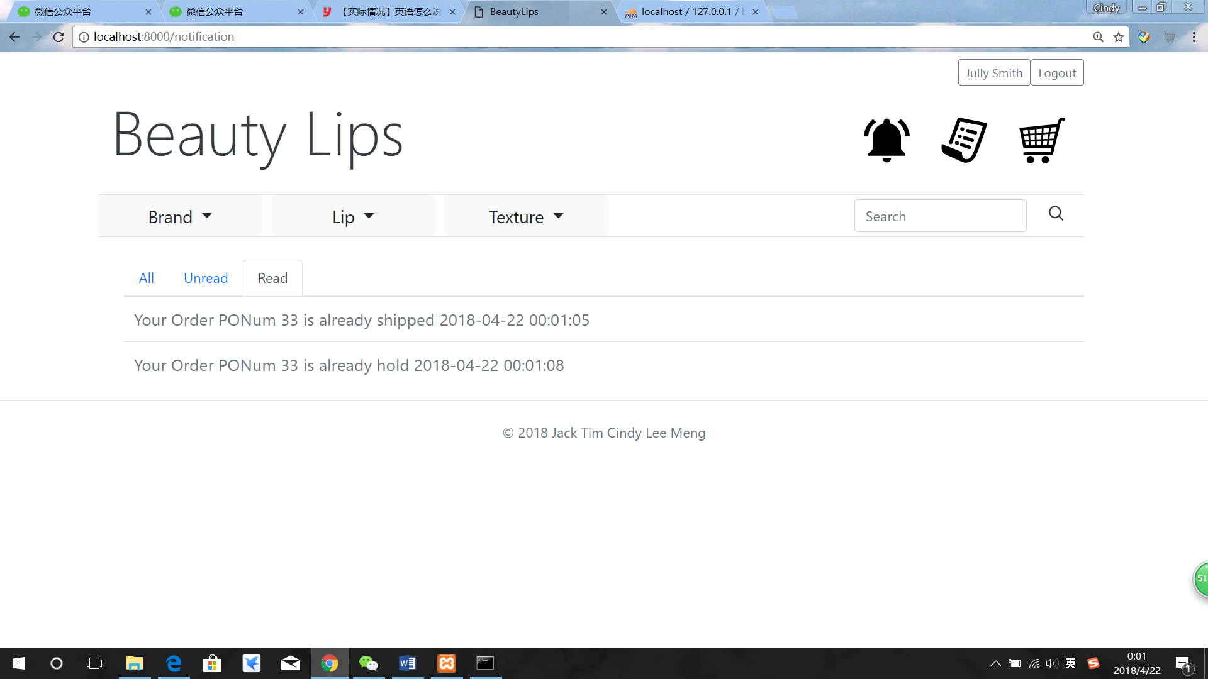

Figure 90: customer clicks the notification

### 5.1.22 **Product rate and review**

For the purchase order rate and review, firstly, the average of customers’ rating would be shown in product detail page as Figure 91. Also, the reviews of customers’ would be shown at the bottom of product detail page as Figure 92.

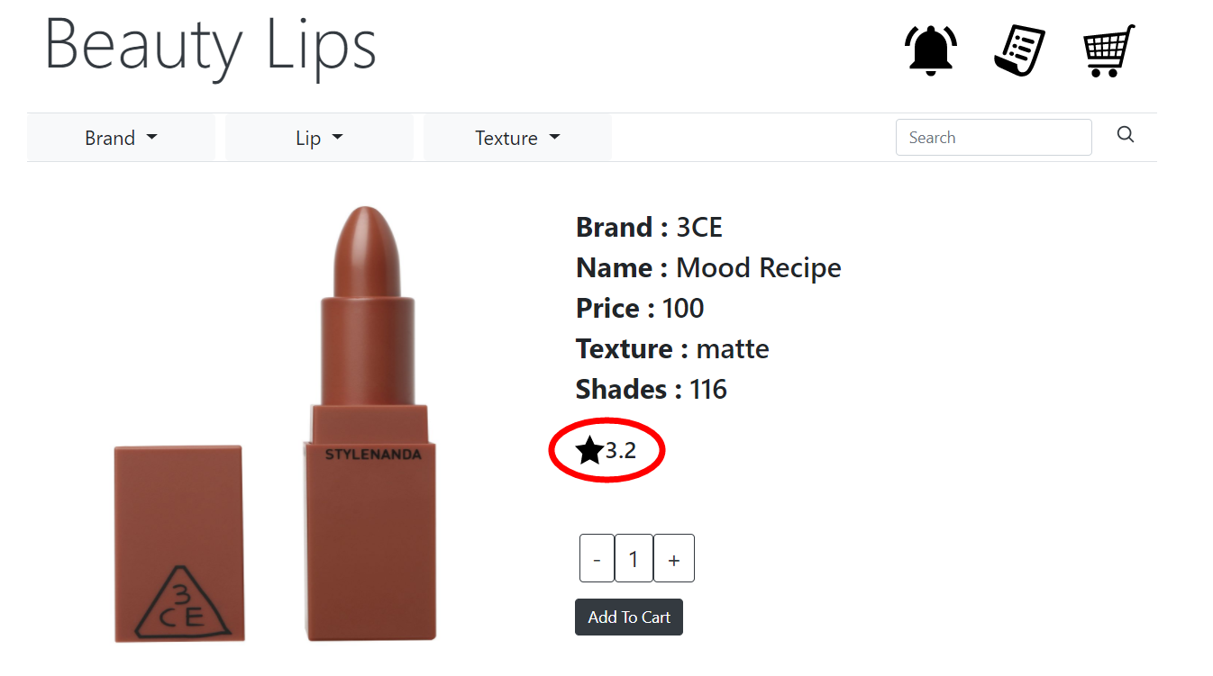

**Figure 91: Average rate in product detail page**

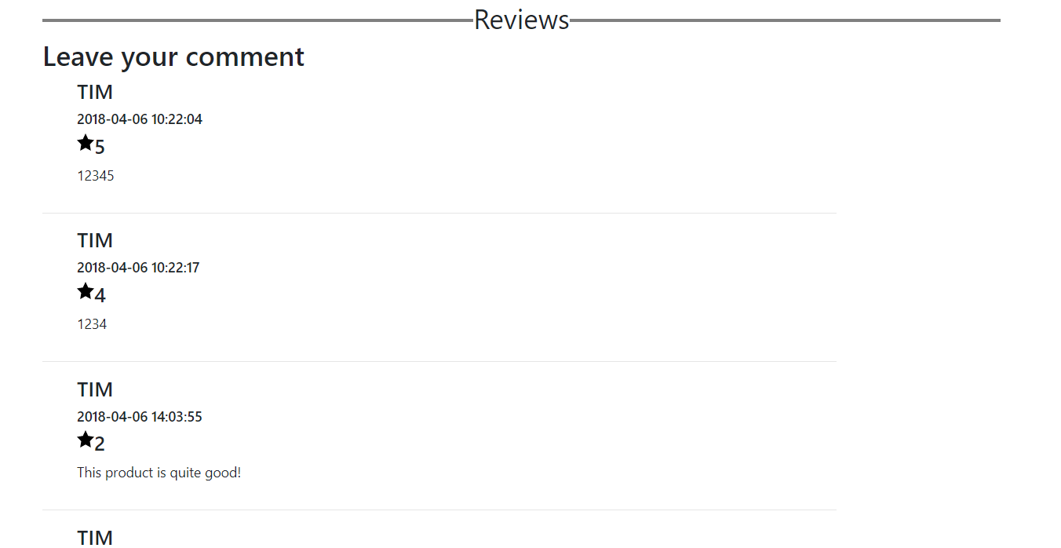

**Figure 92: Product reviews in product detail page**

After vendor have shipped the product and change the specific purchase order to the status “shipped”, the user could give their comment to the product in this purchase one by one, shown in Figure 93.

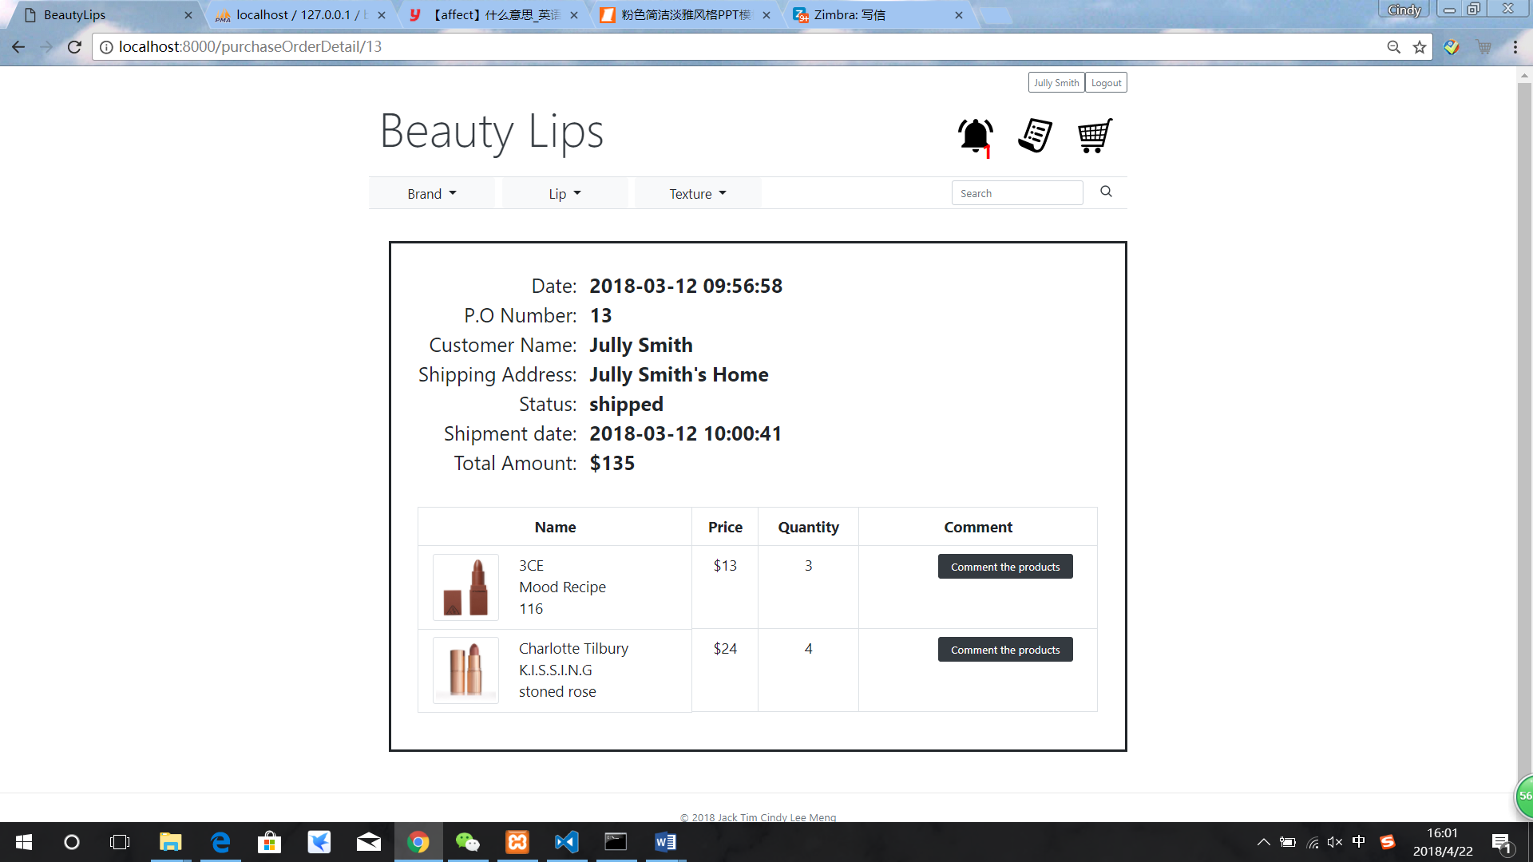

**Figure 93: Purchase order detail page after vendor shipping the product**

The customer could use Comment the product button to go to product review page and give their rate and comment on the product. The default value of rate is five and customer could choose integer rate from 5 to 0, shown in Figure 94.

After submitting the comment, the customer would back to purchase detail page for further comment on other products. The products which have already commented would be shown “product already commented” in comment column, shown in Figure 95.

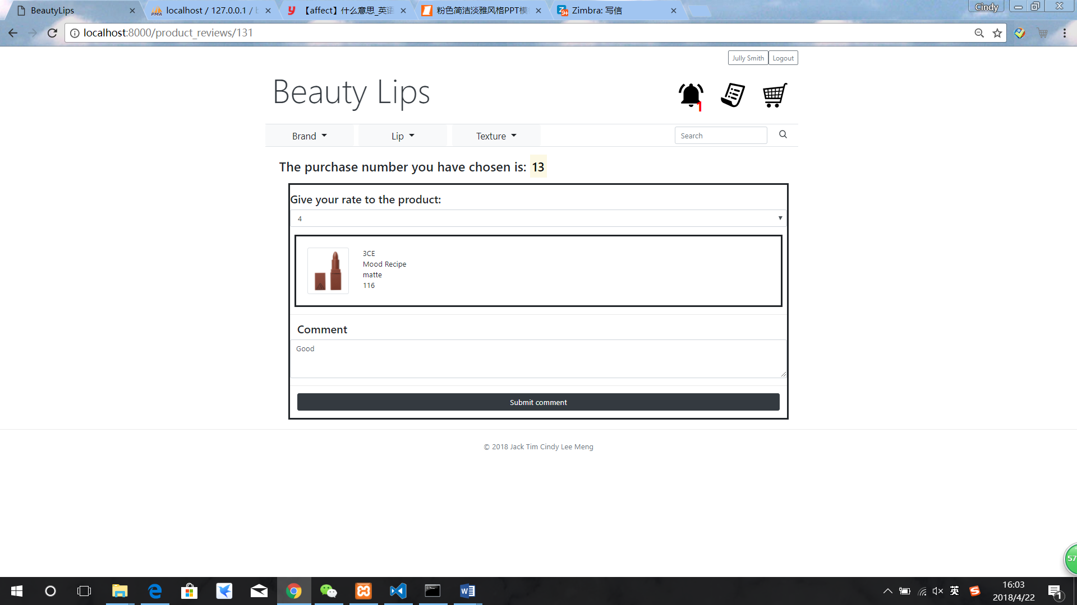

**Figure 94: Product review page**

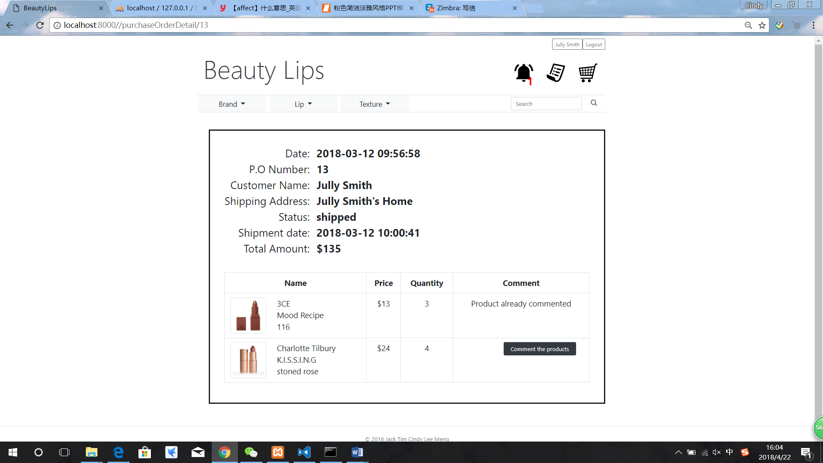

**Figure 95: Product has commented in purchase detail page**

### 5.1.24 **Price change**

This customer bought 3 liquid lipsticks with price $16.5 for each, as the figure 96 shows below.

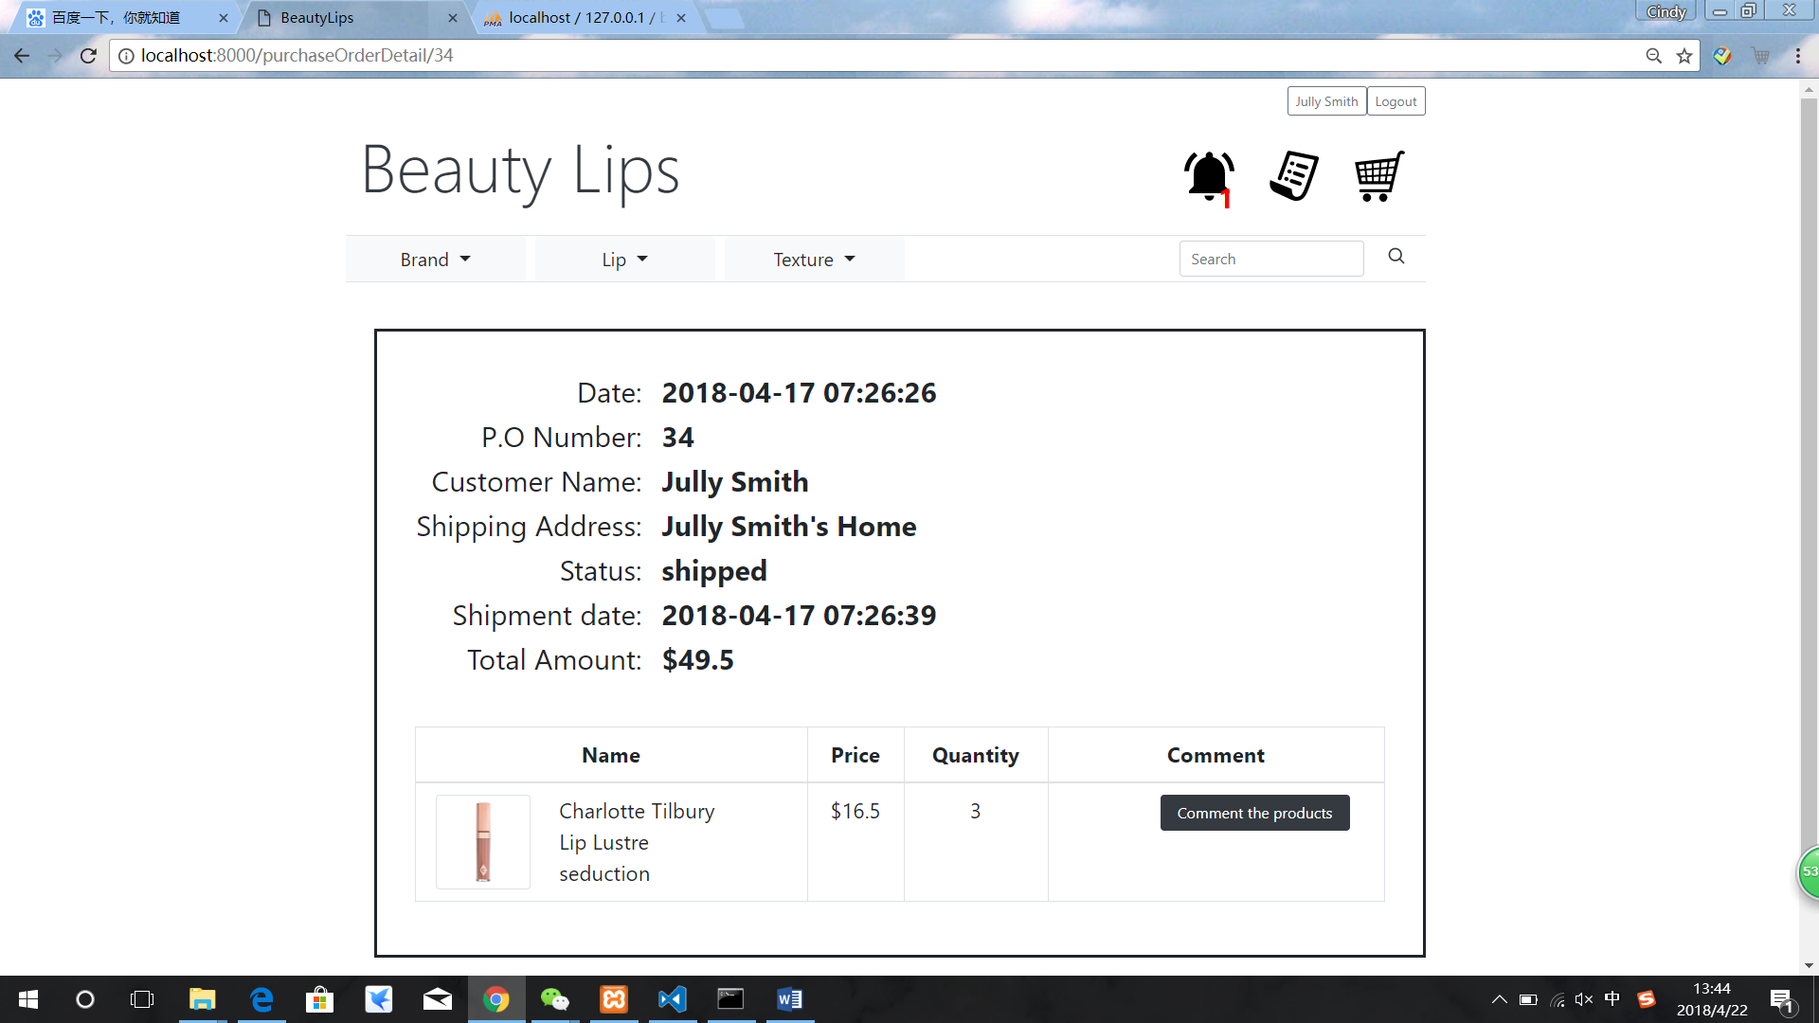

Figure 96: Charlotte Tilbury liquid lipstick with price $16.5

After a while, vendor wanted to do some promotion on this product, so vendor changed this product’s price from $16.5 to $12. Figure 97 shows vendor is changing the price and Figure 98 shows the new price is setup completely for all customers.

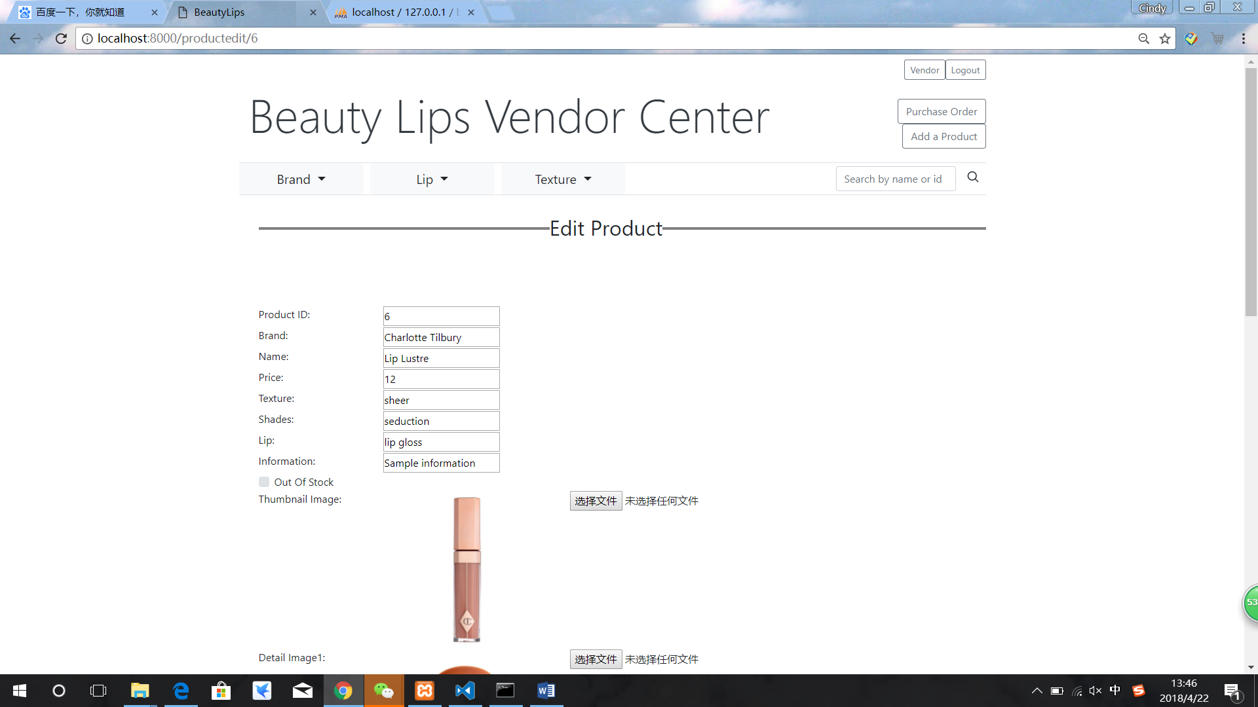

Figure 97: vendor changed price

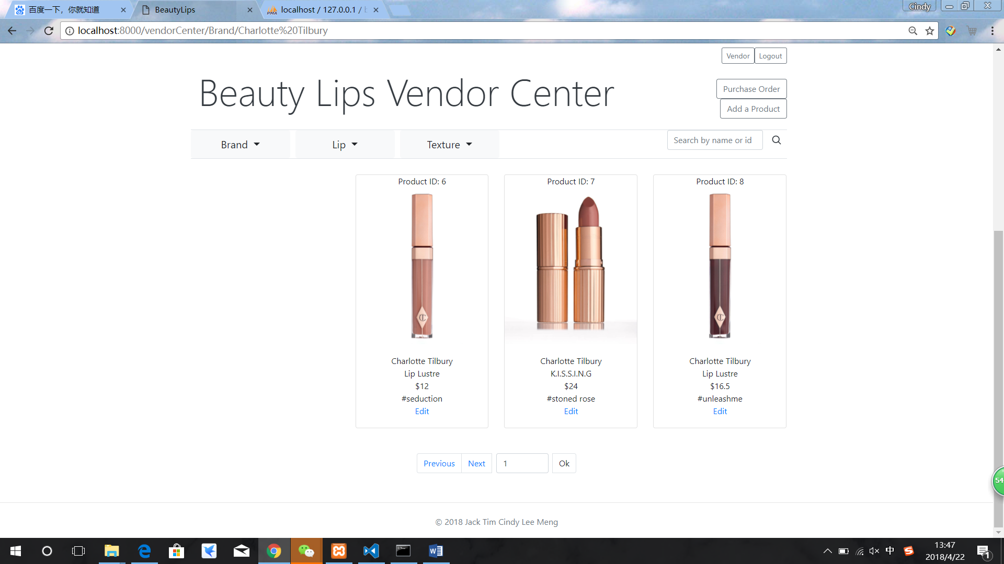

Figure 98: The price is changed already

After vendor changed this product’s price, there is not affect to customer’s purchase order, Figure 99 shows the price of this product remained $16.

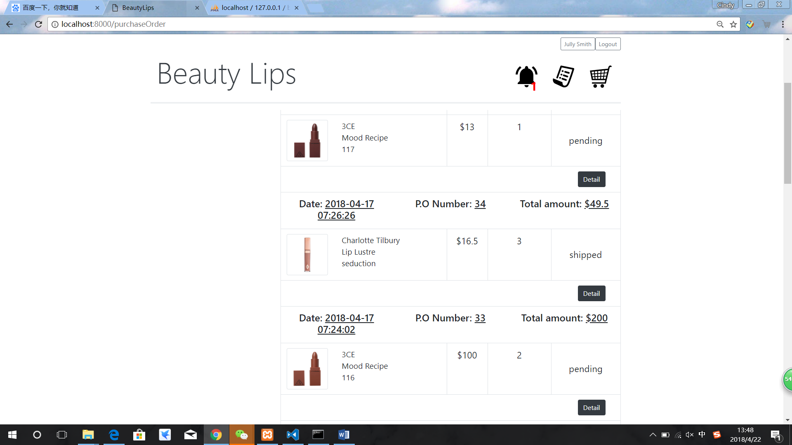

Figure 99: Product price of customer’s purchase order remained the same

### 5.1.25 **Out-of-Stock**

When vendor makes inventory of lipsticks, he finds out lipstick of brand 3CE, shade 116 is out of stock, then he logs into his vendor center to tick the check box “Out Of Stock” in this product edit page.

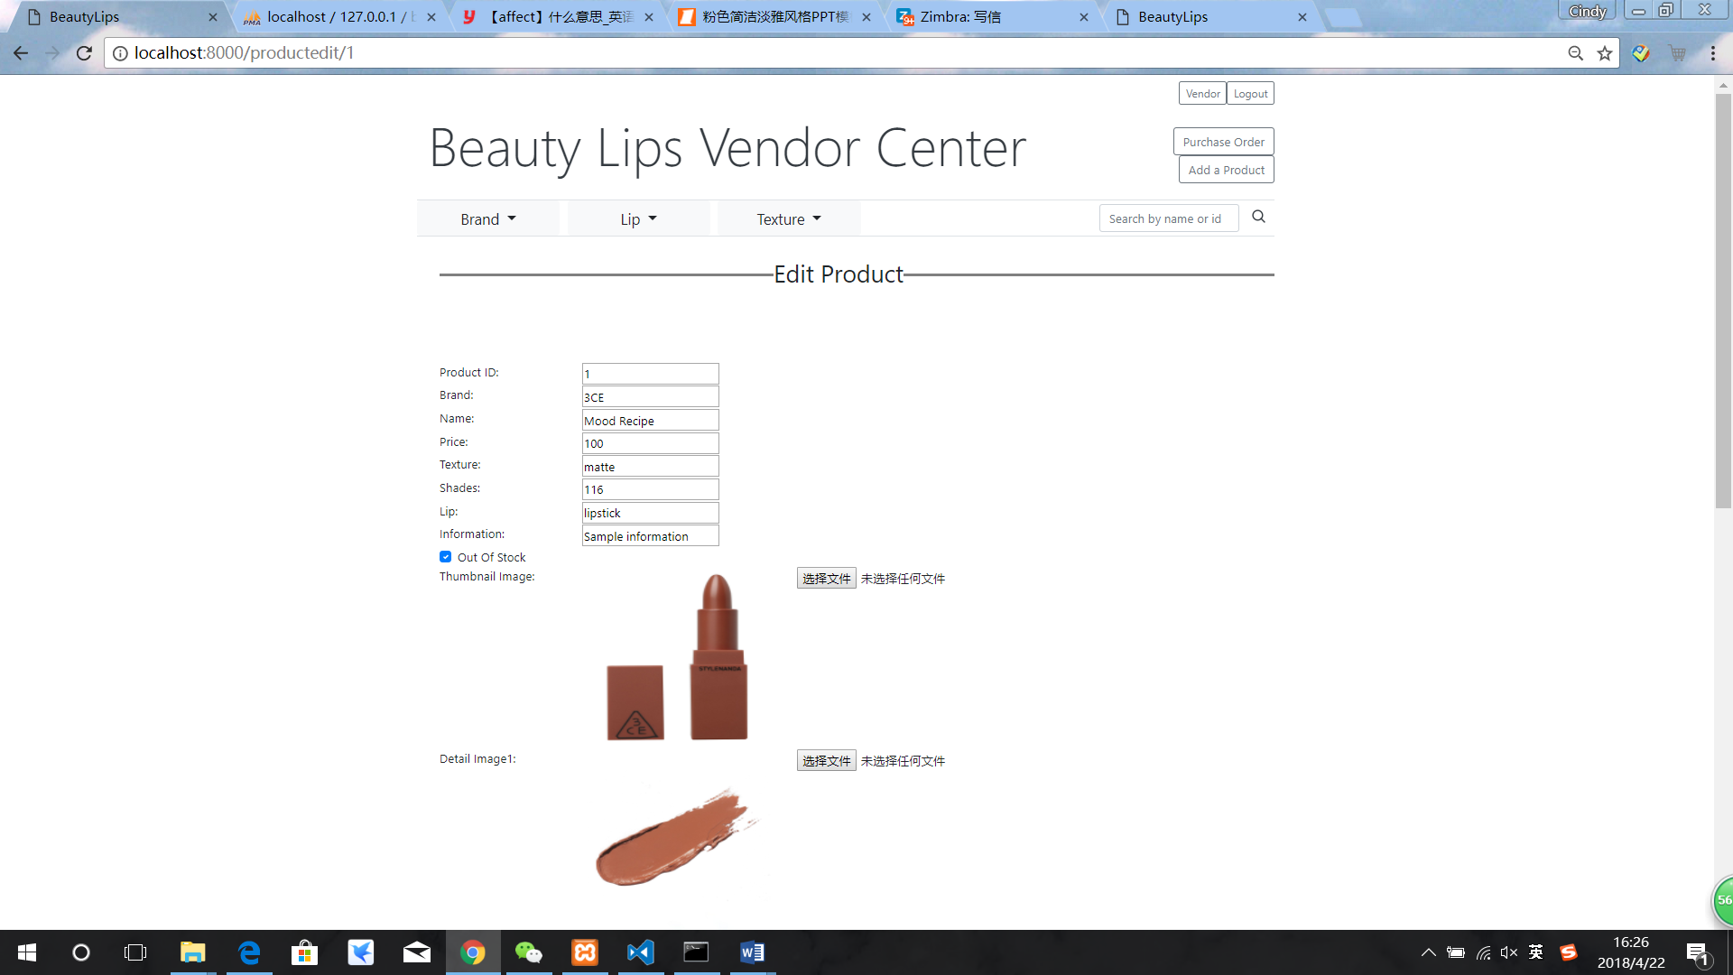

Figure 100: tick the “Out Of Stock” check box

After vendor ticks the check box, the availability of this product becomes “Out of Stock”. On vendor purchase order detail page, there are two choices for vendor to choose, either “Hold the order” or “Cancel the order”.

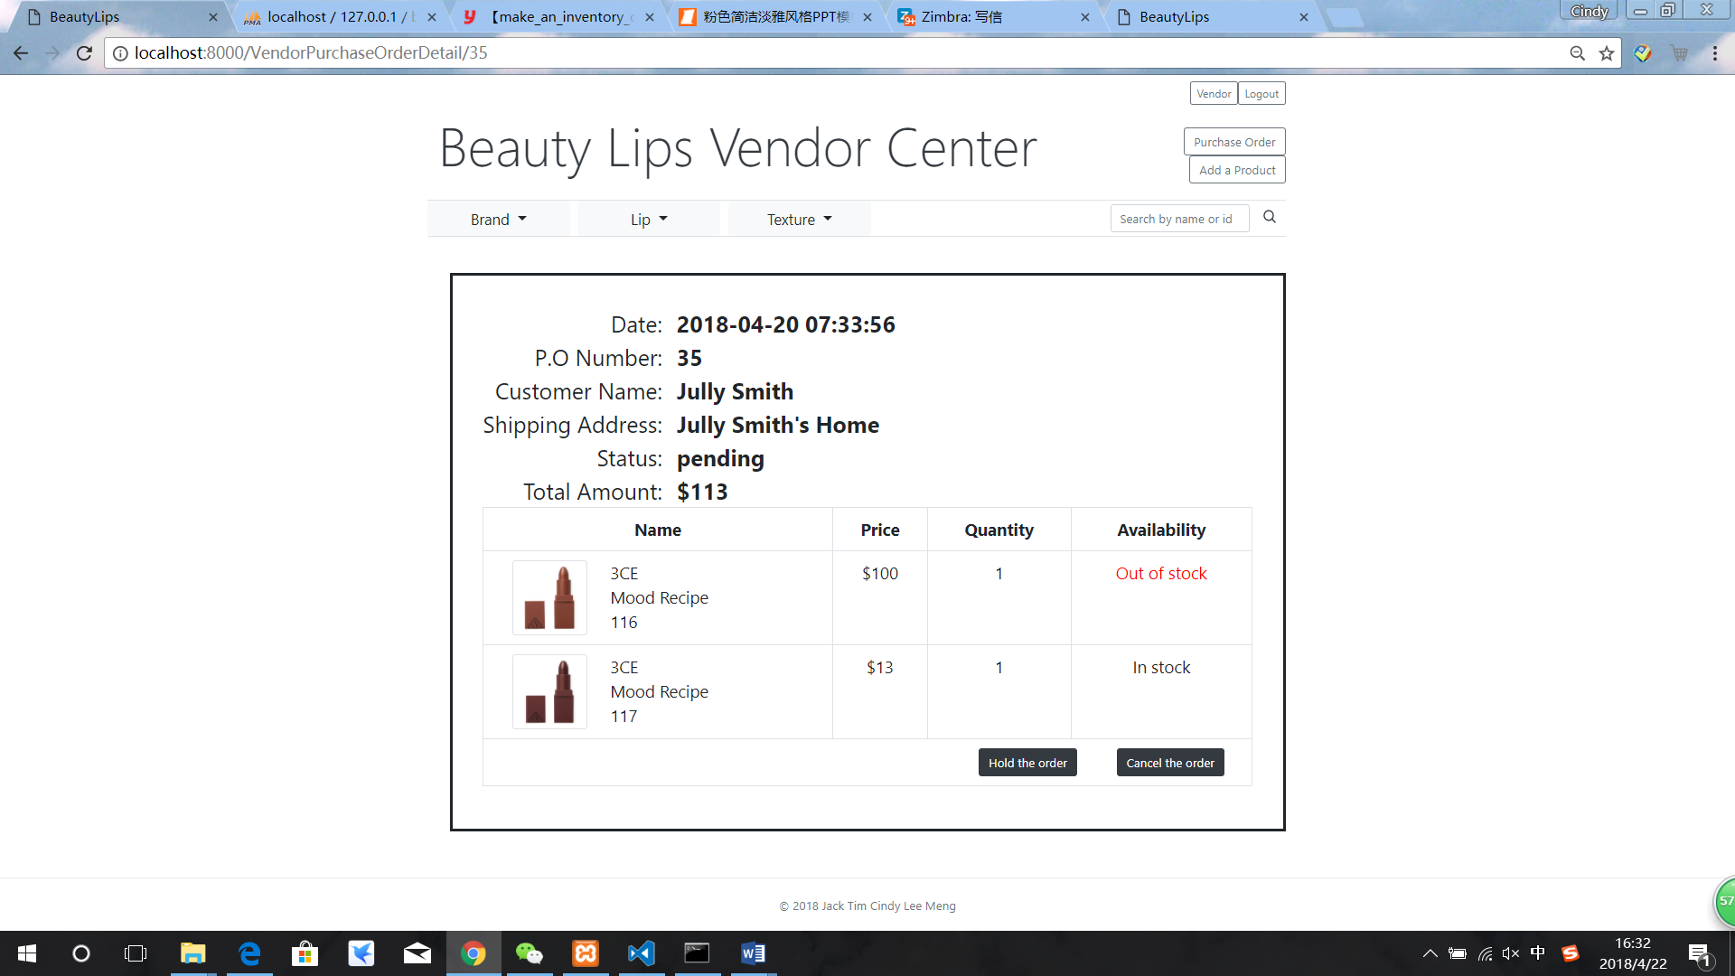

Figure 101: Out of Stock on vendor purchase order detail page

## Testing and System Evaluations

|  |  |  |  |
| --- | --- | --- | --- |
| **Function Number** | **Test Action** | **Test Response** | **Requirements Confirm** |
| A1, E1(1) | Browse products in a list of products.(Including product name, brand, texture, lips and a thumbnail picture ) | Website displays the product name, brand, texture, lips and a thumbnail picture | ✓ |
| A2, E1(2) | Page the product list, for example, page up, page down, go to a specific page while enter a number into paging box | Website page down, page up and go to a specific page successfully | ✓ |
| A3, E1(3) | Use dropdown list to filter the product list by brand | Website supports filtering by brand successfully | ✓ |
| A4 | Search key words to find products by enter the key word into search box | Website shows the result of products with key word | ✓ |
| **Function Number** | **Test Action** | **Test Response** | **Requirements Confirm** |
| A5 | Press "Price from large to small" or "Price from small to large" to filter the products by price | Website supports price filtering successfully | ✓ |
| A6, E1(4) ,A7 | Select one product's brand to go into this product's detail page | Product detail page shows information for this product, which includes the product name, brand, price and a thumbnail image. In addition, the product detail page also shows texture, lips, rating and 1 to 4 detail images | ✓ |
| B1 | Register a new account by clicking 'Register' button | When register an account, user need to fill in the user name, email, address and password | ✓ |
| **Function Number** | **Test Action** | **Test Response** | **Requirements Confirm** |
| B2 | Log in and Log out. (When log in, the name of the account will be shown. Purchase tracking and shopping cart is accessible when log in) | Log in and log out successfully. Name of account will be shown on the top right when log in | ✓ |
| B3 | Change password | When enter numbers“123”, validator will alarm “Must be at least one digit and one capital letter”and “At least 6 digits or words” | ✓ |
| B4 | When add products to shopping cart without log in, website will redirect to log in page. After log in, website will redirect to the preview product detail page | Redirect to log in page successfully | ✓ |
| **Function Number** | **Test Action** | **Test Response** | **Requirements Confirm** |
| B5 | Check the accounts' password in database is stored in hashing | The accounts' password in database is stored in hashing | ✓ |
| C1 | Add products to the account's shopping cart page, and the shopping cart will store the product information whenever user log in | Add products successfully. The shopping cart can store product's information successfully | ✓ |
| C2 | List the products in user's shopping cart in a shopping cart page | Shopping cart page shows the product name, price, quantity of each product, total order amount successfully | ✓ |
| C3 | Checkout by clicking the 'checkout' button. After checkout, shows a purchase order detail page | Checkout and shows the purchase order detail page successfully | ✓ |
| **Function Number** | **Test Action** | **Test Response** | **Requirements Confirm** |
| C4, C5 | In shopping cart page, user can edit the quantity of a product or delete the product. | Change quantity and delete products successfully | ✓ |
| C6 | Website will show a warning massage at the top of the product detail page when adding the duplicate product to the shopping cart | The warning message shows "Product already exist in your shopping cart" | ✓ |
| F1, D1 | Browse purchase order list and purchase orders are sorted in descending order of purchase date, press "Detail" button on every purchase order to go into the purchase order processing page. | Website support browsing purchase order list with descending order of purchase date, after press "detail" button can go to purchase processing page | ✓ |
| **Function Number** | **Test Action** | **Test Response** | **Requirements Confirm** |
| F2, D2 | Vendor filters purchase order list by ticking "pending orders", "orders on hold" and "Past Purchase" these three check boxes; customer filters purchase order list by ticking "Current Purchases" and "Past Purchase" check boxes | When check the “Current Purchase”, it shows the pending and hold orders. When check the “Past Purchase”, it shows the shipped and cancelled orders | ✓ |
| D3 | Press "Detail" to go into purchase order detail page, shows all details that a purchase order needs | Website successfully shows purchase order detail page, it display the product name, brand, texture, price, quantity, status and a thumbnail picture. | ✓ |
| D4 | On purchase order detail page, press "Cancel the order" to cancel the order only with statues "pending" or "hold" | Cancel order successfully | ✓ |
| **Function Number** | **Test Action** | **Test Response** | **Requirements Confirm** |
| E1(5) | In product detail page, vendor will not see 'add to cart' button | Vendor cannot see 'add to cart' button The page display no ‘add to cart’ button | ✓ |
| E2 | Vendor can find products by searching keywords in product names or product ID | When search the key word “3CE”, the website shows all the products which included “3CE” | ✓ |
| E3 | Vendor can add a new product to the catalogue by clicking the 'Add a product' button | Add new product brand, price, name, texture, shades, lip, information, whether out of stock, one thumbnail picture and one to four detail pictures | ✓ |
| E4 | Vendor can upload 1 to 4 detailed pictures and have a user-friendly interface. | Upload pictures successfully. After each upload, the picture will display that is good-looking | ✓ |
| **Function Number** | **Test Action** | **Test Response** | **Requirements Confirm** |
| E5 | In vendor center, vendor can edit information of each product. | Edit brand, price, pictures, name, texture, shades, lip, information and out of stock successfully | ✓ |
| E6 | Vendor can change the thumbnail and detail pictures of a product or delete each of them | Change and delete thumbnail and detail pictures successfully | ✓ |
| F3 | On purchase order processing page, press "Shipping the order" to ship and change status to shipped | The purchase order processing page shows similar information as the purchase order detail page, after press button, status changes to shipped | ✓ |
| F4 | Enter a P.O. number to view and process a specific purchase order | Website support entering a P.O. number to view and process a specific purchase order | ✓ |
| **Function Number** | **Test Action** | **Test Response** | **Requirements Confirm** |
| F5 | Click "Hold the order" button to hold a purchase order on the purchase order processing page, change the status to hold | Purchase order processing page support this action, status changes to hold | ✓ |
| F6 | Press "Shipping the order" to change the status from hold to shipped on the purchase order processing page | Purchase order processing page support this action, hold status changes to shipped | ✓ |
| F7 | Press "Cancel the order" to change the status from “pending” or "hold" on the purchase order processing page | Purchase order processing page support this action, pending or hold status changes to cancelled | ✓ |
| **Function Number** | **Test Action** | **Test Response** | **Requirements Confirm** |
| Z2 | Buy a product and let the vendor change the status of the purchase order | There is a notification at the top right on a ring icon. Press it and check the notification, after click it, the colour is changed from blue to grey | ✓ |
| Z3,Z4 | Buy some products and make some comments and ratings on each product | The detail page will show the comments with the customer’s name, rating, date and the detail information of the comment. Meanwhile , there is an average rating in the detail page of each product | ✓ |
| **Function Number** | **Test Action** | **Test Response** | **Requirements Confirm** |
| Z5 | First, buy a product and add another product into shopping cart on the customer side, then change the price of these two products | The price of the product which customer bought is unchanged as for the price of product which customer added to the shopping cart is changed as the vendor settled | ✓ |
| Z6 | Add a product to the shopping cart on the customer side, then edit the ‘out-of-stock’ function to make the product out-of-stock on the vendor side | The purchase order which include the product with out-of stock is highlighted with red colour and the shipped button is disappeared on the vendor’s purchase order detail page | ✓ |

# Conclusion and Further Work

Based on Information System Implementation project requirements, an online shopping mall is designed. Our online shopping mall is aimed at selling lipsticks, the name of this online shopping mall is called “Beautylips”, which customers can get a clear picture of what kind of things we are selling. This online shopping mall provides a unique opportunity for retail business, which means we only have one vendor, the business model of our project is B2C model, and customers can do window shopping or purchase lipsticks online anytime and anywhere.

The detail function specifications are attached to the appendix. From part A to part D is designed to customers, customers can browse products by searching the name of products, paging or sorting, and filtering products with or without login. Only in login circumstance, customers can check products in the shopping cart and do checkout action. And of course, this website provides register functions for new customers. After purchasing, customers can check the purchase order and track the status of those orders. As for vendor (from part E to part F), the vendor can browser products as well as customers, beyond that, the vendor can edit or upload new products, confirm customers’ orders according to the real-time situation, change the status of orders to “hold”, “shipped” or “cancelled”. After complete all basic function, five advance functions also achieved in this project, such as customer notification, rating and comment, price change and whether product is out of stock (form Z2 to Z6). All these operations satisfied functional requirements of this project. While providing the online shopping experience to customers, our website also brings customers an easy-understanding and beautiful user interface.

Though we have achieved all specifications, there are some limitations that can be improved in the future. These limitations are listed below.

1. Multi-category is not so detailed. The multi-category of our online shopping mall is not so detailed. In our website, customers can classify our products by brand, texture, lips, and price. But they cannot classify products by both brand and texture or both brand and lips. In future work, we may need to classify a more detailed category and set some multi-choice by using the SQL code to solve it.

2. Multi-research is not so detailed. Our search engineer also has a limitation that it cannot search directly by using multiple keywords. In order to solve this limitation in the future, we will learn from some famous search engineer like Google. Do some research to complete the multiple keyword searching.

3. The payment system is not included. The payment system is not included in our online shopping mall. By doing some investigation, we need to develop the online payment with banks or the third-party payment platform to guarantee customers security issue.

4. Return and delivery tracking function is not included. In order to achieve this function, we need to cooperate with logistics companies. Through our cooperation, we will lead the tracking information of each purchase order from the logistics companies into our website.

References

[1] Harold Abelson, Gerald Jay Sussman, and Julie Sussman. Structure and Interpretation of Computer Programs. MIT Press, Cambridge, Massachusetts, 1985.

[2] Robert Baumgartner, Georg Gottlob, and Sergio Flesca. Visual information extraction with Lixto. In Proceedings of the 27th International Conference on Very Large Databases, pages 119–128, Rome, Italy, September 2001.Morgan Kaufmann.

[3] Ronald J. Brachman and James G. Schmolze. An overview of the KL-ONE knowledge representation system. Cognitive Science, 9(2):171–216, April–June 1985.

[4] Georg Gottlob, Nicola Leone, and Francesco Scarcello. Hypertree decompositions and tractable queries. Journal of Computer and System Sciences, 64(3):579–627,May 2002.

[5] Georg Gottlob. Complexity results for nonmonotonic logics. Journal of Logic and Computation, 2(3):397–425, June 1992.

[6] Hector J. Levesque. Foundations of a functional approach to knowledge representation. Artificial Intelligence, 23(2):155–212, July 1984.

[7] Hector J. Levesque. A logic of implicit and explicit belief. In Proceedings of the Fourth National Conference on Artificial Intelligence, pages 198–202, Austin, Texas, August 1984. American Association for Artificial Intelligence.

[8] Bernhard Nebel. On the compilability and expressive power of propositional planning formalisms. Journal of Artificial Intelligence Research, 12:271–315, 2000.

[9] Ivan Marsic. A short guide for writing a thesis. http://www.ece.rutgers.edu/~marsic/thesis-guide.html, 2004 [Mar. 6, 2014].

[10] Matlab documentation. http://www.mathworks.com/help/?s\_tid=hp\_ff\_s\_doc [Mar. 6, 2014].

[11] George Sparling. Spacetime is spinorial; new dimensions are timelike. arXiv:gr-qc/0610068v1, 2006.

[12] Ryan Rifkin. Everything old is new again: a fresh look at historical approaches in machine learning. Ph.d thesis, MIT, 2002.

[13] *javascript*. (2018, 4 21). Retrieved from javascript: https://www.javascript.com/

[14] *laravel*. (2018, 4 21). Retrieved from laravel: https://laravel.com/

[15] *php*. (2018, 4 21). Retrieved from php: http://php.net/

[16] Wikipedia. (n.d.). *Wikipedia*. Retrieved from Wikipedia: https://en.wikipedia.org/wiki/E-commerce

Appendix A. Project Management

Gantt Chart

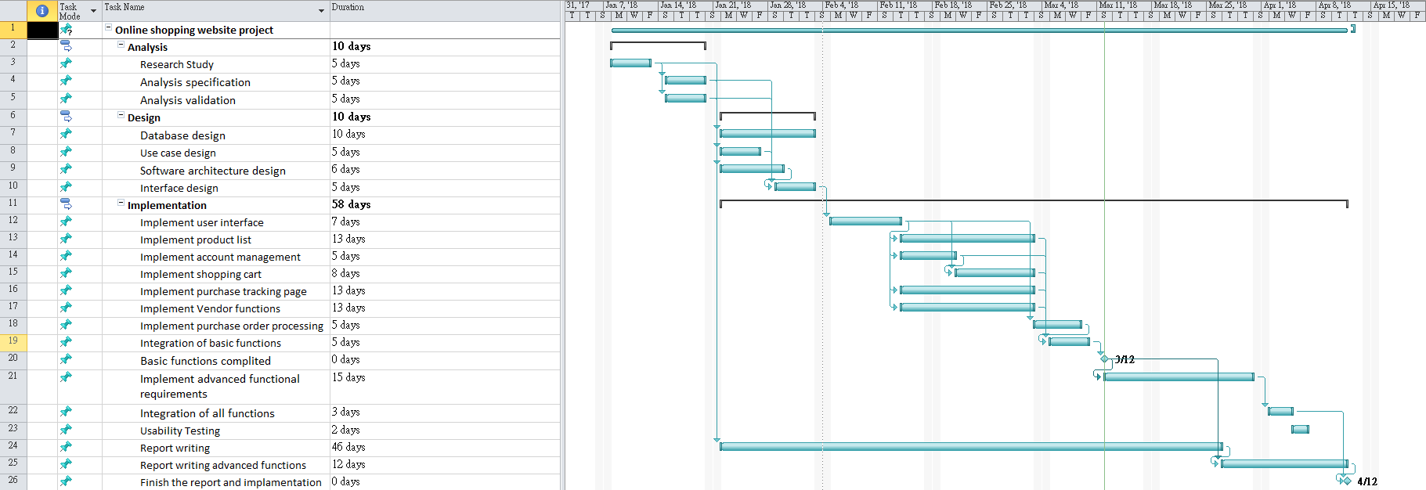

**Project Specification**

Customers do ‘window shopping’ in store at the frontend of the mall, browse and select desired products, and place orders for products in the shopping cart. The application supports the following functions. The front page of the shopping mall shows a product list.

(A1) A customer may browse products in a list of products. The list shows basic information of products, including product name, brand, price and a thumbnail image. Each product belongs to one of the pre-defined brands. (You can also use category instead of brand). •

(A2) The product list supports paging. The customer can navigate the product list by ‘page up’, ‘page down’ and jumping to a specific page. Paging works properly after applying a filter or sorting as listed below.

(A3) The customer can filter the product list by brand. They can also list products of all brands. •

(A4) The customer may filter the product list by searching keywords in the product name. This function work correctly with the brand filter. •

(A5) The customer may sort the product list by price. The product detail page shows detailed information about one product.

(A6) The customer may select a product in the product list to go to the product detail page. The product detail page shows information for one product, which includes the product name, brand, price and a thumbnail image. In addition, the product detail page also shows detail description as a list of at least two properties. For example, the product detail page for a book may show authors, ISBN, publisher, release date and number of pages. •

(A7) The product detail page supports display of one or more detailed photographs of the selected product. The system has basic account management for customers.

(B1) A customer may register a new account. They have to provide full name, email address, password and shipping address. After registration, the user is logged in automatically. •

(B2) A customer may log in and log out, and the interface shows the name of the current user. The product list and product detail page are accessible to customers without login. On the other hand, the shopping cart and purchase tracking are only accessible after login. •

(B3) The customer can change password. There is strength requirement for password. The password should contain at least 6 characters, in which there must be at least one digit and one capital letter. •

(B4) If a customer tries to add a product to the shopping cart on the product detail page without first logging in, the system redirects the user to the login page. After successful login, the system redirects the user back to the original product detail page.

(B5) The server only saves hash values of customers’ passwords. Passwords are never saved in plain text in the server. To make any purchase, a customer must add products to his/her shopping cart. The customer can check out all items in the cart to place an order.

(C1) The customer adds a product to his/her shopping cart by clicking a button in the product detail page. The quantity to buy is assumed to be 1. The items in shopping cart are persisted across user sessions. Next time the customer logs in, they can still see the items in the shopping cart. •

(C2) The customer can list the products in his/her shopping cart in a shopping cart page. In this page, the entry for each product shows the product name, price and the quantity to buy. The page also shows the total order amount (i.e. how much the customer has to pay in total) in the shopping cart. The customer can click an item in the shopping cart to go to the product detail page of the entry. •

(C3) The customer can press a button in the shopping cart page to check out all items in the shopping cart. This action creates a purchase order with a newly allocated unique P.O. number, and clears the content of the cart. After checkout, the system shows the purchase order detail page of the newly created purchase order. (refer to requirement D3). •

(C4) The shopping cart page allows the customer to change the quantity of an item. This allows the customer to order more than one piece of a product (e.g. buy two copies of a book). (C5) The customer can remove an item from the shopping cart. •

(C6) If the customer adds a duplicate product to the shopping cart, the application will give a warning message and does not change the content of the shopping cart. Purchase tracking: After placing an order, the customer can trace the processing status of the order in a purchase tracking page. For simplicity, we assume that each purchase order is fulfilled in a single shipping package. The purchase order status describes the various stages of order processing. Possible values include ‘pending’, ‘shipped’, ‘hold’, and ‘cancelled’.

(D1) The purchase tracking page lists the purchase orders that the customer has placed. This page shows the following for each purchase order: the P.O. number, the purchase date, the total order amount and the purchase order status. The purchase orders are displayed in reverse chronological order of purchase date. When the customer clicks an entry in the list, they can see the detail in a purchase order detail page. •

(D2) The customer can filter the list of purchase orders in two ways. First, the page only shows ‘current purchases’ with status ‘pending’ and ‘hold’. Second, the page only shows ‘past purchases’ with status ‘shipped’ and ‘cancelled’.

(D3) The purchase order detail page shows the P.O. number, the purchase date, the customer name, the shipping address, the total order amount and the purchase order status. If the order is shipped, this page shows the shipment date. If the order is cancelled, the page shows the order cancel date and who (customer or vendor) cancelled the order. The page also includes, for each product in the purchase order, the product name, the quantity, the unit price and the subtotal. •

(D4) Before a purchase order is shipped, the customer can cancel the order. This can be done by clicking a button in the purchase order detail page. This action will change the status of the purchase order to ‘cancelled’. Note that this action is only available for purchase orders in the status ‘pending’ or ‘hold’.

Vendor

The vendor maintains a product catalog in the shopping mall. They can also process purchase orders from customers. Because there is only one vendor, the system only needs to implement a single vendor user account. No account management of vendor accounts is necessary in this project. The application provides the following functions.

Product catalog maintenance: The vendor can browse the product catalog, edit some properties of a product, and add new products.

(E1) The vendor may browse the product catalog in an interface similar to product list for customers. (Refer to requirements A1, A2, A3 and A6). The vendor is not a customer, and no shopping cart or ‘add to cart’ button should be shown. •

(E2) The vendor can find products by searching keywords in product names. They can also find a specific product by entering a unique product ID. •

(E3) The vendor may add a new product to the catalog. The vendor enters basic information of the product, including product name, brand, price and a thumbnail image. They can enter detail information of the new product as a list of properties. (Refer to requirement A6) •

(E4) In addition to the thumbnail image, the vendor can upload 1 to 4 detailed photographs for a product. These photos are usually of higher resolution and are displayed in the product detail page in a user-friendly interface. (Refer to requirement A7) •

(E5) The vendor can edit information of a product in a product detail page. They can change the product name and product brand. They can also change detail information as a list of properties. (Refer to requirement E3). •

(E6) The vendor can change the thumbnail and detail photos for a product. They can add or remove photos. Purchase order processing: The vendor can list purchase orders by different status. They may ship, hold, or cancel a purchase order in the purchase order processing page.

(F1) The purchase order list page lists purchase orders received by the application. It shows the P.O. numbers, purchase dates, customer names, total order amounts and purchase order status. The purchase orders are sorted in descending order of purchase date (i.e. newest first). The vendor can click an entry to open a purchase order processing page. •

(F2) The vendor can filter the purchase order list in three ways. They can show only the ‘pending orders’ (with status ‘pending’). They can show only the ‘orders on hold’ (with status ‘hold’). Finally, the vendor can select to show ‘past orders’ (with status ‘shipped’ or ‘cancelled’). •

(F3) The purchase order processing page shows similar information as the purchase order detail page (refer to requirement D3). In addition, the vendor can click a button to ship a purchase order. This action changes the status of the purchase order from ‘pending’ to ‘shipped’ and starts the shipping process. •

(F4) The vendor can enter a P.O. number to view and process a specific purchase order. • (F5) In the purchase order processing page, the vendor can click a button to hold a purchase order. This is useful, for example, if some product in the purchase order is temporarily out-of-stock. This action is only available when the status of the purchase order is ‘pending’, and this action changes the status to ‘hold’. •

(F6) In the purchase order processing page, the vendor can click a button to unhold and ship a purchase order. This action changes the status of the purchase order from ‘hold’ to ‘shipped’ and starts the shipping process. •

(F7) In the purchase order processing page, the vendor can click a button to cancel a purchase order. This is useful, for example, to inform the customer that the ordered products are no longer available. This action is only available for purchase orders in the status ‘pending’ or ‘hold’. This action changes the status of the purchase order to ‘cancelled’.

You are also required to design and implement some of these advanced features.

(Z1) The vendor needs to analyse the sales of the products and find out the best selling products. The report measures sales by both sales quantities (number of items sold) and sales amount (the dollar amount received in sales). The default reporting period is the last 30 days, but the vendor may also customize the reporting period. •

(Z2) Design a notification feature to make it to easier for a customer to track the change of status of purchase orders. For example, when the vendor ships a purchase order, the customer will receive a notification message. The interface should distinguish between read and unread notifications. You can use the notification in Facebook as reference.

(Z3) A customer can express their satisfaction with a product with customers’ rating. A customer who has purchased a product successfully can rate it on a scale of 1 to 5 stars after the purchase is shipped. Decide whether a customer can rate one product more than once, and whether they can change the ratings afterwards. The product detail page shows customers’ average rating as a decimal number (e.g. 3.5 stars). Pay special attention when number of ratings is smaller (e.g. less than 2). Consider how to use the average ratings in product list for customers and the vendor. •

(Z4) In addition to star ratings, customers also want to write short reviews for products in the shopping mall. Design a feature to allow a customer to write a short review for a product. Consider how to show these reviews to other customers and the vendor. •

(Z5) Design how to implement price change of products. This is useful, e.g., for promotional price reduction or regular price adjustment. Price change should not affect the price in existing purchase order and other historical records. •

(Z6) Sometimes, a hot-selling product is ‘out-of-stock’. Design a feature for the vendor to mark a product as temporarily out-of-stock. Customers can still place orders for such products, but the system should only be able to ship them when the vendor marks the products as in-stock later. Consider how this feature affects the other parts of the system. •

Appendix B. Peer Assessment Form

|  |  |  |  |  |  |  |
| --- | --- | --- | --- | --- | --- | --- |
| S:\3rd ITC\2nd ITC\MPI_logos\MPI logo09_C349 CPE.tif  BSc. in Computing 2016/17  COMP321 Information System Implementation  Peer Assessment Form | | | | | | |
| Project number | Group 10 | | | | | |
| Team members | |  |  |  | | --- | --- | --- | |  | Student ID | Student name | | *1.* | P1507859 | Tim | | *2.* | P1507918 | Cindy | | *3.* | P1507790 | Jack | | *4.* | P1507918 | Lee | | 5. | P1504119 | Meng | | | | | | |
| Contribution **(**Each row must total to 100%) | | | | | | |
|  | | Member 1 | Member 2 | Member 3 | Member 4 | Member 5 |
| 1. Project leadership | | 25% | 20% | 15% | 20% | 20% |
| 2. Data modeling | | 20% | 20% | 20% | 20% | 20% |
| 3. User interface design | | 20% | 20% | 20% | 20% | 20% |
| 4. Program development | | 20% | 15% | 25% | 15% | 25% |
| 5. Solving technical problems | | 20% | 20% | 20% | 20% | 20% |
| 6. Testing and sample data | | 20% | 20% | 20% | 20% | 20% |
| 7. Report writing | | 15% | 25% | 20% | 25% | 15% |
| 8. Preparing / giving presentation | | 20% | 20% | 20% | 20% | 20% |

By default, the eight items above have the same weight when calculating the overall contribution percentage. You are welcome to suggest different weight if you consider some aspects should carry more weight.